Councillor | Comments
John Pitts | Is there a scaled drawing of the inside available? Unable to give a scaled drawing due to layout of toilets can’t be confirmed until roof is removed to show any structural walls (The plan is to have 3 toilets instead of the 4 giving more space to help with parents with small children and the elderly).
Andy Pearce | Further to your E-mail below and to the discussion at this afternoon’s TMWG meeting, my feedback as follows:  If memory serves, I think the agreement reached at Feb Full Council was to try and obtain some further detail about the spec/photos of the interior equipment (sinks, driers, toilets, doors, etc), and then circulate to all Councillors with a delegation to the Clerk in conjunction with Councillors to make a decision on the basis of that additional information. Did we ever obtain any further information?  I was broadly happy to recommend approval at February F&G. Whilst I would not want an inordinate delay, at the same time we are spending over £100K here, so whilst I don’t want to get hung up on the aesthetics of sink or toilet design I do agree with Colin that we need answers to some basic questions about what we are buying. But this is a toilet not an art gallery, so whilst I wouldn’t be looking for a Victorian throwback nor am I particularly fussed about what “looks nice”, I am looking for something that is functional and hard wearing and does the job that it is meant to do, which incorporates environmental/energy sustainability features (as this design does), and which facilitate ease of maintenance and which don’t facilitate vandalism. My only queries are as follows:  - I think our preference was for smooth walls and floors (I.e. no tiles), to facilitate cleaning and reduce the likelihood of mould build-up in the gaps between tiles etc. Tiles are the hardest wearing of all wall covering and the easiest to clean off vandalism.  - Ventilation throughout the building will be increased to reduce condensation.  - Priced it for both wall covering i.e same as wilco toilets or tiles.  - Would lighting etc be embedded in the ceiling I.e. no protruding fittings. Many moons ago, this had been discussed as a preference, to minimise the potential for vandalism. Insert lights have been planned into the refurb which will be low running cost LED  - Fire-proof or at least fire-retardant materials? All materials are fire retardant Note: nothing can withstand the heat from jet lighters which is what the youth of today use.  - As per below comments magnetic timed locks are to be installed which will help with toilet not being open in the evening or left unlocked helping reducing vandalism.  - Driers? Again, the consensus from earlier discussions was cold air driers only.cold air driers will be installed  - The biggy for me: one of the biggest causes of complaints regarding these toilets has been the smell. Paul C said this was down to poor ventilation rather than drainage or anything like that. Hopefully removal of the Sails, which left these toilets in perpetual shade, will have ameliorated that if not eliminated the risk altogether. But has this been considered in this spec? When we met one of the contractors on site, it was agreed that he would look at addressing this situation in the design/spec. What I wouldn’t want to do is spend £100K on refurbing within the existing footprint, only for the ventilation/smell problem to remain because the issue is with the existing structure itself? Would be grateful if we could obtain Nigel or Paul C’s thoughts on this one? There isn’t any Ventilation or extraction in any of the toilets these are the main reasons for smells, this has been factored in the new refurbishment.  - On the face of it, I like the eco roof very much. However, I’m not an architect. Any negatives/cautionary notes that we need to be mindful of? How vulnerable would it be to deliberate vandalism, and are mitigations possible here? Again, do Nigel or Paul C have any thoughts here?  - The roof hight would be slightly higher with only one down pipe for a point to climb this will have a anti-climb cover.  - Due to this having wild flowers, grass etc instead of a flat roof this could be a deterrent for vandalism as there nothing to vandalise and due to slopping hard to seat on.  - This quote is for a shade over £100K and expired in March. We have a £215K budget (if memory serves) to cover the Triangle Market rebuild and the Hering modular build installation at Fen Park (which was approved at Feb Full Council), although that doesn’t have to be a 50/50 split so we could spend £90K on one and £125K on the other if that’s what it came to, increased from the original £200K budget, so we are already eating into our £15K contingency. Any chance we could get an indication as to how much the Triangle Market costs will have increased by since this quote expired, should we decide to proceed?  - The price for toilet refurbishment has increased slightly due to materials and labour increases but only by 11.5% REVISED Quote has been sent.  PS  When I talk about mitigations regarding the eco roof, I’m not talking about mitigations in the roof design as such, I suppose I’m thinking of anything we can do to prevent people gaining access to the roof or/and lobbing something flammable onto the roof.  Eco roof could have a roller barrier non-aggressive anti-climb barrier round perimeter but I feel this should be monitored before spending money in this as it don’t like nice as per picture but could be done to prevent access.  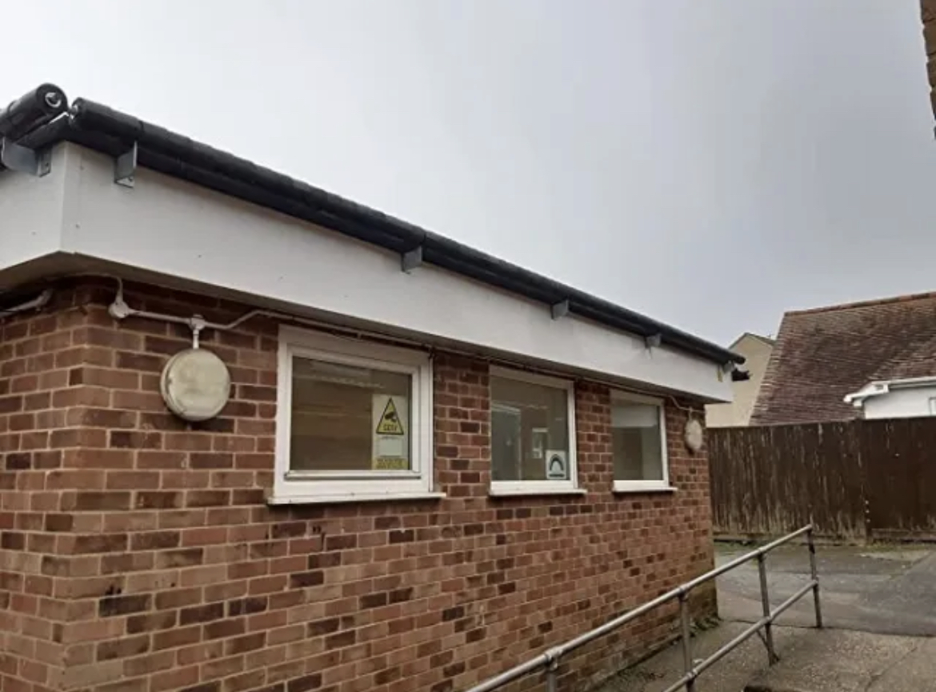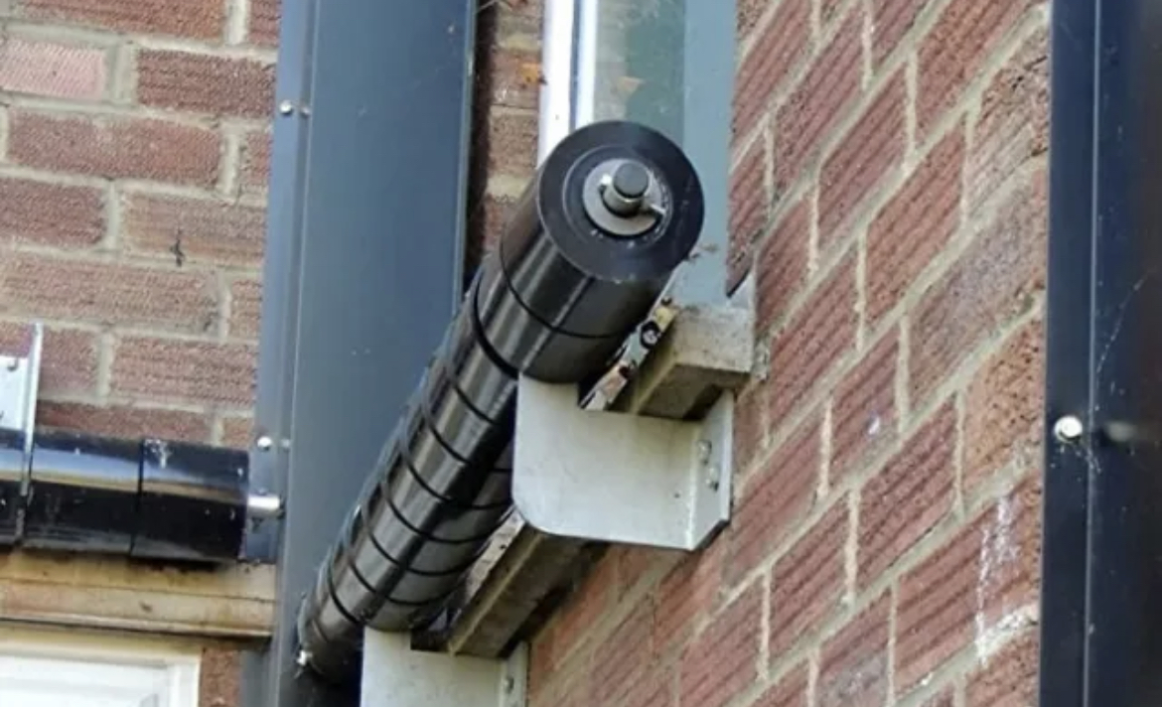
Graham Parker | Thank you for the quote which could be subject to a further increase. As per the quotation statement.  Be interesting to hear by how much is the estimate likely to increase by..  I am concerned about the roof and do not believe it is in keeping with the area .  The reason an eco-roof would be good for this area would promote wildlife i.e. birds, butterfly’s and bee’s etc  Surprised if it would not be subject to planning permission. This will need planning which due to only changing the roof and cladding outside should be straight forward and easier than taking down and installing alternative to the area.  I believe the roof design would attract those wanting to vandalise the unit.  Vandalism seems to be more on the inside of the building which magnetic timed locks have been factored in so have the toilets closed in the evening.  This proposal and the estimated cost do not have my support in its present form.  Will this be further discussed at the next F and G and F.C.
Christian Newsome | I fully agree with this and look forward to seeing this get off the ground.
Keith Patience | Thank you for your email.  I do not approve of the quote.  I would recommend a hold on this project pending further investigations (That the council needs to spend all that money on the toilet block).
Deborah Ray | The quotation expired on 23rd March 2023 therefore with building material prices increasing significantly at the present time, it would make sense to confirm with the building company that the figure is still valid.  Also, I would expect to see a breakdown on the quotation between materials and labour. In addition an estimate of approximate 'man days' to complete the job would enable a check that the labour figure is realistic.  Would it be possible to obtain the above information from A J Builders Suffolk Ltd?  Man day 240 - 1920 man hours – over 3\4 months depending on weather and materials supplies.  Approximately  Materials £47.753.25  Labour £55,440.00
Bernie Rappensberger | Further to your email of 31 May as I haven't been involved in the previous discussions I don't feel I have enough information to make a decision either way based on the attachments.  Just a couple of comments. It would appear that the green roof will be a mix of sedum/wildflowers/grasses? Although great from an eco point of view these kind of roofs can look a bit scruffy once the plants die back at the end of their flowering season and may require additional maintenance (particularly during the first year or so) such as removal of unwanted (self sown) weeds/grasses or watering during any particularly dry spells until established.  Based on the area self-sown should be minimum and watering would only be needed in very dry spells.  I have been ask to look at the paving area to be more green which would also need watering in dry spells.  As it is a refurb rather than rebuild I'm presuming the builder is happy the existing structure can take the weight of a green roof as I don't see costs of any additional extra structural work included?  The existing structure would need extra work to support the eco-roof and this has been included in the cost.  I see that the quote expired 2 months ago so there will probably be an increase in cost.
Jack-Arthur Smith | Thank you for the circular Lauren.  Yes, I would be more than happy to support this.

