MEETING PAPER
Subject: Development of a Pump Track in Normanston Park
Meeting: Parks and Open Spaces Sub-Committee
Date: 21 February 2023

CONFIDENTIAL/NON CONFIDENTIAL

Background/Introduction
A pump track is a circuit of rollers, banked turns and features designed to be ridden by riders ‘pumping’ (generating momentum by up and down body movements, instead of pedalling or pushing). Pump tracks were originally designed for the mountain bike and BMX scenes, but certain designs can also be used with skateboards, scooters, rollerblades and wheelchairs.

Details
There are currently no pump tracks in Lowestoft or the surrounding area, with the closest being in Bury St Edmunds, Haverhill and Colchester.
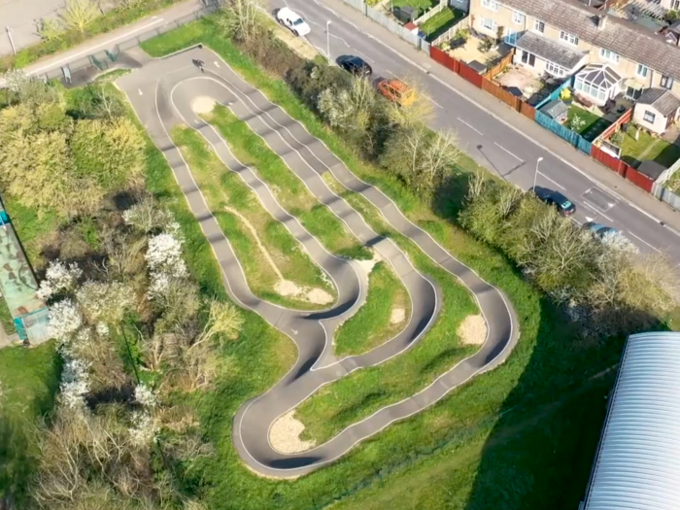
Haverhill Pump Track

The Town Council has previously received approaches from young people who are very keen to see the provision of a pump track in the town. Limited resources and more urgent issues at the time meant this suggestion was not given the attention it deserved, but the Parks and Community Officer and Project and Committee Clerk have started researching ideas and would like the Council to consider progressing this under the five year plans.

Normanston Park would appear the natural choice of location as it would complement the skate park and the general designation of Normanston Park as the Town Council’s ‘sports park’. The Town Council also has other areas of large open space (such as Clarkes Lane), which could accommodate a pump track, depending on how this would fit with other projects planned for such sites under the five year plans.

The cost of developing a pump track would very much depend on its size, design and the materials used, and is something the Council would need to seek advice on. External funding may however be available and options can be explored.

Recommendations/Decision
The Parks and Open Spaces Sub-Committee is being asked to consider giving its view on the concept of a pump track in Lowestoft. Should this be an idea which appeals to the Sub-Committee, officers will make enquiries regarding the estimated cost, and whether external funding options are available, to enable consideration of the concept in line with the five year plans.

Lauren Elliott
Project and Committee Clerk

