Fen Park Fencing Proposal

Due to the lay of the land within the park, a lot of footballs and basketballs are ending up in the water from people using the park. There are currently 7 balls in the water.
It seems that some members of the public are trying to retrieve their balls, as a result many branches and up-rooted smaller trees (one being 20 feet long) are being used and then discarded in the water.
The idea is to have a fence installed at the edge of the water along the length of the concrete, this is a length of 60 metres.

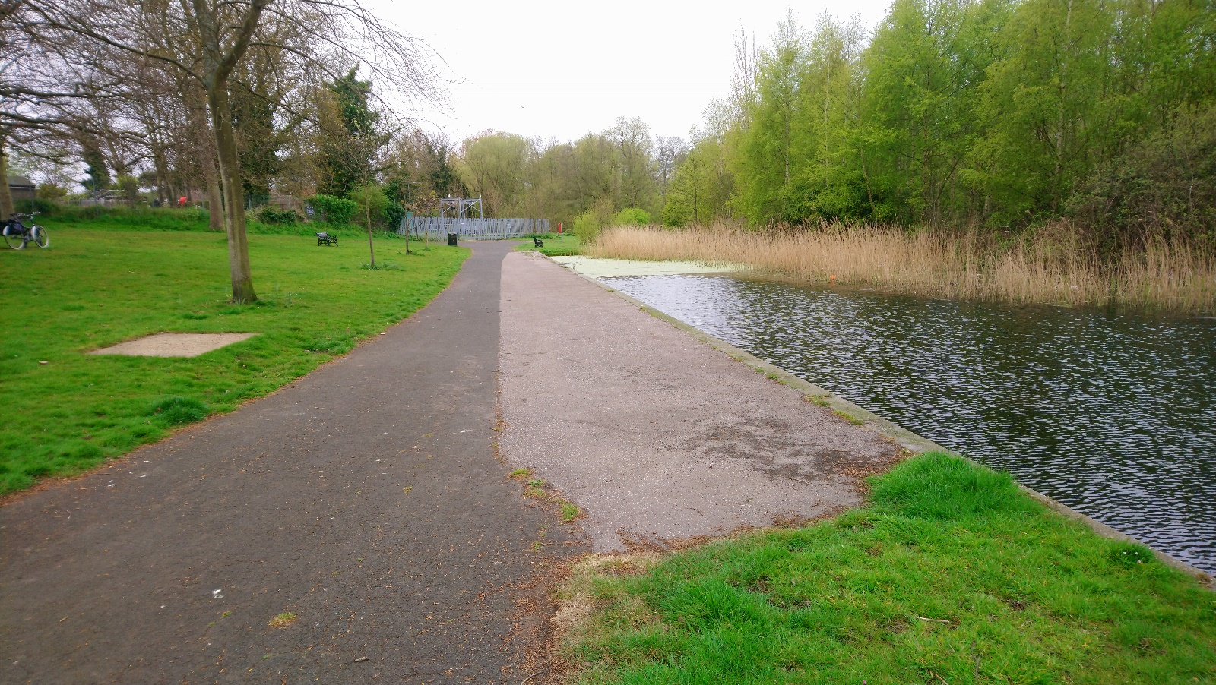

A fence here would;
- reduce the chances of balls entering the water
- reduce the frequency of the associated damage to the park and debris entering the water
- reducing the risk to members of the public on the waters edge.

We have recently had 30 metres of loop topped fencing removed from Nightingale Road Play Area. This fencing is absolutely fine to be re-used at Fen Park, but new posts will be needed.
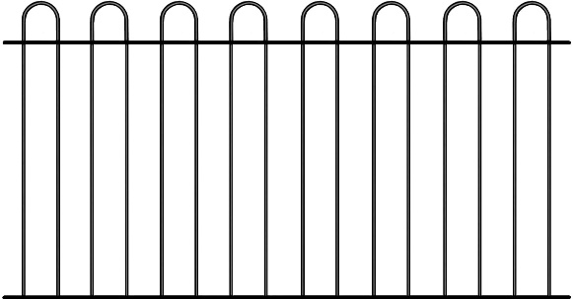
The length of the concrete section along the waters edge is 60 meters in total.
I have attached a quote from AJ Builders as a guide for the cost. There are two options with the quote, one to install the fencing we already have from Nightingale Road as well as 30 metres of new fencing.
The other option is to install a complete new 60 metre fence if the fence isn’t available to purcase.
AJ builders already have the fencing in storage as they completed the works at Nightingale Road.
I recognise that I currently only have one quote. If my proposal is welcomed, I will endeavour to gather more quotes.

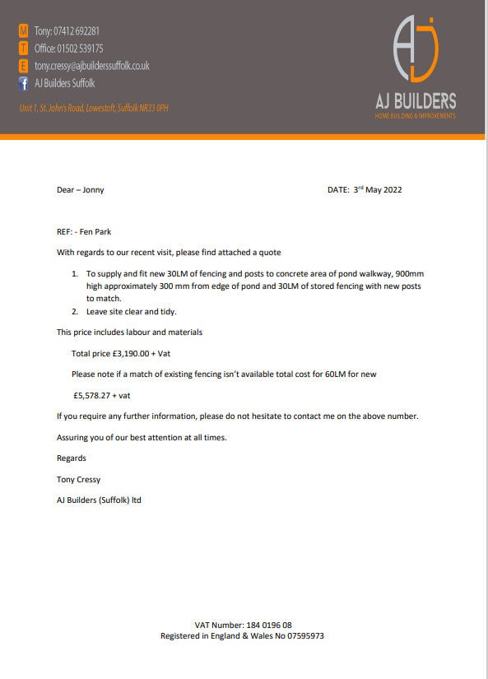

If the proposal of new fencing was agreed, another possibility would be for LTC to buy the fencing and myself and Paul can fit it. The fencing can be bought for just over £3,000 and would take away any additional labour costs.
- Jonny Hawes - Community Warden

