Planning notes 22/6/2021

11 The Parklands
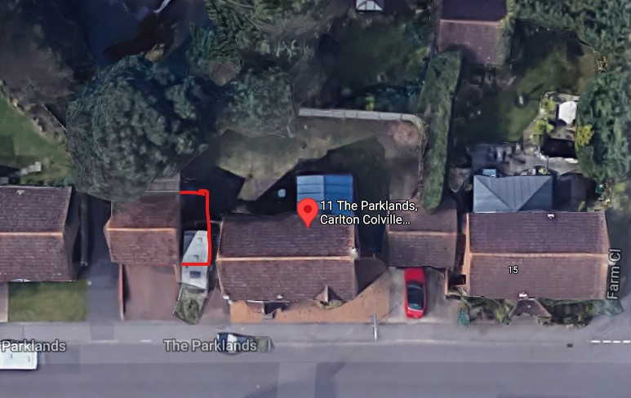
11 The Parklands Lowestoft NR33 8RN  Conversion and extension of existing double garage and all associated works, to form self contained annexe, ancillary to the main dwelling.  Date Description Information 1 Information 2  01/06/2021 Info Sheet INFO  26/05/2021 Application Form & Certificate  26/05/2021 Plans 21/247/01 C Existing/proposed elevation,floor,site,block  26/05/2021 Supporting Documents supporting statement | DC/21/2580/FUL  Public comments  Constraints  Related cases  Documents  Map

14 Summerfield Gardens
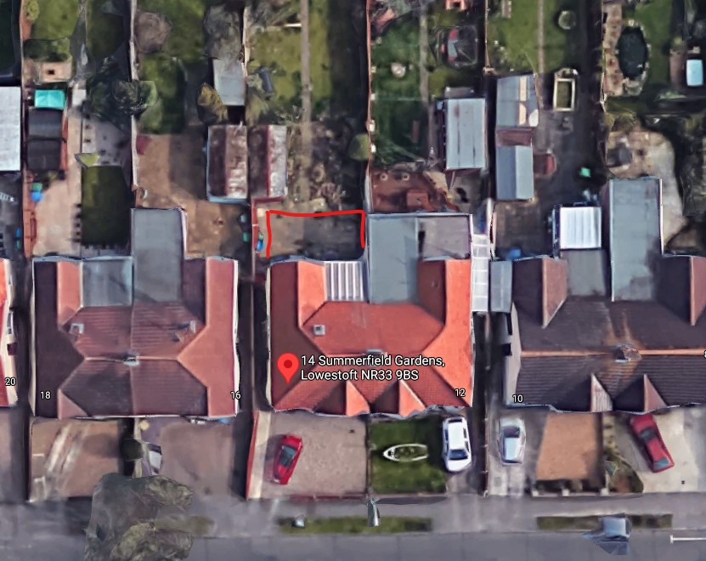
Note size of rear extension is similar to neighbouring properties.
14 Summerfield Gardens Lowestoft NR33 9BS  Single storey, flat-roof rear extension.  Date Description Information 1 Information 2  11/06/2021 Info Sheet INFO  09/06/2021 Application Form & Certificate  09/06/2021 Plans 2140-001 Existing and proposed floor plans, elevations and block plans  09/06/2021 Site / Location Plan | DC/21/2777/FUL  Public comments  Constraints  Related cases  Documents  Map

32 The Avenue
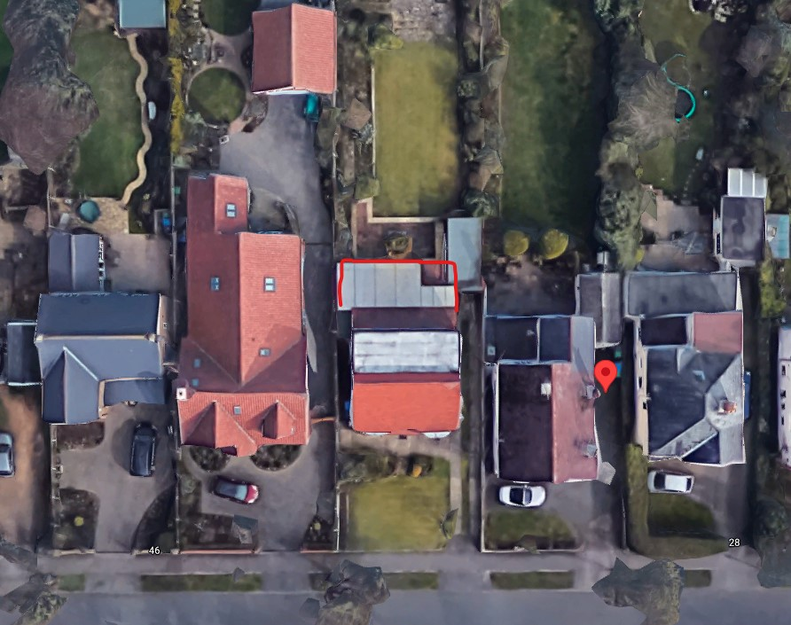
Planning documents have now appeared for this application.
32 The Avenue Lowestoft NR33 7LL  Construction of a rear extension  Date Description Information 1 Information 2  27/05/2021 Town/Parish Consultation Response  18/05/2021 Info Sheet INFO  13/05/2021 Application Form & Certificate  13/05/2021 Plans 1655-1-C Existing/Proposed elevations,floor,site,block | DC/21/2354/FUL  Public comments  Constraints  Related cases  Documents  Map

Pakefield Caravan Park, Arbor Lane
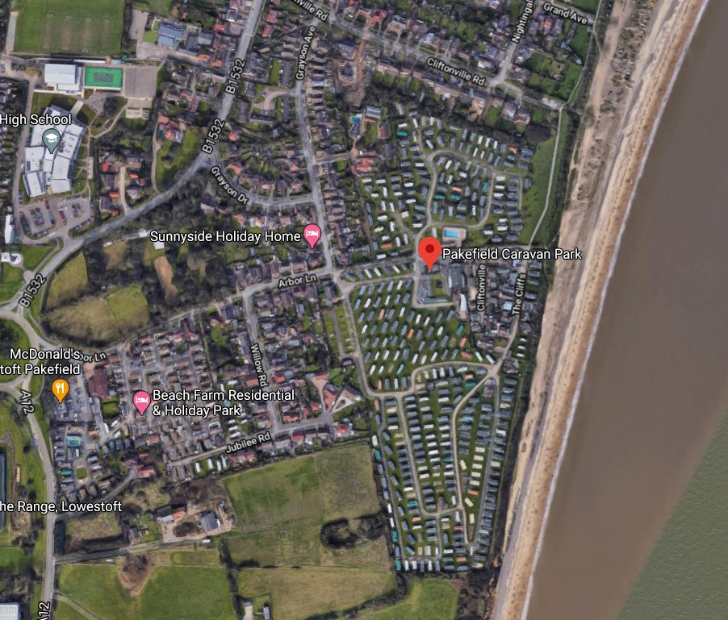
Application for the north side of the park. This is an amended proposal after an application for 12 month occupation was unsuccessful. It currently has permission for 10.5 month occupation.
Pakefield Caravan Park Arbor Lane Lowestoft NR33 7BE  Variation of Condition 2 of W8089/7 - Use of approx 7.1 acres as static holiday caravan site and the construction of roads, drains and hardstanding for reorganised layout ("The Bushes Site"), north of Arbor Lane, Pakefield. To allow for 11 month holiday occupation.  Date Description Information 1 Information 2  07/06/2021 Info Sheet INFO  27/05/2021 Application Form & Certificate  27/05/2021 Design & Access Statement  27/05/2021 Site / Location Plan  27/05/2021 Supporting Documents Coastal Erosion Vulnerability Assessment  27/05/2021 Supporting Documents cover letter | DC/21/2616/VOC  Public comments  Constraints  Related cases  Documents  Map

59 Durban Road
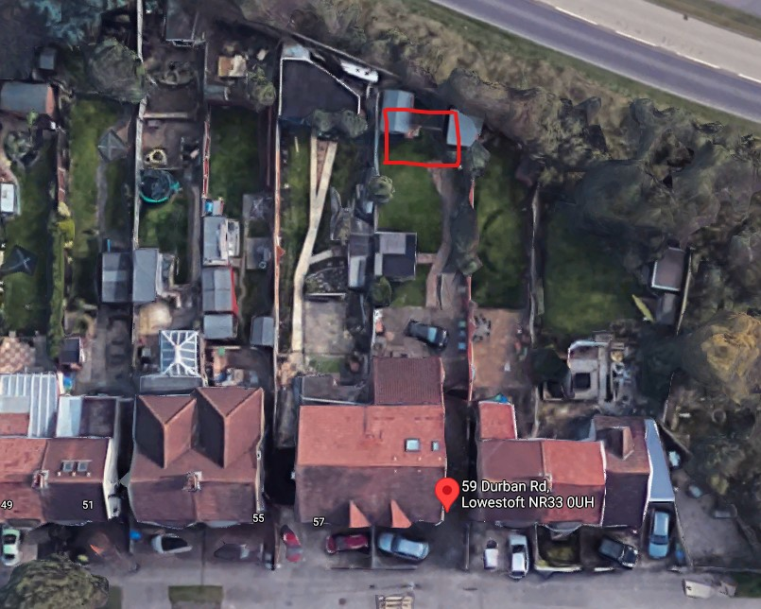
Application for a games room.
59 Durban Road Lowestoft NR33 0UH  Proposed Out Building  Date Description Information 1 Information 2  09/06/2021 Info Sheet INFO  28/05/2021 Application Form & Certificate Application form  28/05/2021 Plans Proposed plans | DC/21/2627/FUL  Public comments  Constraints  Related cases  Documents  Map

186 London Road South
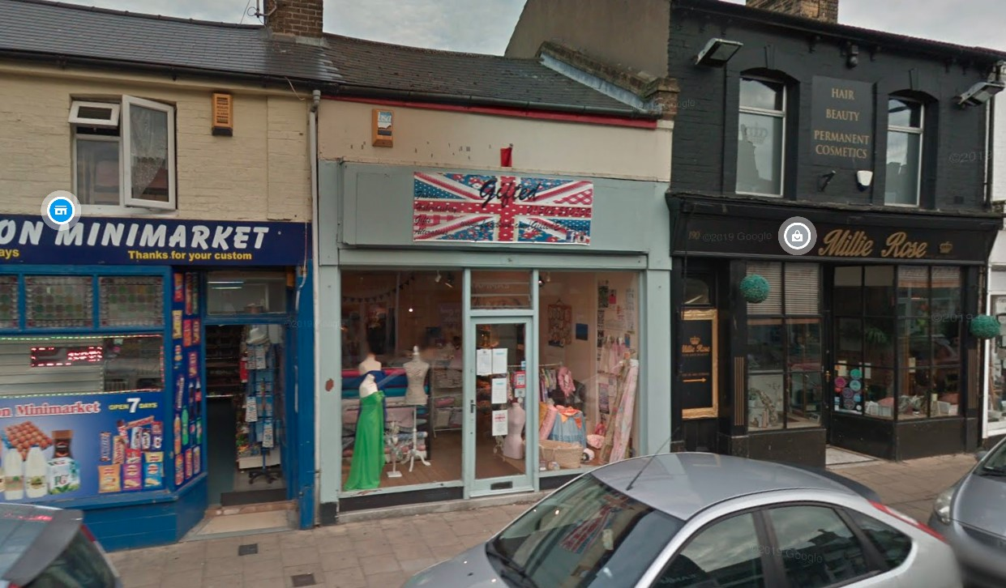
186 London Road South Lowestoft Suffolk NR33 0BB  Refurbishment of existing retail shop front and installation of 2no. New windows at first floor level; alterations to the rear street elevation to accommodate vehicle access for loading to the rear storage room; new first floor rear extension and exterior alterations; change of use of entire first floor to form a separate 2 bedroom flat with dedicated entrance door and bin store to the rear.  Date Description Information 1 Information 2  11/06/2021 Info Sheet INFO  04/06/2021 Application Form & Certificate Application form  04/06/2021 Design & Access Statement Design & Access Statement  04/06/2021 Existing Elevations 2112-EX-300 Existing Elevations  04/06/2021 Existing Floor Plans 2112-EX-100 Existing Floor plans  04/06/2021 Existing Floor Plans 2112-EX-110 Existing Roof plans  04/06/2021 Flood Risk Assessment Flood Risk Assessment  04/06/2021 Plans 2112-EX-200 Existing Section AA  04/06/2021 Plans 2112-PA-200 Proposed Section AA  04/06/2021 Plans Block plan  04/06/2021 Plans Flood Map  04/06/2021 Proposed Elevations 2112-PA-300 Proposed Elevations  04/06/2021 Proposed Elevations 2112-PA-310 Proposed Elevations  04/06/2021 Proposed Elevations 2112-PA-320 Proposed Elevations  04/06/2021 Proposed Floor Plan 2112-PA-100 Proposed Floor plans  04/06/2021 Proposed Floor Plan 2112-PA-110 Proposed Roof plans  04/06/2021 Proposed Floor Plan 2112-PA-120 Proposed Floor plans & Section AA  04/06/2021 Site / Location Plan Site plan | DC/21/2707/FUL  Public comments  Constraints  Related cases  Documents  Map

141 London Road South
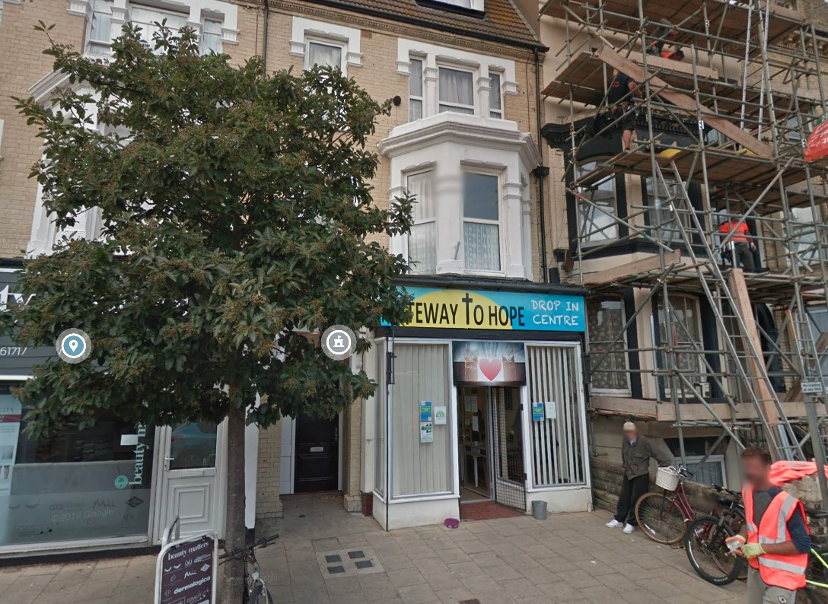
Change of use from A1/A2/Sui Generis to A3 (Restaurants/Cafes). One neighbour comment in support of the application.
141 London Road South Lowestoft Suffolk NR33 0AX  Prior Notification - only applying for change of use. No building work will be carried out at the premises.  Date Description Information 1 Information 2  15/06/2021 Info Sheet INFO  15/06/2021 Neighbour Responses King 294 London Road South  09/06/2021 Site / Location Plan  06/04/2021 Application Form & Certificate  06/04/2021 Plans Ground Floor Layout 1150 00JRN | DC/21/1641/PN3  Public comments  Constraints  Related cases  Documents  Map

Land Rear of 17 Yarmouth Road
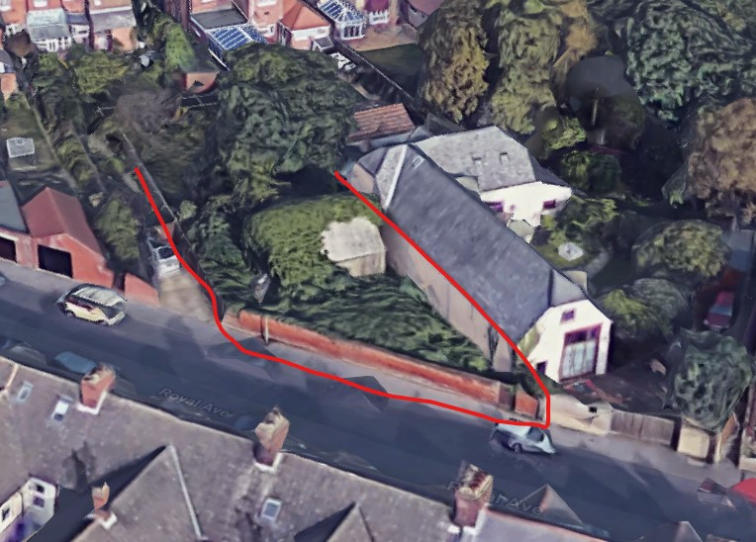
This application was previously refused by this committee due to over development of the site ant the harmful impact of such development on the ecology of the site. The plans have since been resubmitted.
Land Rear Of 17 Yarmouth Road Lowestoft Suffolk NR32 4AW  Construction of a 3 bedroom detached bungalow & garage  Date Description Information 1 Information 2  28/05/2021 Plans 2021-BB2 Proposed Elevations, Floor & Block Plans  16/04/2021 Town/Parish Consultation Response  09/04/2021 Consultee Responses Environmental Protection  09/04/2021 Neighbour Responses Hall on behalf of Weavers 53 Royal Avenue, Lowestoft  07/04/2021 Consultee Responses Suffolk Highways  06/04/2021 Neighbour Responses Savage 55 Royal Avenue, Lowestoft  01/04/2021 Consultee Responses Essex & Suffolk Water  23/03/2021 Info Sheet INFO  19/03/2021 Contaminated Land Assessment Envirosearch  11/03/2021 Application Form & Certificate  11/03/2021 CIL Additional Questions form  11/03/2021 Contaminated Land Assessment Questionnaire  11/03/2021 Design & Access Statement  11/03/2021 Plans 2021-BB/1 Proposed Elevations, Floor & Block Plans  11/03/2021 Plans 2021-BB/2 Existing Block & Site Plans | DC/21/1187/FUL  Public comments  Constraints  Related cases  Documents  Map

Tackle Exchange, 2 Essex Road
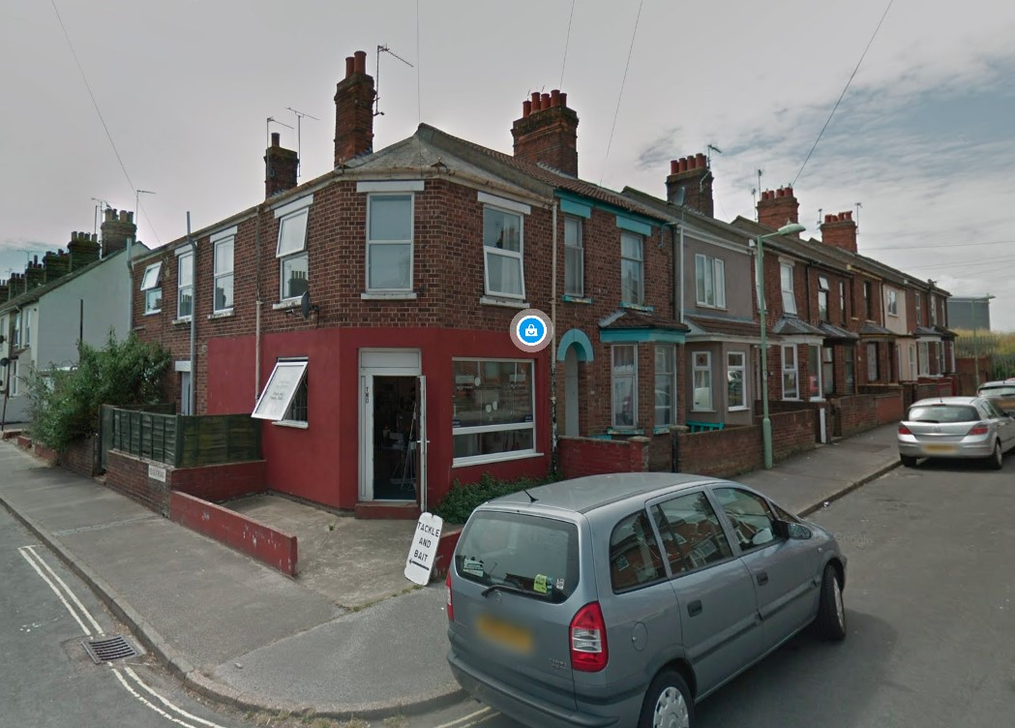
Conversion from shop to studio flat.
Tackle Exchange 2 Essex Road Lowestoft Suffolk NR32 2HH  Prior Notification - Convert the corner shop into a studio flat, which would give the area much needed affordable housing. This conversion would not require any structural work. Currently at the back of the shop there is a pre-existing internal door leading into a pre-existing room with a toilet and wash basin and another room suitable for a large shower/wet room. There would be no change to the existing utilities or drainage. There is already plenty of adequate natural light in the habitable rooms due to a front window and good size opening side window.  Date Description Information 1 Information 2  08/06/2021 Info Sheet INFO  01/06/2021 Plans Proposed Floor plan  01/06/2021 Site / Location Plan Site plan  13/05/2021 Application Form & Certificate Application form | DC/21/2361/PN3  Public comments  Constraints  Related cases  Documents  Map

Holm Sands, 9 Gunton Cliff
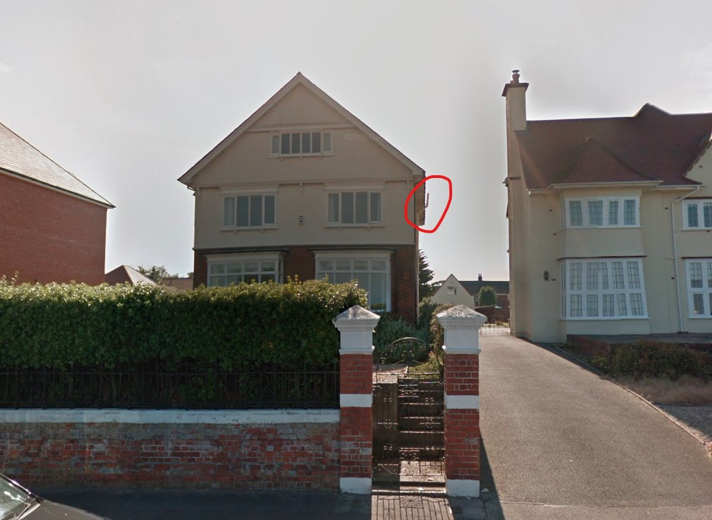
Planning permission for an external flue, in indicated position.
Holm Sands 9 Gunton Cliff Lowestoft Suffolk NR32 4PE  Flue will run external up the side of the property (right side). A twin wall flue system through the wall using a wall sleeve, 135 degree tee for external sweeping and drain cap for condensation drain, two stainless steel external supports, external pipe finished in Stainless Black (to match the black drainpipes and guttering) and wind master cowl fitted.  Date Description Information 1 Information 2  08/06/2021 Info Sheet INFO  02/06/2021 Existing Block / Layout Plan  02/06/2021 Proposed Elevations Front elevation  02/06/2021 Proposed Elevations Side elevation  25/05/2021 Application Form & Certificate  25/05/2021 Existing Floor Plans  25/05/2021 Photographs  25/05/2021 Photographs  25/05/2021 Photographs  25/05/2021 Plans Proposed lounge plan  25/05/2021 Site / Location Plan | DC/21/2557/FUL  Public comments  Constraints  Related cases  Documents  Map

