Planning notes 10/8/2021
With apologies – this was manually generated as recent changes to the planning portal have stopped our report script from working. This report has been manually generated.

169-170 The High Street
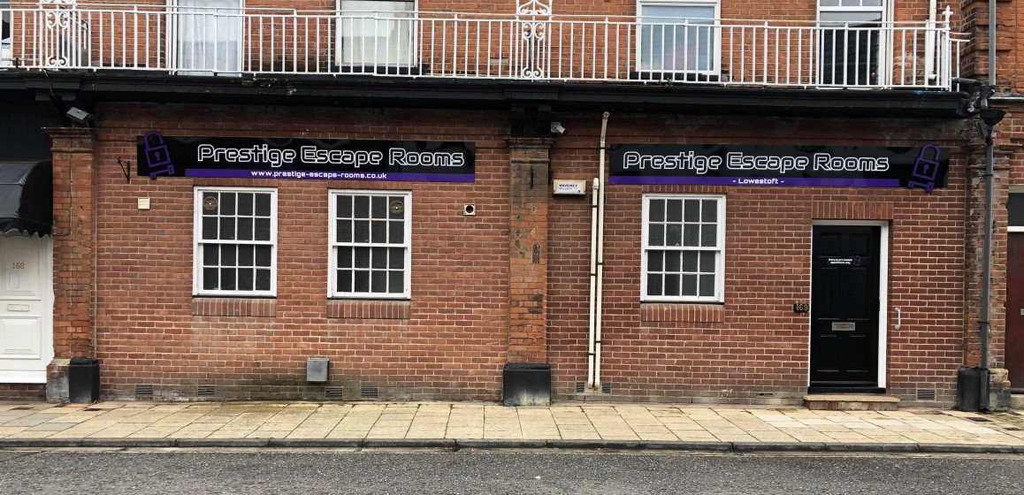
169-170 High Street  Retrospective Application for Non Illuminated Advertisement - Retention of 2 fascia signs with name of business so that our customers can find us  Date Description Information 1 Information 2  Info Sheet  Application Form & Certificate  Existing Block / Layout Plan  Photographs  Photographs  Site Location Plan | DC/21/3493/ADN

Proposed Advertising Board, Peto Way Location 1
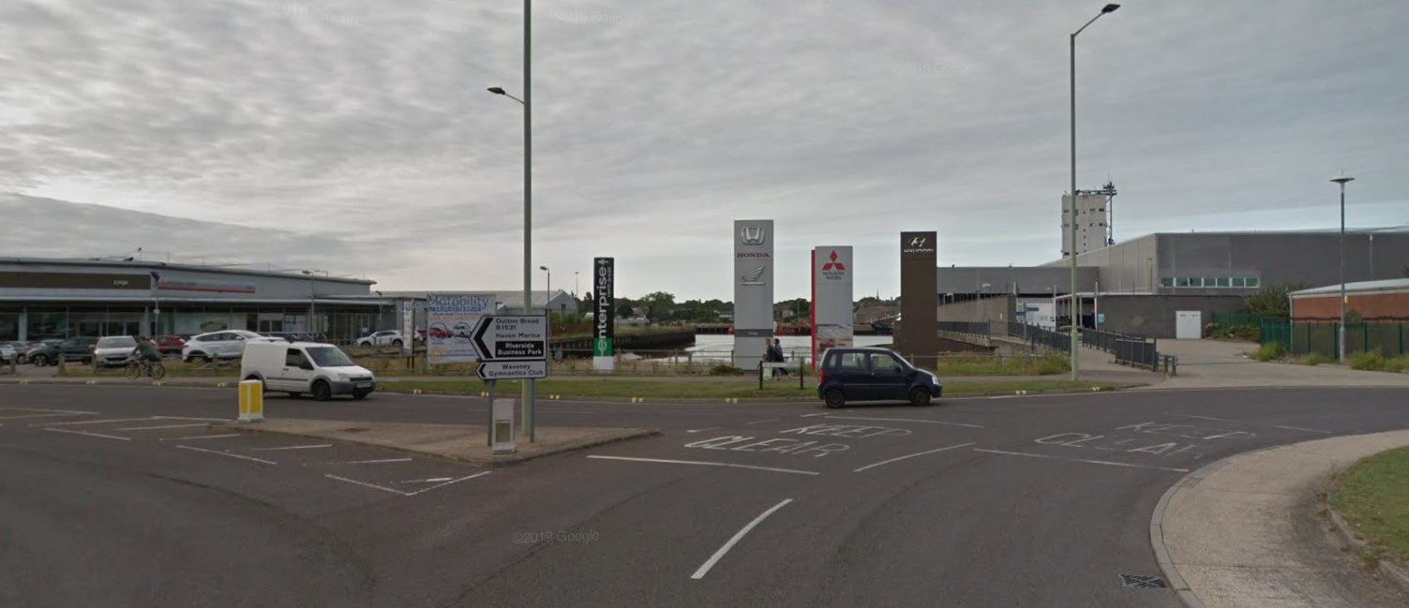
Peto Way  Proposed Advertising Board Peto Way - Non Illuminated Advertisement Consent - Hoarding to display details of Gull Wing bridge construction on the southern approach of the project  Date Description Information 1 Information 2  Consultee Responses SCC Highways  Plans Location plan - Southern  Application form  Plans Sign locations  Plans Sign Signage Final Layout  Proposed Elevations | DC/21/2741/ADN

Proposed Advertising Board, Peto Way Location 2
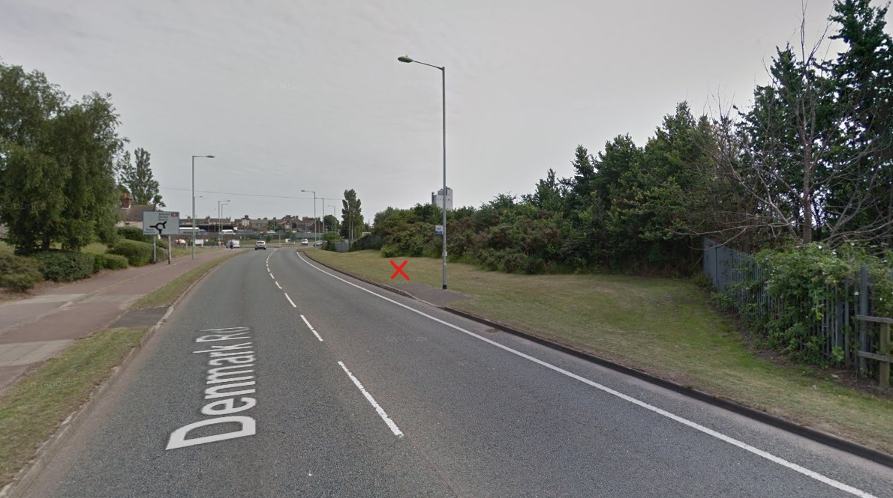
Peto Way  Proposed Advertising Board Peto Way - Non Illuminated Advertisement Consent - Hoarding to display details of Gull Wing bridge construction on the northern approach of the project  Date Description Information 1 Information 2  Consultee Responses SCC Highways  Plans Advertising board planning application location plan  Application form & Certificate  Plans Sign locations  Plans Site Signage Final Layour  Proposed Elevations | DC/21/2740/ADN

29 High Street
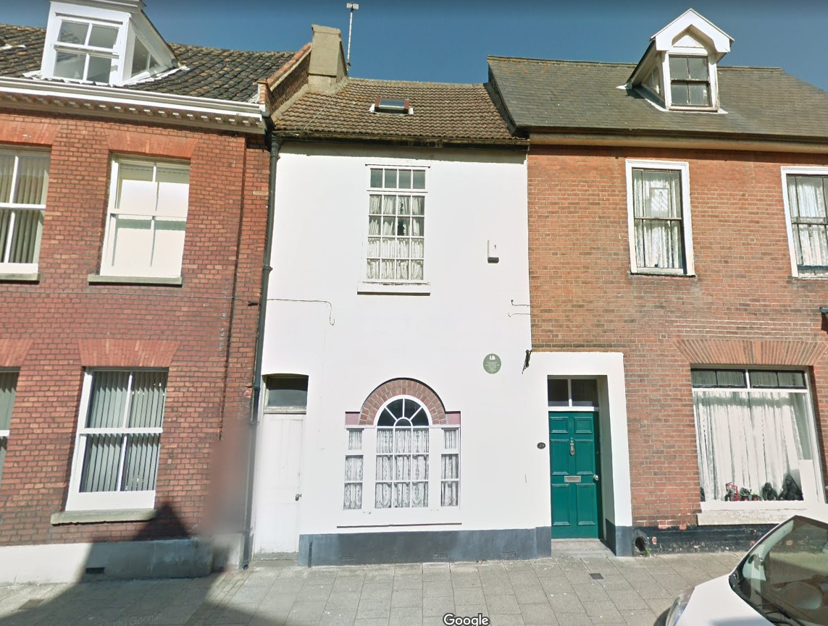
29 High Street  To replace old, existing skylight on front elevation roof (High Street side). This is currently in poor condition, very old, leaking and heavy with old rusty hinges. The aim is to replace it with a heritage skylight of similar dimensions recommended by the builder, who will be carrying out repairs to both the roof and chimney stack. The project is part grant funded by Lowestoft Heritage Action Zone. Proposed New Skylight: Velux roof window GGL 2570H / traditional black conservation style with vertical central bar. Dimensions: 55x 98cm | 29 High Street Lowestoft Suffolk NR32 1HY  Date Description Information 1 Information 2  Info Sheet  Application Form & Certificate  Photographs 1  Photographs 2  Photographs 3  Photographs 4  Proposed Block / Layout Plan  Site / Location Plan  Supporting Documents Proposed window details  Supporting Documents Roof window specification | DC/21/3506/FUL

DC/21/3507/FUL has been withdrawn. Appears to be a duplicate of DC/21/3506/FUL

60 Denmark Road
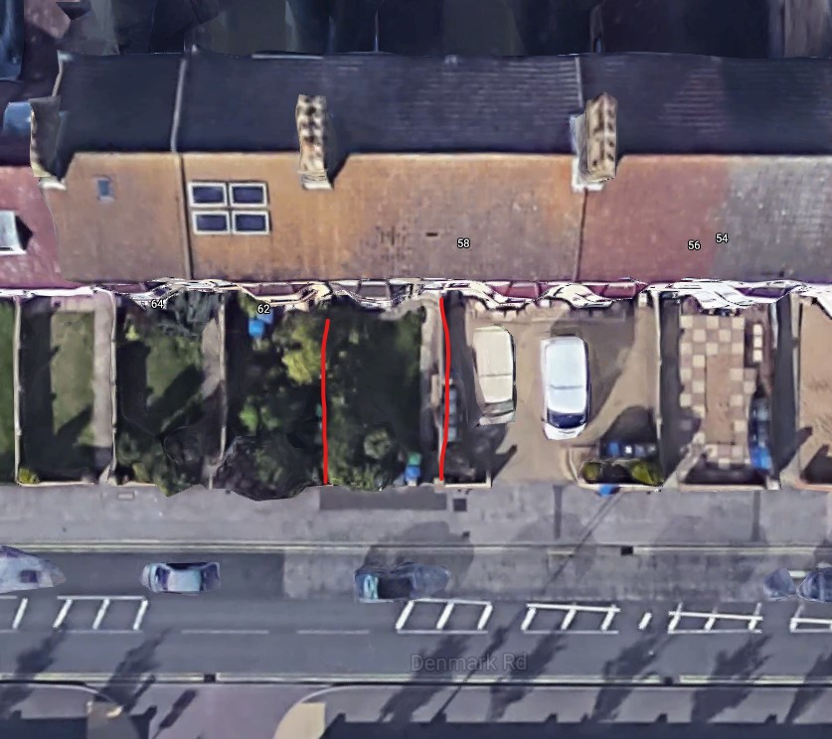
60 Denmark Road - Application to create driveway/carstanding in front garden  Date Description Information 1 Information 2  Consultee Responses SCC Highways  Info Sheet  Existing Block / Layout Plan  Site / Location Plan  Application Form & Certificate  Proposed Floor Plan | DC/21/3021/FUL

5 Ringsfield Road
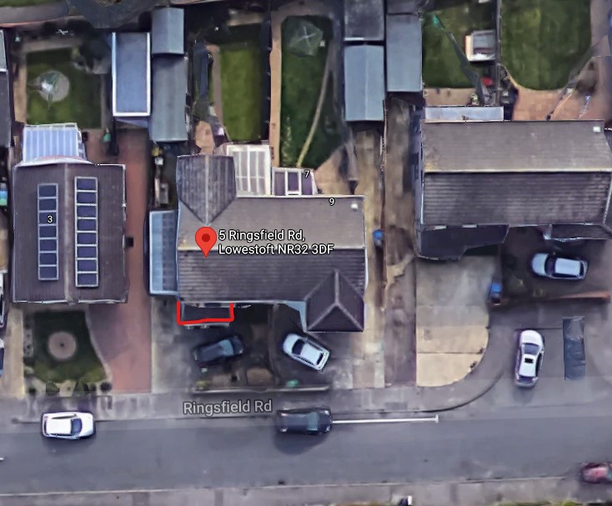
5 Ringsfield Road - First floor front extension  Date Description Information 1 Information 2  Application Form & Certificate  Plans Existing  Plans Proposed  Site / Location Plan  Site / Location Plan | DC/21/3642/FUL

23 Waveney Road
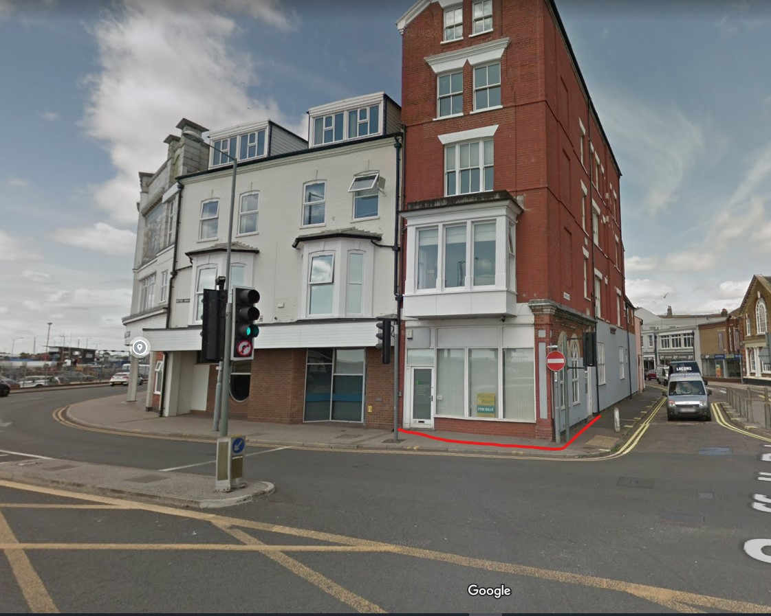
23 Waveney Road - Prior Notification - 1) The proposed building change of use from office to a single dwelling will offer good levels of natural light and ventilation through the use of the current windows to the east and north where the bedroom and dining accommodation will be placed as plan no. 2815.21.1 attached to the application. 2) D&S attached with FRA and contamination report 3) Change of Use from Office to Dwelling (1) One  Date Description Information 1 Information 2  Application Form & Certificate  CIL Additional Questions form  Contaminated Land Assessment  Contaminated Land Assessment  Design & Access Statement  Flood Risk Assessment  Plans  Plans | DC/21/3568/PN3

1 Westwood Road

1 Westwood Avenue -Additional storey over existing single storey side extension  Date Description Information 1 Information 2  Amended Plans & Documents  Info Sheet  Application Form & Certificate  Plans (superseded)  Site / Location Plan | DC/21/3439/FUL

9 Pollard Piece

9 Pollard Piece - Construction of a single storey rear extension  Date Description Information 1 Information 2  Info Sheet  Application Form & Certificate  Plans | DC/21/3567/FUL

Dovecote, Arbor Lane

Dovecote Arbor Lane - Demolition of existing dwelling rebuilding of new dwelling, fencing and materials  Date Description Information 1 Information 2  Consultee Responses SCC Highways  Info Sheet  Application Form & Certificate  Contaminated Land Assessment Envirosearch  Contaminated Land Assessment Questionnaire  Design & Access Statement  Plans  Supporting Documents Coastal erosion vulnerability assessment | DC/21/3600/FUL

9 Glebe Close
This application has currently attracted 4 neighbour objections.

9 Glebe Close - Construction of two detached single storey dwellings and all associated works  Date Description Information 1 Information 2  Consultee Responses SCC Highways  Neighbour Responses Ellis  Neighbour Responses Baldwin  Neighbour Responses Fordham  Neighbour Responses Button  Info Sheet  CIL Additional Questions form  Contaminated Land Assessment  Design & Access Statement  Plans  Site / Location Plan  Supporting Documents Contaminated Land Questionnaire  Supporting Documents Planning Statement | DC/21/3570/FUL

36 Gunton Drive
36 Gunton Drive - Amendment - New porch and single storey rear extension  Date Description Information 1 Information 2  Info Sheet  Application Form & Certificate  Block & Site Plan  Plans Existing  Plans Proposed | DC/21/3537/FUL

Green Gables, Gunton Avenue
Green Gables, Gunton Avenue - Construction of a 1.5 storey side extension  Date Description Information 1 Information 2  Application Form  Existing Elevations  Existing Floor Plans  Plans  Proposed Block / Layout Plan  Proposed Elevations  Proposed Floor Plan  Site / Location Plan | DC/21/3635/FUL

