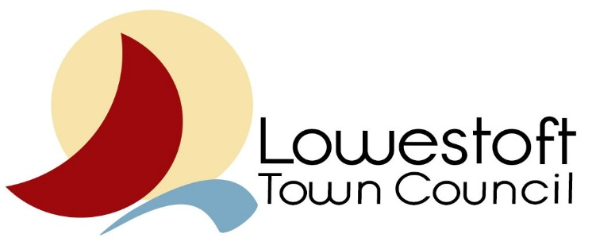

See separate Word document for summaries of presentations under the following agenda items.

1. Covid update
2. Towns Fund Update
3. Town Hall Update
4. Historic Quarter
5. Towns Fund Project Update

* Legal
* Cultural Quarter
* Station Quarter
* Port Gateway
* Seafront Vision

1. City of Culture
2. Maintenance and Pride

Lowestoft Place Board 7th September 2021

Key issues discussed during the meeting(s)

(relevant to LTC)

Meetings attended & dates

Councillor: Colin Butler

Body: Lowestoft Place Board

Report Date: 10th September 2021

Cllr Representation Reporting Form

Date 10th September 2021

Signed: Colin Butler

Actions by LTC?