Planning notes 23/3/2021

118-122 St Peters Street
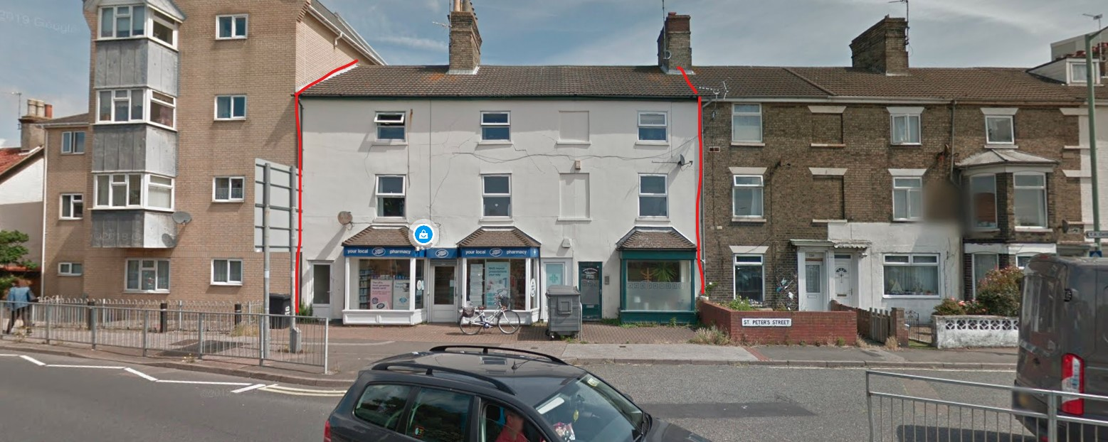
This is a new shop on the site of the existing Boots and Chinese medicine businesses.
118-122 St Peters Street Lowestoft Suffolk NR32 1UD  New shopfront  Date Description Information 1 Information 2  10/03/2021 Info Sheet INFO  05/03/2021 Application Form & Certificate  05/03/2021 Plans 21/337/01 Existing floorplans, elevation and site plan  05/03/2021 Plans 21/337/02 Proposed floorplan, elevation, section and block plan | DC/21/1084/FUL  Public comments  Constraints  Related cases  Documents  Map

51-53 Westwood Avenue
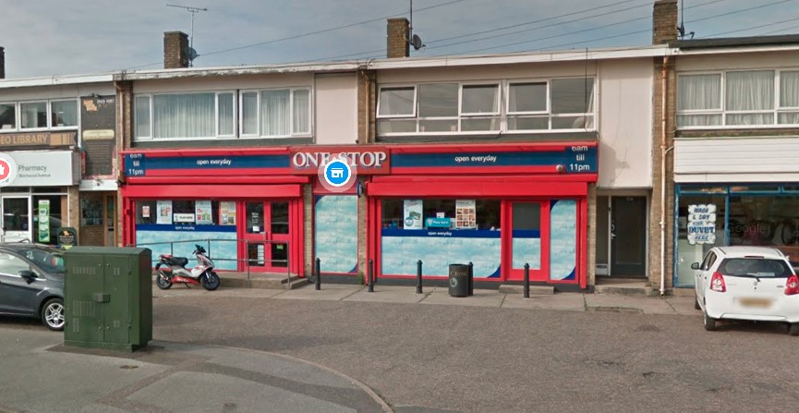
New illuminated signage. One neighbour objection, raising that ambient lighting will increase antisocial behaviour, fear of crime, light pollution, noise, and reduce traffic safety. No issues raised by SCC Street Lighting or Highways.
51-53 Westwood Avenue Lowestoft Suffolk NR33 9RW  Illuminated Advertisement Consent - Signs displayed on a business premises related to that business: Item 1: Fascia Sign Item 2: 3 x ACM Panels Item 3: 3 x Window Vinyls Item 4: Manifestation (not required) Item 5: 2 x Poster Cases  Date Description Information 1 Information 2  05/03/2021 Consultee Responses SCC Highways  05/03/2021 Neighbour Responses Rushbrook 66 Westwood Avenue, Lowestoft  05/03/2021 Neighbour Responses Rushbrook 66 Westwood Avenue, Lowestoft  03/03/2021 Consultee Responses SCC Street Lighting  03/03/2021 Consultee Responses SCC Street Lighting  03/03/2021 Info Sheet INFO  01/03/2021 Application Form & Certificate  01/03/2021 Existing Elevations  01/03/2021 Proposed Elevations  01/03/2021 Proposed Elevations  01/03/2021 Site / Location Plan Plus Proposed Block | DC/21/0979/ADI  Public comments  Constraints  Related cases  Documents  Map

10 Fleet Dyke Drive
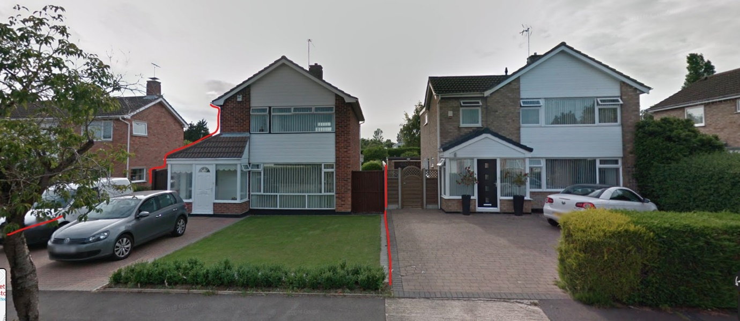
New porch and first storey side extension. The proposed development is very similar to neighbouring property.
10 Fleet Dyke Drive Lowestoft NR33 9HD  Construction of a two storey side extension with front porch  Date Description Information 1 Information 2  03/03/2021 Info Sheet INFO  02/03/2021 Application Form & Certificate  02/03/2021 Plans 210221 1 Existing Floor and Elevations  02/03/2021 Plans 210221 2 Proposed Floor and Elevations  02/03/2021 Site / Location Plan 210221 3 Plus Proposed Block Plan | DC/21/1003/FUL  Public comments  Constraints  Related cases  Documents  Map

4 Tudor Walk
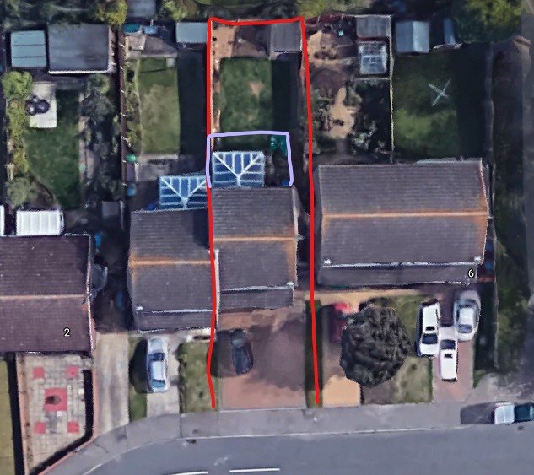
Approximate area of development marked in lilac.
4 Tudor Walk Carlton Colville Lowestoft Suffolk NR33 8NE  Demolish existing conservatory and replace with single storey Kitchen/Diner  Date Description Information 1 Information 2  09/03/2021 Info Sheet INFO  04/03/2021 Plans 02 All plans  04/03/2021 Site / Location Plan 01  01/03/2021 Application Form & Certificate | DC/21/0977/FUL  Public comments  Constraints  Related cases  Documents  Map

Friends Mission Hall, St Georges Road
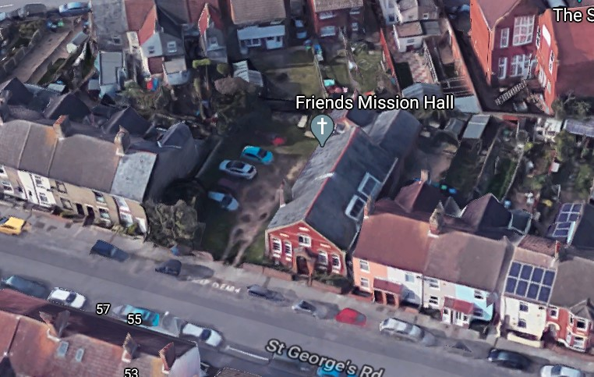
A proposal to convert the Mission hall and to construct houses on the grounds.
Several neighbour objections mentioning loss of light, privacy, noise pollution, impact on property value, inadequate parking, noise of construction, not reflecting character of adjoining dwellings, lack of design or access statement, overlooking, rainfall drainage, overdevelopment. Several mentioned lack of car parking as a particular issue.
Also some neighbour responses in support.
Friends Misson Hall St Georges Road Lowestoft Suffolk  Conversion of Mission Hall into two units and construction of two houses.  Date Description Information 1 Information 2  22/03/2021 Neighbour Responses Drew 54 St Georges Road Lowestoft  22/03/2021 Neighbour Responses Mizen 615 London Road South Lowestoft  22/03/2021 Neighbour Responses Ward 6 Kirkdale Court Lowestoft  17/03/2021 Neighbour Responses Mosley 40 St Georges Road, Lowestoft  17/03/2021 Neighbour Responses Ward 6 Kirkdale Court, Lowestoft  16/03/2021 Neighbour Responses Creamer 49 St Georges Road Lowestoft  16/03/2021 Neighbour Responses Creamer 49 St Georges Road Lowestoft  16/03/2021 Neighbour Responses Hewis 46 St Georges Road, Lowestoft  15/03/2021 Neighbour Responses Mosley 40 St Georges Road, Lowestoft  15/03/2021 Neighbour Responses Nicholson 63 Morton Road Lowestoft  12/03/2021 Consultee Responses East Suffolk Council Infrastructure Team  12/03/2021 Consultee Responses Suffolk Fire and Rescue  09/03/2021 Consultee Responses Environmental Protection  08/03/2021 Info Sheet INFO  03/03/2021 Application Form & Certificate  03/03/2021 Contaminated Land Assessment Land Contamination Questionnaire  03/03/2021 Plans 2671.20.2 Existing Site Plan, Floor and Elevations, Plus existing and Prop  03/03/2021 Plans 2671.20.3 Proposed Floor and Elevations  03/03/2021 Supporting Documents Design/Business Statement/ Resident Comments and Envirosearch | DC/21/1035/FUL  Public comments  Constraints  Related cases  Documents  Map

The Hotel Victoria, Cliff Road
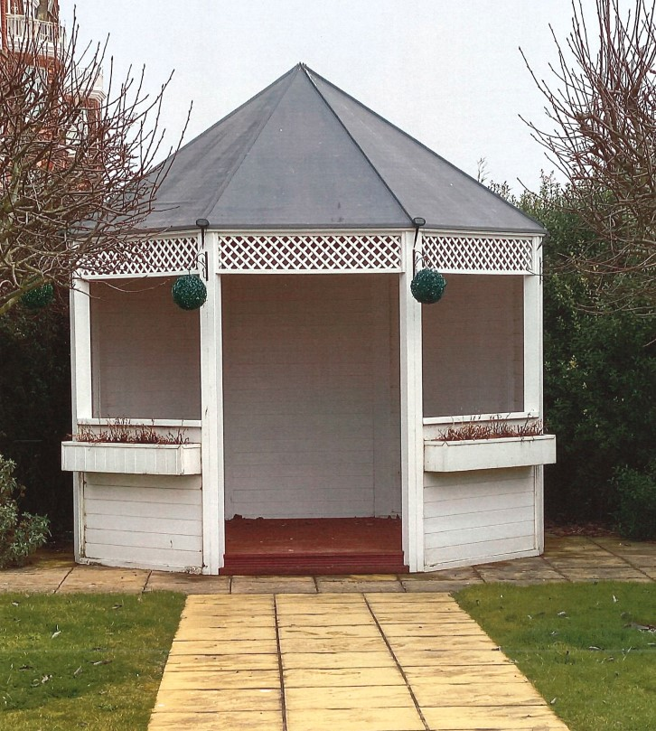
Request to extend permission. No change.
The Hotel Victoria Kirkley Cliff Road Lowestoft NR33 0BZ  Retention of a Wooden Structure for Weddings in the hotels Garden Area which has been given planning permission for 3 years  Date Description Information 1 Information 2  09/03/2021 Design & Access Statement  02/03/2021 Application Form & Certificate  02/03/2021 Existing Block / Layout Plan  02/03/2021 Photographs Current structure with no change  02/03/2021 Site / Location Plan | DC/21/1030/FUL  Public comments  Constraints  Related cases  Documents  Map

86 Walmer Road
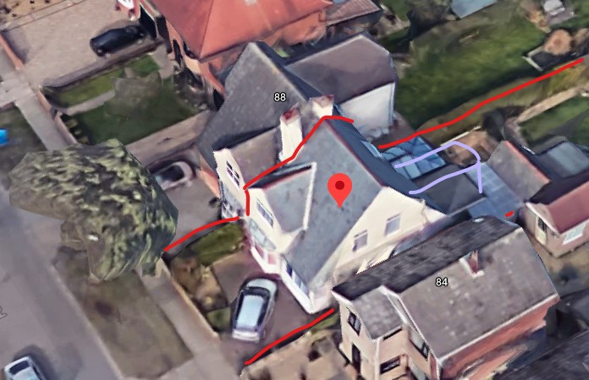
Rebulding of conservatory and first floor extension. Note similarity to neighbouring property.
One neighbour objection, which appears to be misfiled by the planning authority as it refers to “Land North Of The Street, The Street, Kettleburgh”, “Construction of 17 new dwellings including 5 affordable homes…”.
86 Walmer Road Lowestoft Suffolk NR33 7LD  Proposed rebuilding of conservatory to garden room and first floor extension above existing extension.  Date Description Information 1 Information 2  17/03/2021 Neighbour Responses Eaton 1 Red Roofs, The Street,  10/03/2021 Info Sheet INFO  05/03/2021 Application Form & Certificate  05/03/2021 Plans 2755.21.1D Proposed Floor, Elevations and Block plans, plus Site Plan | DC/21/1075/FUL  Public comments  Constraints  Related cases  Documents  Map

24 Harrington Avenue
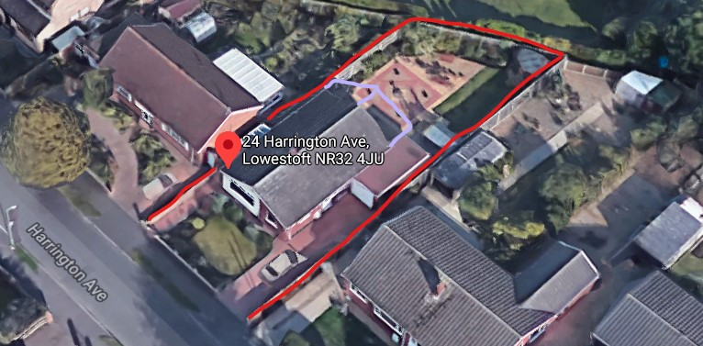
Proposed rear extension outline shown in lilac.
24 Harrington Avenue Lowestoft Suffolk NR32 4JU  Construction of a single storey rear extension  Date Description Information 1 Information 2  03/03/2021 Info Sheet INFO  02/03/2021 Plans 240221 1 Existing Floor and Elevations  02/03/2021 Plans 240221 2 Proposed Floor and Elevations  02/03/2021 Site / Location Plan 240221 3 Plus Proposed Block  26/02/2021 Application Form & Certificate | DC/21/0961/FUL  Public comments  Constraints  Related cases  Documents  Map

54 Gunton Drive
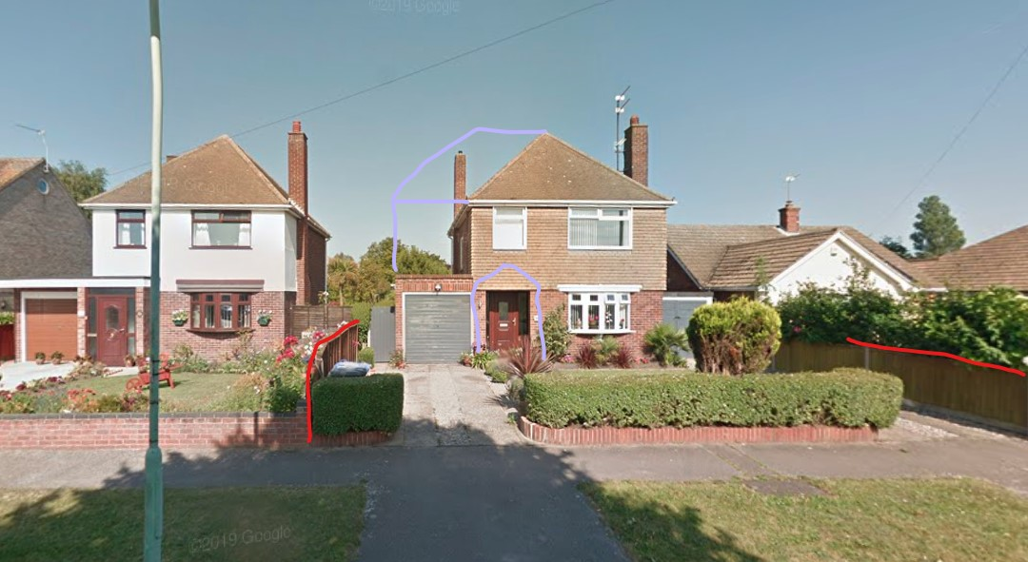
One neighbour objection, citing concern that development is close to neighbouring property, and possible damage to drainage.
54 Gunton Drive Lowestoft Suffolk NR32 4QB  Proposed single and two storey extensions  Date Description Information 1 Information 2  17/03/2021 Neighbour Responses Yeo 56 Gunton Drive, Lowestoft  10/03/2021 Info Sheet INFO  09/03/2021 Application Form & Certificate  09/03/2021 Plans 020321 1 EXISTING FLOOR LAYOUTS AND ELEVATIONS  09/03/2021 Plans 020321 2 PROPOSED FLOOR LAYOUTS AND ELEVATIONS  09/03/2021 Plans 020321 3 Site and block plan | DC/21/1117/FUL  Public comments  Constraints  Related cases  Documents  Map

28 Gunton Church Lane
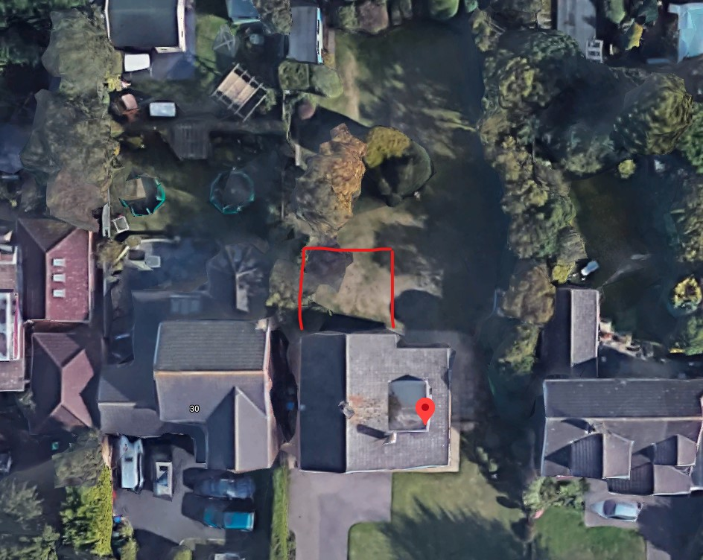
This committee recommended approval of this application recently, but it has since been amended. This amendment adds 1.5m to the rear with an additional balcony. Three neighbour objections with similar grounds to previous application.
28 Gunton Church Lane Lowestoft NR32 4LF  Double Storey Rear Extension  Date Description Information 1 Information 2  16/03/2021 Neighbour Responses Moore 8 Squires Walk  15/03/2021 Neighbour Responses Collins 32 Gunton Church Lane, Lowestoft  12/03/2021 Neighbour Responses Denny 30 Gunton Church Lane, Lowestoft  08/03/2021 Amended Plans & Documents NA-GCL-LS-02 E Proposed Elevations & Floor Plans  11/02/2021 Town/Parish Consultation Response Lowestoft Town Council  08/02/2021 Neighbour Responses Moore 8 Squires Walk  08/02/2021 Neighbour Responses Steer 10 Squires Walk  03/02/2021 Neighbour Responses Collins 32 Gunton Church Lane  01/02/2021 Neighbour Responses Denny 30 Gunton Church Lane Lowestoft  25/01/2021 Plans NA-GCL-LS-02 D Proposed - Elevations & Floor Plans  25/01/2021 Plans NA-GCL-LS-SL01 Site & Proposed Block Plan  20/01/2021 Application Form & Certificate  20/01/2021 Plans NA-GCL-LS-01 Existing Elevations/Floor | DC/21/0251/FUL  Public comments  Constraints  Related cases  Documents  Map

9 West Side Close
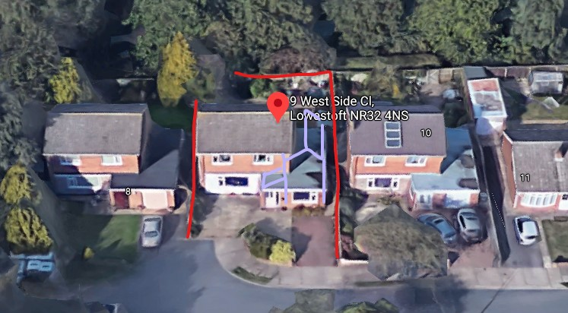
No neighbour objections.
9 West Side Close Lowestoft Suffolk NR32 4NS  First floor gable extension and single storey extension to rear and pitched roof to porch  Date Description Information 1 Information 2  12/03/2021 Info Sheet INFO  09/03/2021 Application Form & Certificate  09/03/2021 Supporting Documents All plans | DC/21/1121/FUL  Public comments  Constraints  Related cases  Documents  Map

