Sparrow’s Nest, Lowestoft, Suffolk

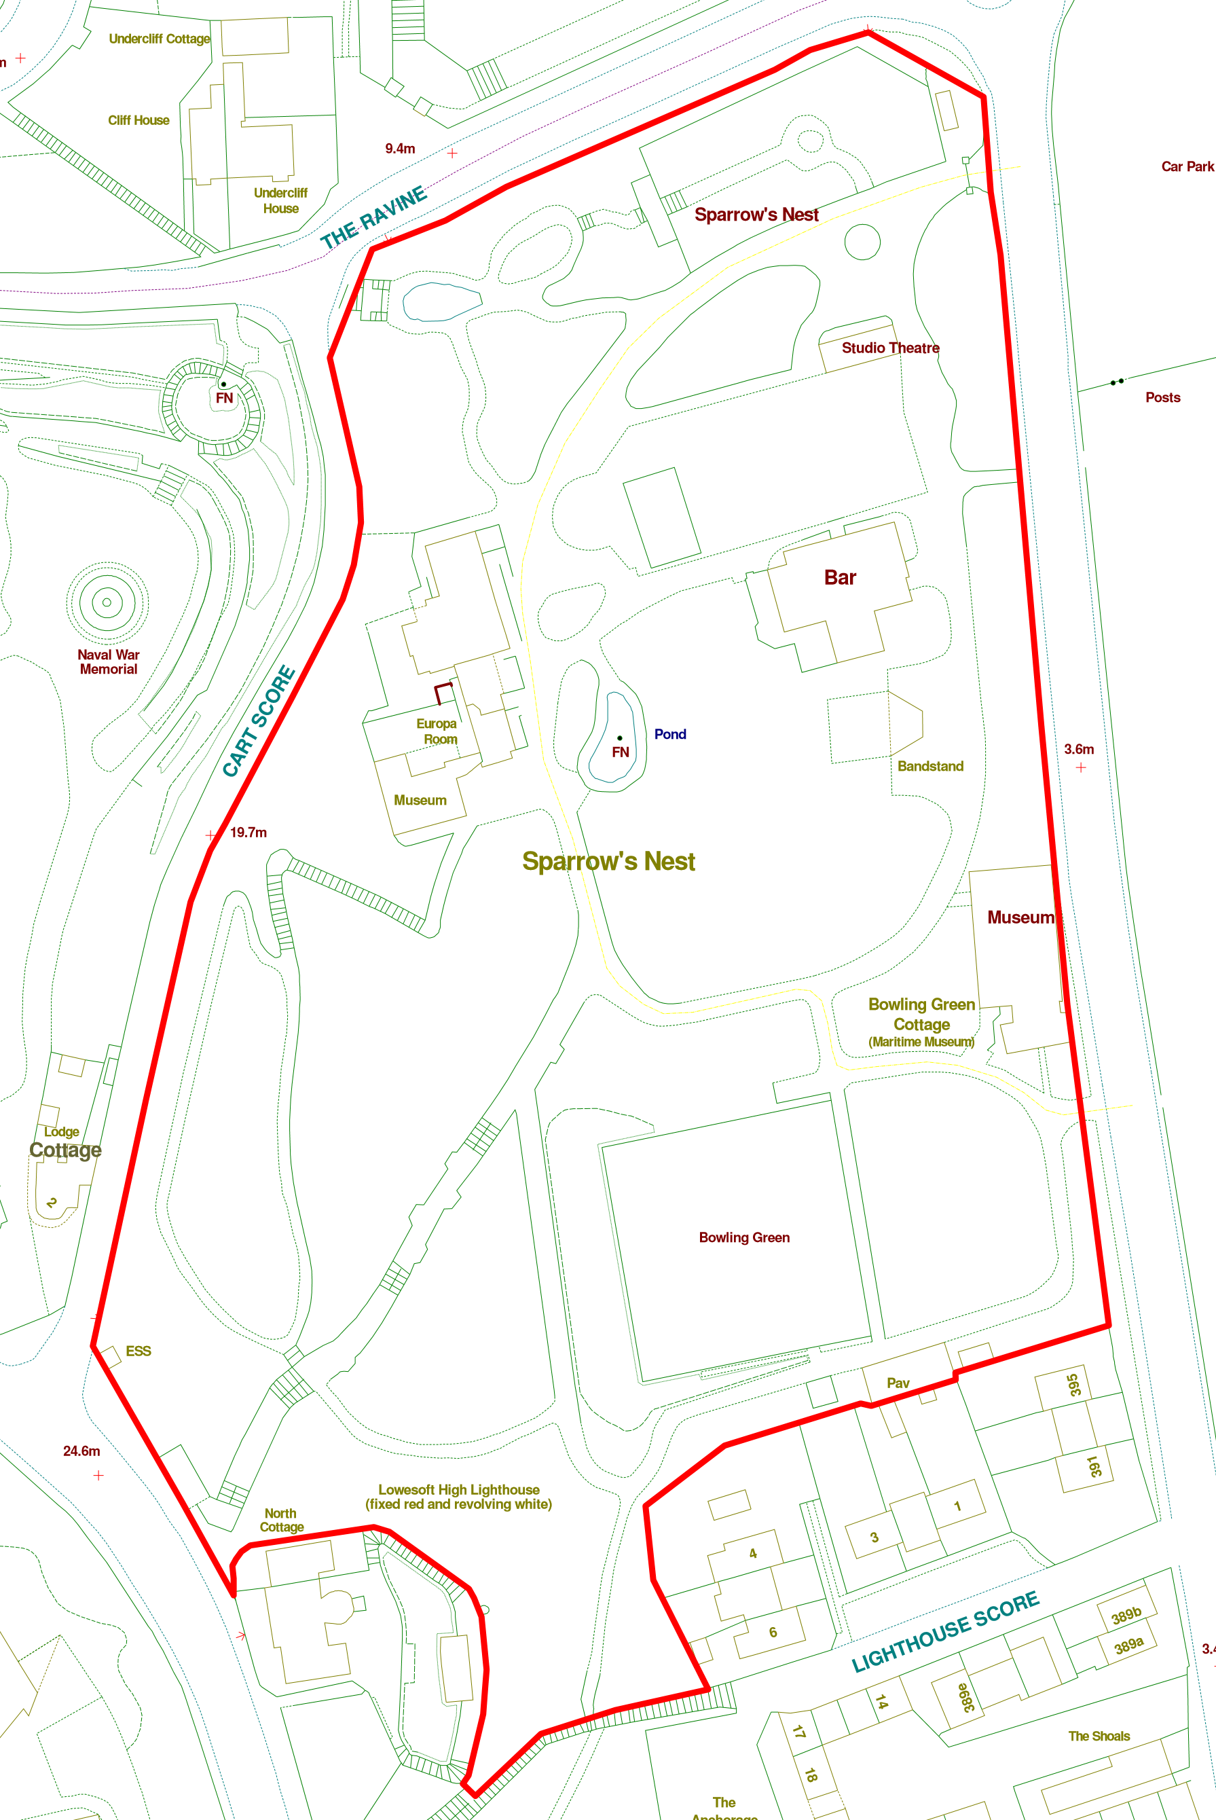

Current Site information
Ward: Harbour Site Reference: SK261656
Area: Special Status:
Covenants: Entrances: 5
TPOs:
Services: Facilities on site:
Access:
Species on Site: Soil Type:
Issues:

Current main use of site:
Park

Future planned use of site:
Sparrow’s Nest will be the Destination Culture Park in Lowestoft. It was home to what was once an iconic theatre in the town and still houses three museums, a movie theatre, a restaurant and a very popular café and bowling green used by three clubs. It is a natural amphitheatre and has a shell designed band stand which can also be used/adapted for outdoor projection as well as one of the town’s beacons.

Sparrow’s Nest still has most of the bones of what made it one of the premier parks in the town. It would not be practical to restore some areas of the park however it should be possible to restyle them to maintain the feeling of the park whilst adding a slightly more modern planting palette. It is proposed that a theme based around Alice in Wonderland/Through the Looking Glass be used in the park.

The older Japanese garden with its water features would be too costly to restore and maintain and we have a better example which we should restore at Kensington Gardens. It is proposed to create a sensory garden in this area with the old pond being turned into a mini “maze”, the rockeries planted with tactile, aromatic or bright plants and a living willow structure planted on the northern raise areas where currently steps lead to nowhere. This would be enhanced by the croquet scene from Wonderland with playing car hoops as tunnels in the maze and hedgehog balls and flamingo mallets. To replace the missing ponds and provide the sound of running water a self-contained solar wall fountain and tank would be place against the wall where the steps lead down from the Cart Score entrance. Where often these fountains have a lions head with water coming out of the mouth this could be the head of the Cheshire Cat. There would also be a living willow feature towards the walled area to the north of the garden.

Between the Japanese Garden and the old Rose Garden is the terrace which is surrounded by a box/privet hedge which is coming to the end of its life. It is proposed that we consider replacing the hedge with a pergola to provide height and interest as well as planting opportunities which would house picnic bench style communal seating and overlook the new replacement to the rose garden. This seating would include the Mad Hatter at one end and the March Hare at the other with the Dormouse emerging from a tea pot on one of the tables.

The old rose garden was removed several years ago and the few roses which are left do not to wall in the location. This space had been a rose garden for more than half a century and would probably need most of the soil replaced if growing roses again was thought about. This area however does appear unloved as it currently it and the location and the all year-round attraction of the park would allow us to develop a winter garden (i.e. one which had interest all year around but comes into its real glory over the winter months). As part of the design it would be proposed to incorporate a pergola from Harrods and also a couple of concrete chess tables and seats each overseen by a chess queen, one white and one black/red as per Looking Glass.

Along the eastern boundary of the park we had been hoping to use secondhand wrought iron fencing to replace the wooden fencing and open up the view into the park. As a long term aspiration it should still be looked at as a possibility. As part of this we need to consider commissioning a new entrance between the bowls pavilion and the Maritime Museum to attract visitors and link across to the Ness.

The Japanese entrance from Yarmouth Road needs to be restored and a lot of effort has gone into working with East Coast College on this however other partners should be considered. The old line of box/privet behind this should be removed as most of it is dead and the soil improved and planted with Lavender as not only would it look nice it would also serve to mask any smells from anti-social behaviour. Here we could also have the top of the rabbit hole with the White Rabbit disappearing into it with the other end of the hole at the bottom of the steps and his head coming out.

The old central handrail which led down the steps and path down to the main part of the park need to be restored for safety and reasons and the benches in the recesses along this path need to be re-installed to provide resting places during the climb/descent.

Consideration needs to be given to the planting in the upper area of Sparrow’s Nest and this is where one or more of the potential National Collections could come to the fore. The areas is referred to as the Bluebell Walk and this is being built on year on year with the planting of new spring bulbs. There is an area which will make a fine fernery and also a level area which was once old toilets which could be utilised. It is proposed that a sculpture of the Jaberwocky would work very well in the centre of the Bluebell Walk.

Handrails also need to be considered near to the Lighthouse Score entrance to the park and down to the bowling pavilion as this area can become slippery.
The concrete water tank in this area and the natural springs need to be investigated to see how they might be used to help irrigate the park.

The old second bowling green that is now just grass needs to given a use and something to welcome visitors into the park. Maybe this could be another place that we could work with schools to create re-cycled plastic bricks to built raised beds in the form of a ships prow and create an wheelchair friendly garden.

The pond in the centre of the park requires planting and the depth considered as it may not currently be deep enough to sustain fish. It needs surface cover, marginals and oxygenators. Unfortunately, the fountain is not really compatible with water lilies if they are too close so other alternative need to be considered, flowering marginals will help enhance the pond and attract pondlife such as dragonflies etc. The aim should be to get the pond to a level to sustain some fish.

In line with the culture theme of the park it would be fun to have outdoor games tables such as chess/draughts, snakes and ladders etc
Park signage is also important especially information and interpretation signage.

We should investigate the potential of working with the Moviemakers and the Marina to see if the movie theatre could be used as an arthouse cinema or similar as this could help both of them out and possibly benefit Giardino’s as well.

Key Development Opportunities:
- Toilets – renovate existing toilet block
- CCTV – improve coverage
- Consider options for pond depending on survey results
- Work with Suffolk County Council to investigate transfer of the Ham and adjoining land along Tom Crisp Way and possible dowry
- Seating
- Bins
- Bike Racks
- Investigate kayaks/punts on pond and kiosk near pond for refreshments & hire
- Bike Track
- Assault course/fitness
- Sensory garden
- Butterfly garden
- Signage
- Drinking Water fountain
Resources Required: | Various
Funding Required: | Funding for toilets as agreed by council  CCTV as part of future budget  Grant via environment agency and matched funding for aerator
Stakeholder Group | Yes
Friends Group | Yes

Park signage is also important especially information and interpretation signage.

The play area could do with renovating and extending because of the amount of use the park receives and this could be on the same theme. Local sponsorship has been offered in the past and could be investigated.

We should investigate the potential of working with the Moviemakers and the Marina to see if the movie theatre could be used as an arthouse cinema or similar as this could help both of them out and possibly benefit Giardino’s as well.

Key Development Opportunities:
- Toilets – renovate existing toilet block
- CCTV
- Consider options for pond
- Seating
- Bins
- Bike Racks
- Alice Theme
- Winter Garden
- Sensory Garden
- Play area (Junior/Toddler)
- Railings and new entrance
- Handrails
- Rain water collection/storage
- Signage
- Drinking Water fountain
- Stakeholder group

Resources Required: | Various
Funding Required: | Funding for toilets as agreed by council  CCTV as part of future budget  Sponsorship and council investment
Stakeholder Group | Yes
Friends Group | No

Rosedale Park, Lowestoft, Suffolk

Current Site information
Ward: Elmtree Site Reference: SK261260
Area: Special Status:
Covenants: Entrances: 3
TPOs:
Services: Facilities on site:
Access:
Species on Site: Soil Type:
Issues:

Current main use of site:
The site is currently used as a park with grass football are and play area. It has two lit paths going through the park.

Future planned use of site:
Rosedale is a sizeable park but lack the facilities and parking to make it a destination park making it a community park.

The Junior play equipment in the park has only been installed since the foundation of LTC however the Toddler provision could be enhanced and could do with extra picnic benches as well as a children’s themed bin within the play area.

The full-size football pitch area has been lost and the knockabout area has only one mini goal these could do with replacing with possibly a MUGA or MUGA ends.

There were benches along the hedge line on the northern edge of the park which could do with replacing (2+)

There are also some trees missing from the tree line alongside the road and the paths and play area could benefit from additional tree planting which has been considered via the tree council grant.

There are at least three different types of bins in the park which should be standardised to two types with regular bins at the three entrances plus a child-friendly bin(s) at the play area.

The park is used by youths in the evenings so a specific area with meeting point/hub seating and maybe WIFI/Bluetooth column in the eastern recess could be positive.

By nature, this is an open space style park so does not need a lot of shrub/perennial planting although some of the boundaries might be enhanced by this and the play area might be enhanced by sensory planting. It has been agreed to plant a new avenue of trees and add to the other avenue of trees as well as the trees along the Elm Tree Road boundary. The top end of the park will become a wildlife area with paths for dog walkers. The dog leg at the top end of the park could become a teenager area with appropriate seating and the Elm Tree end of the park would be the sport area.

Key Development Opportunities:
- CCTV – improve coverage
- Seating
- Bins
- Bike Racks
- MUGA
- Wildlife Area
- Signage
- Drinking Water fountain

Resources Required: | Various
Funding Required: | Funding from the council
Stakeholder Group | No
Friends Group | No

Resources Required: | Various
Funding Required: | Funding from the council
Stakeholder Group | No
Friends Group | No

