Fen Park, Kirkley, Lowestoft, Suffolk

Current Site information
Ward: Kirkley Site Reference: SK261230
Area: Special Status:
Covenants: Entrances: 4
TPOs:
Services: Facilities on site:
Access: The park has several entrances. The two main entrances are off of Southwell Rd and the junction of Southwell Rd and Martin’s Road. There are also pedestrian entrances at the junction of Martin’s Avenue and Newark Road and from Tom Crisp Way. Additionally, there is an entrance from Tom Crisp Way at the old junction with Southwell Rd which is gated with access only for LTC, Norse, Anglian Water and the Friends.
Species on Site: Soil Type:
Issues:
Large body of water with fish and oxygenating issues. Derelict toilets on site

Current main use of site:
Play area, fishing, recreation, woodland

Future planned use of site:
Ideally Fen Park should be a destination ‘wetland’ park in the south of the town. It is close to local residents’ hearts. The park along with surrounding land forms a wildlife corridor through the southern half of the town which needs to be maintained. There are adjoining parcels of land which would enhance the park if they could be added to our portfolio especially if they could be secured with a dowry. Most important of these would be Kirkley Ham to the north east but also the corridor of woodland running south along Tom Crisp Way to the rear of the Phoenix St Peter Academy as far as to Pakefield Riding Stables. This would secure this land as a nature corridor and provide an excellent public space. Much of the space is natural or semi-natural woodland and this should not be substantially altered. The site also adjoined allotments owned by LTC as was as a pumping station which can only be accessed via LTC lands. Next to the pumping station is an area of land that we have been contacted regarding its use as a butterfly area. To the south west there is an area of shrubby woodland with a cleared mound which could provide a location for a bike/nature trail.

The majority of the park has always been grass, ponds and woodland and there would be no major plans to change that. Any planting would be around the edges of the park and in the north east corner where the key shaped entrance to the park is, that was previously attractively planted. However, planting should be done to maintain sight lines through the park.

Key Development Opportunities:
- Toilets – renovate existing toilet block
- CCTV – improve coverage
- Consider options for pond depending on survey results
- Work with Suffolk County Council to investigate transfer of the Ham and adjoining land along Tom Crisp Way and possible dowry
- Seating
- Bins
- Bike Racks
- Investigate kayaks/punts on pond and kiosk near pond for refreshments & hire
- Bike Track
- Assault course/fitness
- Sensory garden
- Butterfly garden
- Signage
- Drinking Water fountain
Resources Required: | Various
Funding Required: | Funding for toilets as agreed by council  CCTV as part of future budget  Grant via environment agency and matched funding for aerator
Stakeholder Group | Yes
Friends Group | Yes
Maintenance Contractor | Waveney Norse

Clarkes Lane, Lowestoft, Suffolk

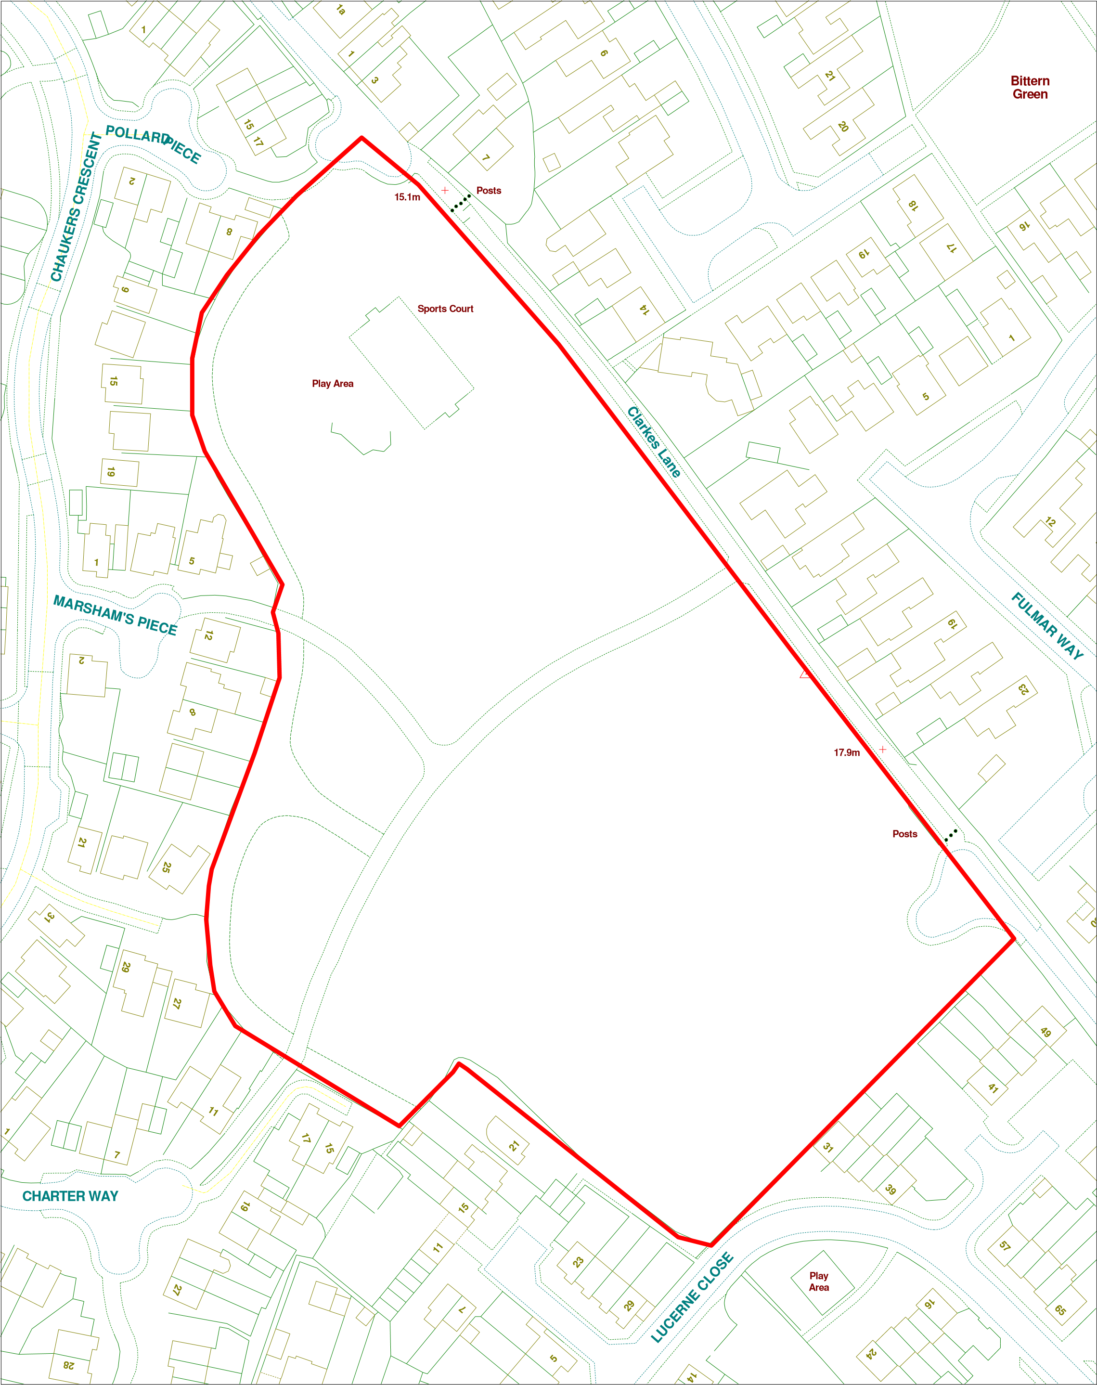

Current Site information
Ward: Elmtree Site Reference: SK139067
Area: Special Status:
Covenants: Entrances:
TPOs:
Services: Facilities on site: Play area
Access: The site has several access points for pedestrian, bicycles and motorised vehicles.
Species on Site: Soil Type:
Issues:
The site is almost surrounded by housing with limited external views across the park for security. Existing facilities may also have been placed without an overall plan

Current main use of site:
It is currently a large open space which does not really attract people to visit or stay. There are good pedestrian and cycle tracks across the park. There is some play provision and good boundary planting.

Future planned use of site:
Clarkes Lane has the potential to become a destination park in an area of the town that is lacking such a facility. It is a large area of land that is both under used and developed. LTC would like to have a skatepark in the south of the town and, after consulting with experts, this would be the best location for it

An overall plan for the park has been agreed through the Parks sub-committee.

Resources Required:
A landscape architect/play area designer to develop a concept and layout of the park and include budgets to enable the council to consider grant and further the development of a destination park in this location.

Key Development Opportunities:
- Toilets – renovate existing toilet block
- CCTV – improve coverage
- Consider options for pond depending on survey results
- Work with Suffolk County Council to investigate transfer of the Ham and adjoining land along Tom Crisp Way and possible dowry
- Seating
- Bins
- Bike Racks
- Investigate kayaks/punts on pond and kiosk near pond for refreshments & hire
- Bike Track
- Assault course/fitness
- Sensory garden
- Butterfly garden
- Signage
- Drinking Water fountain
Resources Required: | Various
Funding Required: | Funding for toilets as agreed by council  CCTV as part of future budget  Grant via environment agency and matched funding for aerator
Stakeholder Group | Yes
Friends Group | Yes

Normanston Park, Lowestoft, Suffolk

Current Site information
Ward: Normanston Site Reference: SK261598
Area: Special Status:
Covenants: Entrances: 4
TPOs:
Services: Facilities on site: Café, parking, football pitches, cricket pitches, skatepark, tennis courts, changing rooms, basketball hoop, running circuit, children’s’ play area
Access:
Species on Site: Soil Type:
Issues:
The changing facilities/toilet provision need updating. The is no toilet provision near to the children’s play area
Current main use of site:
The park is mainly used for sports, dog walking and family time. It is also attached to a conservation area managed by SWT.

Future planned use of site:
The park is the key destination sports park in the north of Lowestoft but needs investment and consideration to achieve its potential.

Key considerations to achieve this are:

Improvement of the existing changing rooms, toilet and café. Provision of toilets and changing space is geared towards men. With the reduction of teams playing at the park the is the facility to reduce and improve the changing room provision and create new toilet provision within the existing changing room block.

Replacement of old tennis pavilion. This would be a ready location to site a second set of toilets close to the children’s play area. It would only need to be a one or two multi-functional cubicle structure, which could be prefabricated. There is an existing concrete foundation and the services to the site were capped and should still be available.

Witches Garden Bike Trail. The wooded area in the south-west of the park is known as the Witches Garden. It is overgrown and not really considered part of the park. This could be turned into a bicycle trail (it is understood that it might already be used unofficially in this way) but by specifically making it into a designed area it would reduce safety risks and improve use possibly leading to a reduction in the other uses. It would also make the areas easier to maintain.

Tennis Courts. There is an excess of tennis courts in Lowestoft however there are regular users of these courts but generally only three of them. It would be practical to reduce the number of courts (retaining those favoured by the tennis players) and erecting a new fence between the two sections along with a new gate. The newly formed area could form a multi-use area. It would not be big enough to be a stand alone MUGA however its surface would make it an ideal hockey training area which is lacking in the north of the town and it could also potentially be used for some other sports such as basketball widening the use of the facility and use by younger generations.

Outdoor Gym. Council has already been considering installing an outdoor gym and as the main destination sports park this should be our initial location. Looking at an overview of the park and the other installations we are discussing there are three possible locations depending on layout and council have already agreed to invite in companies to look at the site and draft proposals. The three possible locations are:
- The south west corner bounded by the tennis courts, Leathes Ham and Constable Close. This is a relatively square, flattish area of land which could have a rotational form of outdoor gym.
- To the north of the ‘running track’ on the grassed area between it and the backs of the houses on Normanston Park so that it could be used in conjunction with the running track. It could be individual items at a distance from each other or small clusters or equipment
- South of the skate park and east of the football pitches making in convenient to the changing rooms and café.

Skatepark. The skatepark is relatively self-contained and well used. It does not need a lot of ongoing general maintenance but does require specific work from time to time. This should be considered and a budget provided. There is the potential to light the skatepark. It was approved by Suffolk County Council Highways Department and Environmental Health at the time the skatepark was built and all the necessary services and ductwork were included in the build to future proof for this possibility.

The running track. This is currently an adapted path and not a really running facility. Installation of a better surface and the costs involved could be investigated. The runners, as well as dog-walkers, have requested lighting along the path. The cost was considered prohibitive but that was without knowing the information regarding lighting the skatepark. The feasibility of installing low-level downlighters (either connected to the mains or via solar panels) could be investigated as part of the overall long-term plan for improvements to the park.

Table tennis. There are currently two concrete outdoor table tennis tables which rarely see use. We should investigate the cost of outside paddles and balls and speak to the café about whether they would be willing to hold them and lend them out on deposit. We should also ensure that information on how to borrow paddles and balls is by/on the table tennis tables.

Football/Cricket pitches. These are not used as much as previously and we need to gain more info on this. There are issues as the top pitches slope and the bottom pitches can flood. This is due to a layer of clay beneath the park and how it slopes and causes an unusual water table. It would be difficult to solve and probably expensive and might not lead to an increase in usage. There may be the same issue with the underground electric supply which affected the children’s play area. Adult football play is reducing as is cricket and whilst provision is currently still being used, we need to be considering potential usage in ten- or twenty-years’ time. Interestingly there is still a growth in youth football and the main centre in north of the town is Barnards Meadow which is adjacent.

In the western half of the park there is also the potential to place an area which could be more landscaped in a zen style and used for yoga and Tai Chi. There has been positive public expression about this possibility and it could work well near to the north-west entrance from Normanston Drive or Lakeland Drive and engage another type of park user and exercise activity.
With all of this it will be important to work with experts to plan out a scheme and locate each element to form a whole, build a schedule and costing and look for funding.
The Council will also need to maintain a long-term view of sports and leisure development to ensure that we don’t just provide what we have always provided and seek to work with health and leisure specialists to maximise the use and benefits of our sports parks.
There is also a potential to create an area where dogs could safely be let off of the lead.
Seating. Normanston is probably not that short of seating because of the nature of its usage however the nature of the seating could possibly be addressed. Are traditional park style heritage benches the best option? Would they be better sited elsewhere and replaced with something more suited to the use of the park? If they are memorial benches, would those who donated them be happy with them being moved? Are they in the best locations? There are some excellent sports style benches available even skateboard specific. Maybe we need more picnic benches or communal seating? This could all be investigated.
Key Development Opportunities:
- Toilets – renovate existing changing room/toilet block
- CCTV – improve coverage
- Seating
- Bins
- Bike track
- Bike Racks
- Investigate options for café and
- Relocation and provision of Norse storage
- Bike Track
- Adult fitness equipment
- Lighting
- Signage
- Drinking Water fountain
- Conversion of part of tennis courts
- Additional toilet provision
- Dog Area

Resources Required: | Various
Funding Required: | Funding for toilets as agreed by council  CCTV as part of future budget  Grant via environment agency and matched funding for aerator
Stakeholder Group | Yes
Friends Group | Yes

