Parks, Play Areas and Open Spaces Five Year Plan Strategy

Introduction

This draft of this strategy is an initial starting point for a long term strategy for the council with regard to existing and potential sites in order to develop a plan which can be placed before the public for consultation and provide the basis to enable the council to move forward in managing land in its ownership for the benefit of the local community. It will also be used to inform budgeting decisions and to take into account climate and heath concerns following the council’s commitment to the climate and health emergencies.

The body of this document is divided into three sections:
- General policies which are mainly covered by the existing Open Spaces Strategy
- Individual Location Plans
- Future considerations.

The aim of this draft is to detail the discussed plans and then use to discuss priorities and timescales in order to develop a SMART scheme to be able to present to the public. It will not be written in stone but form a guide for councillors to follow or amend as necessary either due to circumstances or public demand.

General Policies

As mentioned above most of these are already outlined within the Open Spaces Strategy which was agreed within the first two years of the formation of this council but also ties in newer policies such as the Wild Flower Policy and the Mulching Policy as well as the declarations of both the Climate and Health Emergencies. It is planned that this five year strategy and any decisions taken should be included within the Open Spaces Strategy and will form an overall guidance which can be consulted upon with the public. It is important to note that the size of the content of all of these items together would be overwhelming and therefore consultation may be better on a site by site basis with reference to the larger overall plan for those who are interested.

New areas which need to be added to the Open Spaces Strategy which are currently being considered by council will include the Signage paper currently progressing through council as well as the proposal that the council will have bins at the entrances to every open space as well as benches and bicycle racks as appropriate.

Belle Vue Park, Yarmouth Road, Lowestoft, Suffolk, NR32 4AL

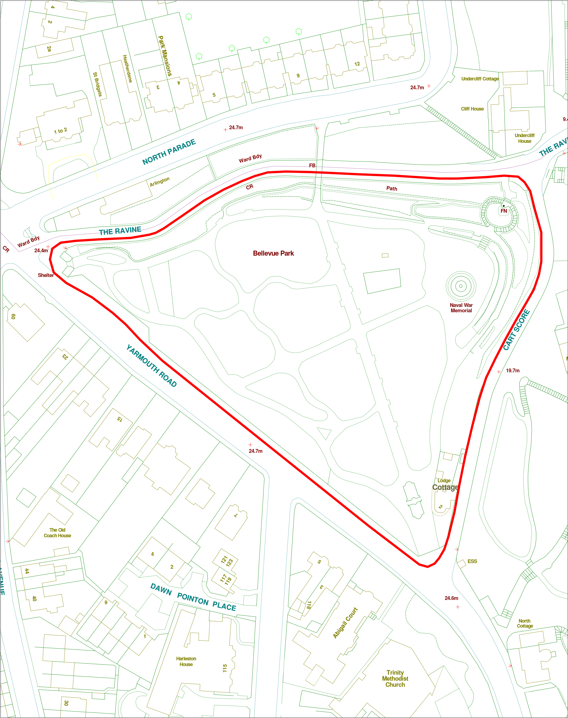
Current Site information
Ward: | Harbour
Site Reference: | SK263069
Area: |  | Entrances: | 4
Special Status: | Grade II listed Park & Cemetery
Covenants:
TPOs:
Services: | Water, Electricity, Drainage
Facilities on site:
Access: | Pedestrian access from three points on the north side of the park and pedestrian and vehicular access at the south from Cart Score.
Species on Site:
Soil Type:
Tenants: | Cottage
Issues: | Restrictions due to Grade II status and use as cemetery
Current Use | Park and cemetery, mainly used for walking or passing through.

Future planned use of site:
Destination Park with the theme of Remembrance/Memory. Although originally the park had a bandstand and would have been a pleasure garden it now has the RNPS memorial as cemetery. The park is Grade II listed and is currently being mapped by Historic England. It is also home to the new Peace garden.
The park falls into the HAZ and as such may gain both financial and professional help in restoring lost features. Initial replanting has been begun in 2018 however this should be an ongoing project. Planting should be reflective of its heritage whilst considering modern public gardening restrictions and to a large extent be at a height of less than four feet to maintain a view across the park.

Key Development Opportunities:
- 10 year Snowdrop Plan
- Pink beds
- White Beds
- Azalea Walk
- Pergola (to replace the thatched shelter that was burnt down)
- Re-instatement of Toilet and improvements to north-west entrance
- Re-instatement of the original gated entrance at the south end of the park
- Feature Rhododendrons (Seven Dwarfs)
- Slope planting (long term project with Community payback?)
- Restoration of more original style pathways than the tarmac whilst still maintaining the original path layout.
- Natural feature play area
- Repair/replace ironwork.
- Memorial Plaque replacement
- Peace Garden Plaque
- Sculpture
- Benches & picnic benches
- Bins
- Bicycle Rack
- Drinking water fountain
- Information Boards
- Oriental Poppies

Resources Required: | Various
Funding Required: | Elements could be funded from the Parks Development Budget as well as the Capital programme. We could also look at sponsorship for specific items or Arts Council funding for sculptures. Potential for grants from Historic England but also other bodies. Work with local metal workers for gates etc
Stakeholder Group | Yes
Friends Group | No
Maintenance Contractor | Waveney Norse

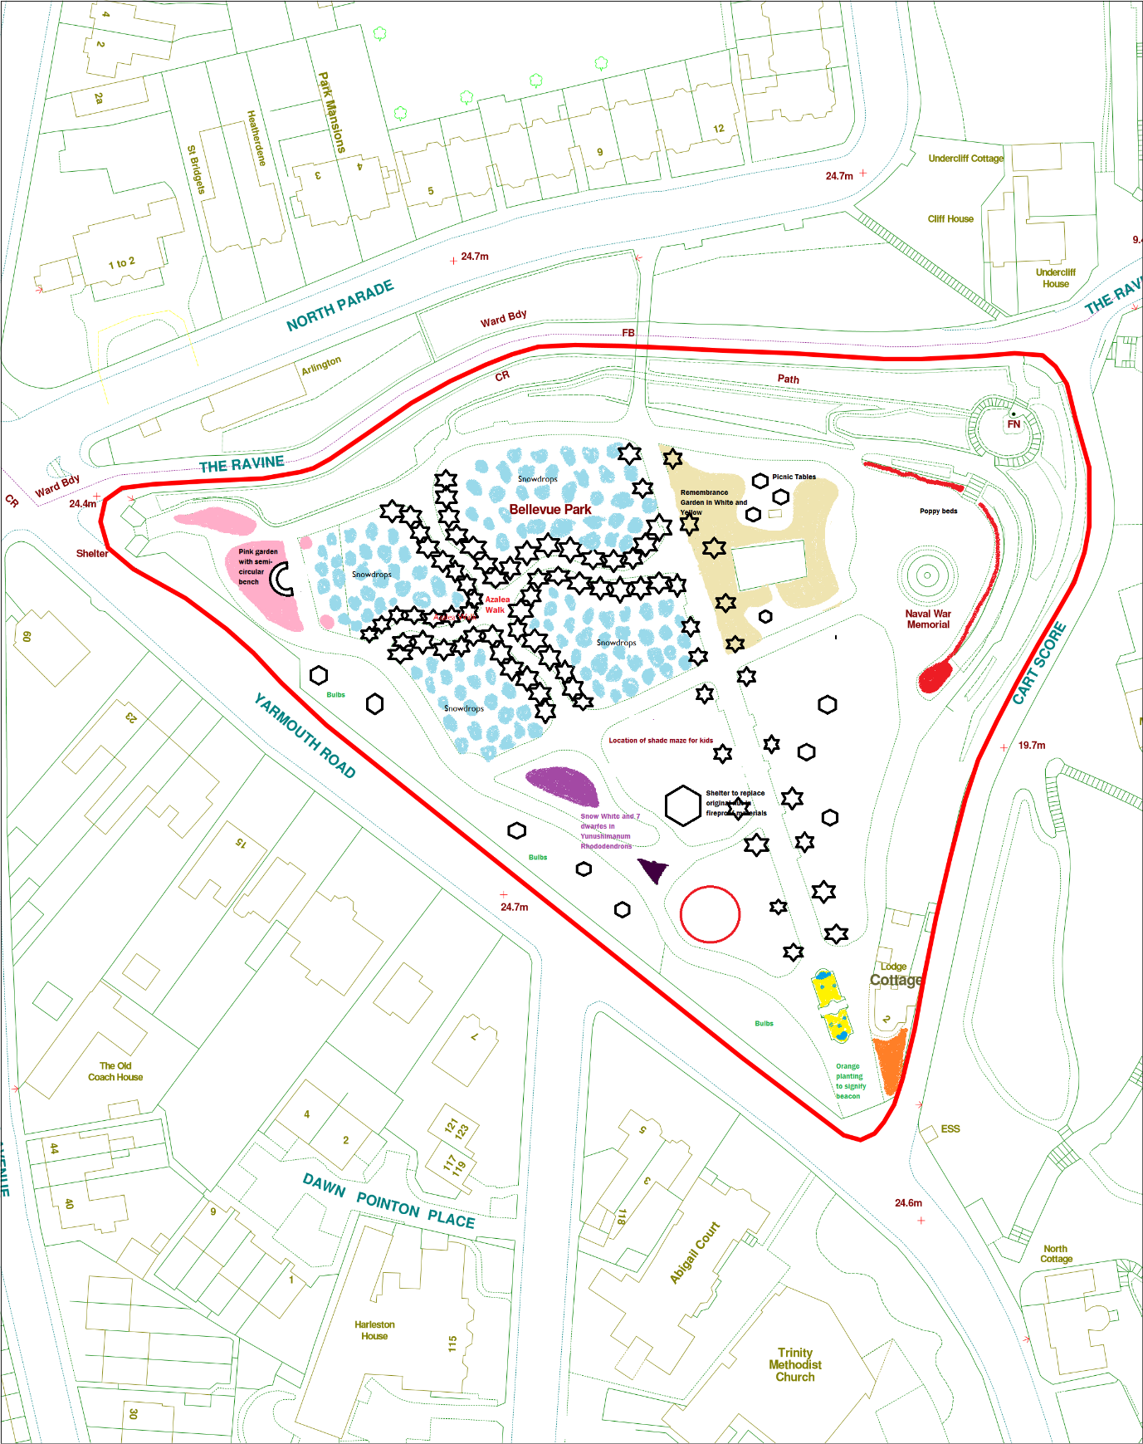

Britten’s Piece, Lowestoft, Suffolk, NR32 9BL

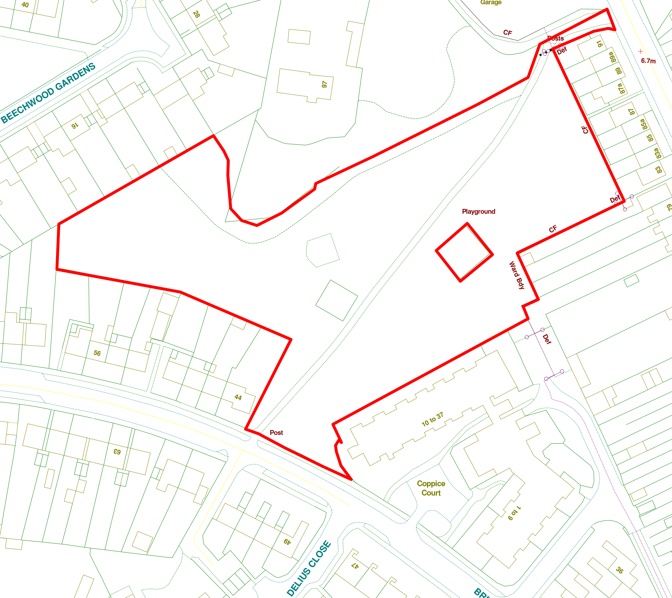
Current Site information
Ward: | Elmtree
Site Reference: | SK261316/SK263156
Area: |  | Entrances | 2
Special Status: | Grade II listed Park & Cemetery
Covenants:
TPOs:
Services: | Water, Electricity, Drainage
Facilities on site:
Access:
Species on Site:
Soil Type:
Tenants: | Cottage
Issues: | Restrictions due to Grade II status and use as cemetery
Current Use | Park and cemetery, mainly used for walking or passing through.

Future planned use of site:
Currently just called “Land and Britten Road”, Britten’s Piece would give the park more of an identity as a Community Park and as it would be named after the composer it could be musically themed (hence the name Piece). The essential elements play score is an 8/9 and there are no missing elements on site. It is recommended that the site be aimed at the junior/teen age group play wise.

Rather than traditional benches (as at present) this park would benefit from community seating and meeting points/pods with wind up bluetooth posts.

The park benefits from a lit pathway and already has approved planting of a cherry tree avenue

Key Development Opportunities:
- Musically themed play equipment
- community seating/teen seating pods with wind up bluetooth
- bins,
- widening the path to provide a pedestrian path and a cycle path,
- planting to soften the boundary whilst allowing sightlines through the park at the Britten Road end of the park.
- Grass football area with goalposts or MUGA
- Musical artwork and maybe something commissioned to celebrate Benjamin Britten.
- A community garden/orchard at the west end of the park

Funding Required:
New play equipment built into the play equipment schedule, sponsorship, ACE England and Sports grants as well as seed funds from the Parks Development budget

Resources Required: | Various
Funding Required: | Elements could be funded from the Parks Development Budget as well as the using for seed funding. We could also look at sponsorship for specific items or Arts Council funding for sculptures.
Stakeholder Group | No but potential relationship with EPA
Friends Group | No
Maintenance Contractor | Waveney Norse

