Britten Road play area matting

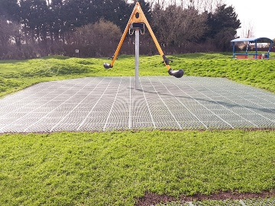

The prices below are hopefully self-explanatory and would be subject to our standard 10% mark-up.

If you have any questions please let me know.

The HAGS Mobilus is the easier unit to resurface. We would import around 2 ton of top soil and lay new Safety Matta in Natural Green to the required area. This is a Diameter of 9.6m. Current surfacing is not compliant.

Total cost £5412.00 plus VAT for Safety Matta. Image attached.

You could have Play Matta using the shock pads and membrane for this unit which would cost £6098.40 plus VAT (shaded colours)

In the toddler area the astro turf can be overlaid but there is much prep needed to scrap away the grass that's over grown to the edges and the level dips that have occured. We can sort the levels out before we would overlay with our Recover Matta Tiles. Shock pads needed for the toddler unit though.

Shaded Greens in a mixed design I think would look good.

Toddler unit

We would use 35mm shock pads and top tiles into grass. Level improvements and prep beforehand. £2208.25 plus VAT

Orange Spinner

Recover Matta over astro turf 2.5m x 2.5m Shaded Greens £412,50 plus VAT

White Horse Springie

Recover Matta over astro turf 3m x 2.5m Shaded Greens £495.00 plus VAT

Motorbike Springie

Recover Matta over astro turf 3m x 2.5m Shaded Greens £495.00 plus VAT

Swings

Recover Matta over astro turf 6.5m x 3.5m Sahded Greens £1501.50 plus VAT

