AID Committee
Stoven Close Play Area
Further to discussion of item 102.3 on the agenda for the AID Committee meeting on 7th December 2020, regarding a wheelchair accessible picnic bench at Stoven Close, please note the following additional details of gates and the existing bench as promised.
There are four sprung gates into the fenced play area, none of which has a surfaced path.
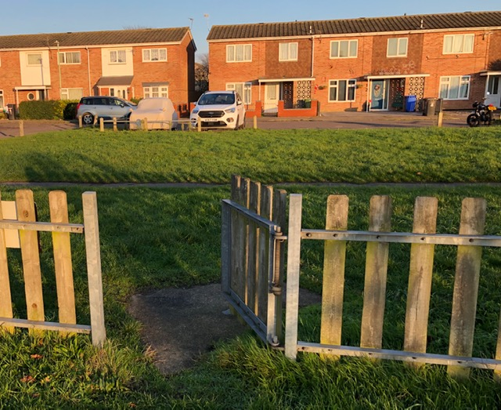
NE Gate – 900mm wide, 7m from a N-S path from Stoven Close

SE Gate – similar but 8m from the path.
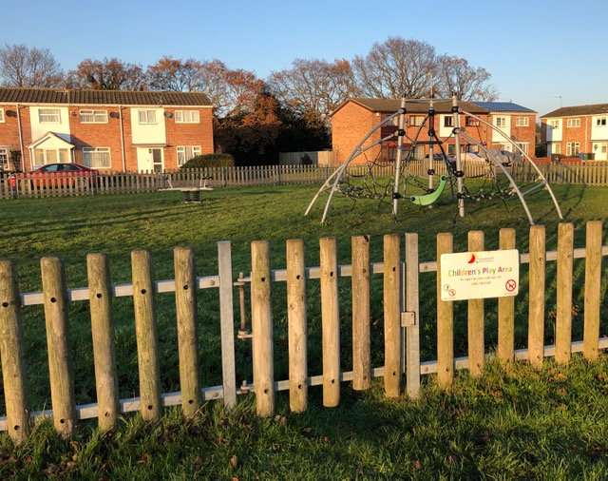
South Gate – 900mm wide but opens onto the extensive, grassed area towards Wisset Way.

West Gate – 950mm wide, close to the existing picnic bench, but 19m from the pavement on Weston Road, opposite the Village Rise 101 bus stop.
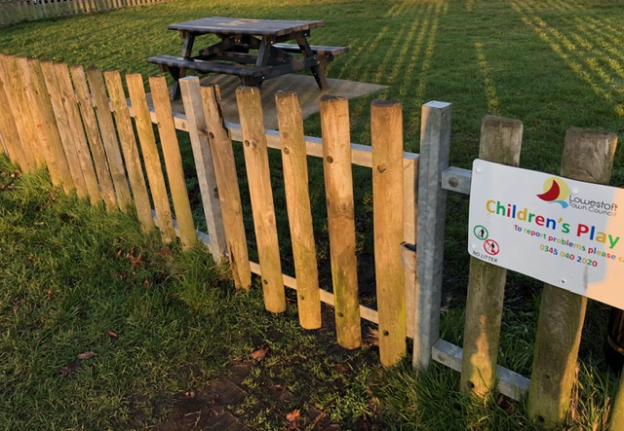
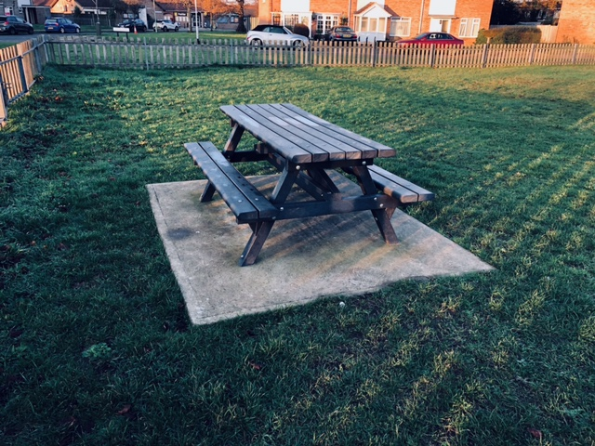
Picnic Bench – Glasdon type 1800 x 1300mm, concrete slab 2500 x 2000mm.

Given the difficulty of access through the sprung gates, and their distance over rough grass from the nearest hard surface, it is suggested that rather than installing a wheelchair bench at Stoven Close, one could be placed at the nearby Gunton Community Park. There is only one bench provided there (other than perches beside the football/basketball enclosure), and there are surfaced paths from all four cardinal points of the compass from the neighbouring roads.
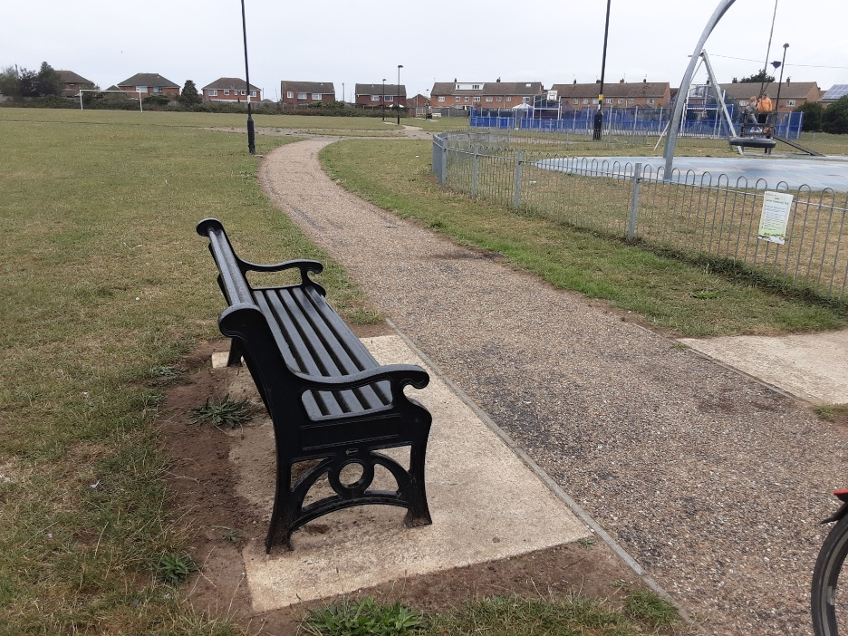

Colin Butler
Cllr St Margaret’s East Ward
8th December 2020

