Holocaust Memorial Plinth

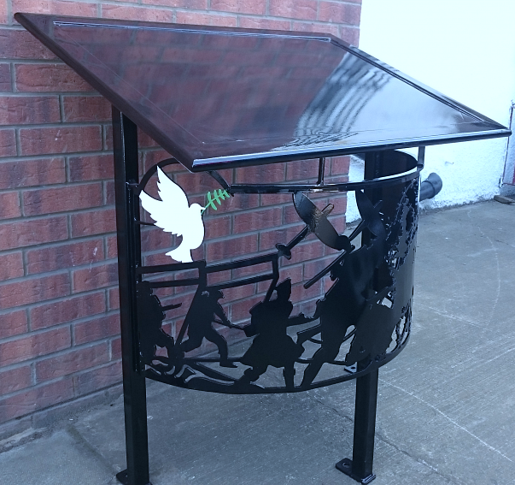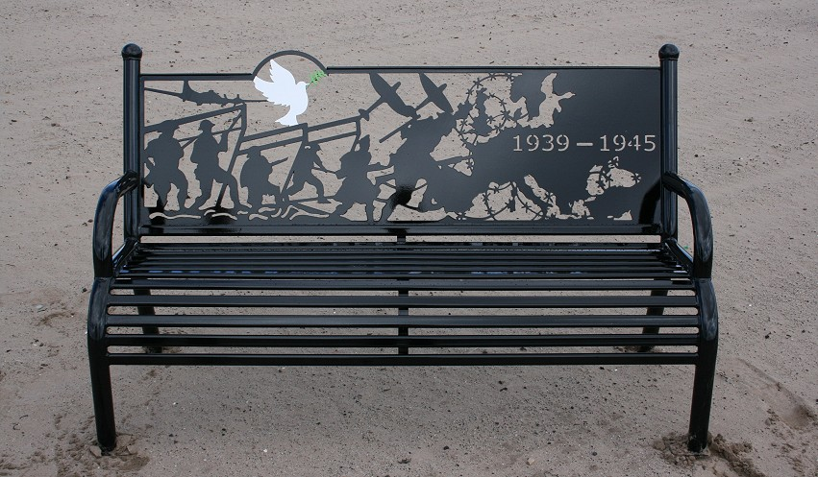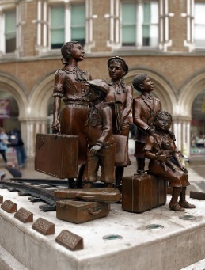

Above is the plinth which we hope to have funded for the Holocaust Garden with the wording below. It would also be good to have a WWII bench and a specially commissioned bench to commemorate the Kinder Transport which could depict a train, a sign and a representational outline of the statues at Liverpool St Station with the date of the arrival of the train in Lowestoft.

