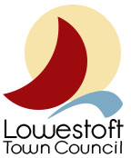
Sustainability Strategy
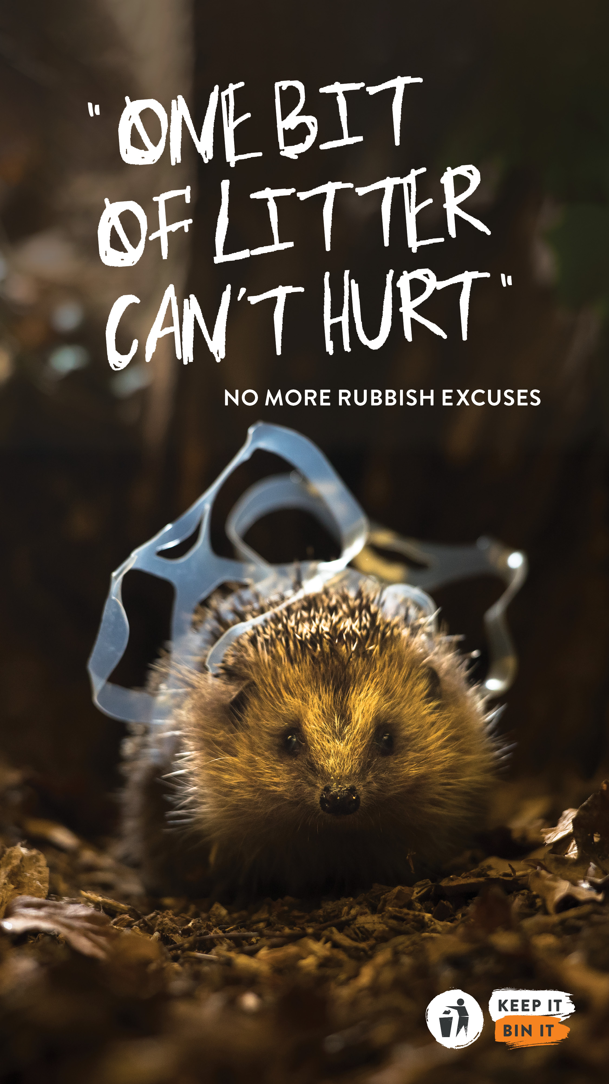

About our Sustainability Strategy

The Town Council has declared a climate emergency. It did so in recognition that everyone needs to play their part in addressing the current crisis and that we all have to start somewhere.
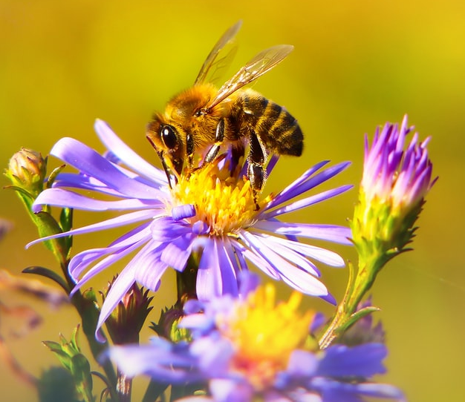
We will interpret sustainability as meeting the needs of the present without compromising the ability of future generations to meet their own needs.
We will apply this socially, environmentally and economically.
We will interpret this in the context of Lowestoft, and our services, facilities, powers and resources, and this will change as the world around us changes.
Our Sustainability Strategy is our high-level plan which will help us to:
- Tread lightly on the planet and do our bit to help it to flourish

- Treat people decently and provide ethical and fair services

- Contribute to economic recovery and increase local resilience to crisis

We are a large Town Council but there are many bigger local authorities and we know that our potential impact is limited by our powers and resources.

However, by doing what we can within our own remit plus working with the community, partners and other public service providers, we can achieve much more.

The question of sustainability is a complex but important one. We will not always get it right not least because accessible and relevant expertise, information and technology are not always sufficiently developed to address all the needed major changes in the everyday practices of most people and organisations.

The pressures on this Council are considerable but we know that in order to contribute positively to current and future generations, we need to move on with change as rapidly as we reasonably and surely can.

Our Sustainability Strategy takes account of our climate emergency declaration, which involves moving toward having a zero impact on our climate.

At its Full Council meeting on 27 October 2020, the Town Council committed to becoming a ‘net zero’ authority by 2030. Net zero refers to the balance between the amount of greenhouse gas produced and the amount removed from the atmosphere. Net zero is achieved when emissions do not exceed the amount taken away.

What is our Sustainably Strategy?

In recognition of the connections between social, environmental and economic activities in successfully delivering sustainability, we will progress measures which aim to make a social, economic and environmental difference to:

- Vulnerable people
What have we done so far?
Provided grants to community support organisations
Introduced the real national living wage
Maintained open spaces which are free for all
Maintained leisure facilities which are free for all
Trained staff in mental health
Increased access to defibrillators
Planning community orchards
Contributed to food delivery during the pandemic
Worked with partners on homelessness and anti-social behaviour

- Healthy-living and well-being
What have we done so far?
Maintained and developed new open spaces and introduced areas for increased social interaction and separate areas for quiet reflection
Improved and increased play area equipment
Maintained leisure facilities and funded sports clubs
Trained staff in mental health and first aid
Increased access to defibrillators
Planned community orchards
Contributed to food delivery during the pandemic
Organised and supported community events

- Respect for equality and diversity including opportunities for learning, and gender equality and empowerment of all women and girls
What have we done so far?
Adopted Council Equality and Diversity Policy
Maintained Council services and facilities open to all insofar as reasonably possible
Promoted and budgeted for democratic elections
Established fair recruitment practices
Trained councillors and staff in equality and diversity
Reviewing Council equality and diversity practices
Obliged Friends of Groups, volunteers and contractors to act inclusively and fairly

- The availability of safe and healthy public facilities, infrastructure and services
What have we done so far?
Adopted Council Health and Safety Policy
Established suitable compliance checks and grounds maintenance arrangements
Appointed Health and Safety consultants where needed
Planned ecology assessments for ponds
Planned fountains in parks (to reduce one-use plastic)
Established toilet working group
Considering compostable toilets

- Sustained, inclusive and sustainable economic growth, innovation and decent employment
What have we done so far?
Contributed to partnership projects and plans aimed at economic regeneration
Supported businesses during the pandemic
Facilitated the use of our parks and open spaces for commercial operations
Planned recruitment to sound Council posts on fair terms
Worked with Lowestoft Vision and supported the Bid Levy area
Worked on plans to regenerate the Town Hall and the Heritage Action Zone including the Triangle Market

- Lowestoft’s safety and resilience
What have we done so far?
Planned recruitment of community wardens
Established Community Safety Committee
Worked with anti-social behaviour officers and police officers
Funded CCTV and transferred the service to East Suffolk Council
Fulfilled our duty to consider Crime and Disorder when making decisions, including recommendations on planning matters
Developed and supported Friends of Groups
Maintained and considering expanding Public Space Protection Orders

- Urgently addressing climate change and its impact
What have we done so far?
Declared climate emergency
Established Climate Emergency Committee with public representatives
Established a Climate Action Group involving members of the public
Complied with our duty to consider biodiversity in relevant decisions
Conducted audit and improved office practices, including reduced paper and plastic waste and reduced work travel
Planned water fountains to reduce plastic bottle pollution
Planned biodiversity measures across many open spaces
Responding to Suffolk Wildlife Trust advice and specialist environmental surveys
Considering electric vehicles for work travel
Planned pond ecological assessments
Developing Neighbourhood Plan which majors on protecting green space and increasing biodiversity
Working with contractors on better environmental practices including reduced use of pesticides

- Urgently contributing to the sustainable use of water and management of waterways
What have we done so far?
Planned pond ecological surveys
Conducted litter-picks to decrease water pollution
Implemented better watering practices for new trees and plants
Maintained assets for water preservation, health and safety
Maintained and emptid bins to reduce risks of water contamination
Improved management of water including addressing algal bloom
Planned water fountains to reduce coastal plastic pollution

- Urgently contributing to the protection, restoration and sustainable use of terrestrial ecosystems including addressing the lack of tree coverage, biodiversity and green space, and halting (and reversing where reasonably possible) land degradation and inappropriate development
What have we done so far?
Let grass grow longer in some areas
Targeted open spaces for increased biodiversity
Implemented policy of planting two trees for every one lost
Planted more trees and planning more
Using sustainable products where possible for new facilities
Increasing sophisticated decisions about tree and other planting to take account of biodiversity
Developing Neighbourhood Plan and planning decisions prioritise protection of open green spaces and safeguard the preference of brownfield over green development

- The inclusivity and accountability of public services and their partners
What have we done so far?
Comply with local authority transparency and accountability requirements including meetings in public and audit
Provide full-time officer contact
Provide information via website and social media
Budget appropriately
Maintain comprehensive governance arrangements
Maintain risk management including insurance
Oblige commercial park users, Friends of Groups, and grant applicants to have appropriate policies
Act as a community voice and hold other public services to account
Developing a community engagement policy
Planning community engagement and a review process for this Strategy

What next?
Our starting points for helping us to deliver our Strategy are:

- Confirming this Council’s commitment to this Strategy and asking the community and partners whether we have set an appropriate high-level plan.

- Conducting a ‘materiality assessment’ – asking the community and other organisations for input on what we should be reporting on? This might include carbon emission levels, the area of land managed for biodiversity, money invested and saved on environmental initiatives and a range and ethical matters such as the number of workers paid at or above the national real living wage.

- Determining our existing carbon footprint.

- Determining how we assess and report our progress on reducing our carbon footprint and achieving other agreed measures

- Setting our targets and reporting stages in such a way that it enables our staff and anyone assisting them on delivering the Strategy to progress the day-to-day work of improving performance.

- Reviewing our assumptions and adjusting our direction accordingly when conditions change.

Date of adoption by Full Council: July 2020

Revisions
Date | Amendment

