Planning notes 17/12/19

19 Monckton Crescent
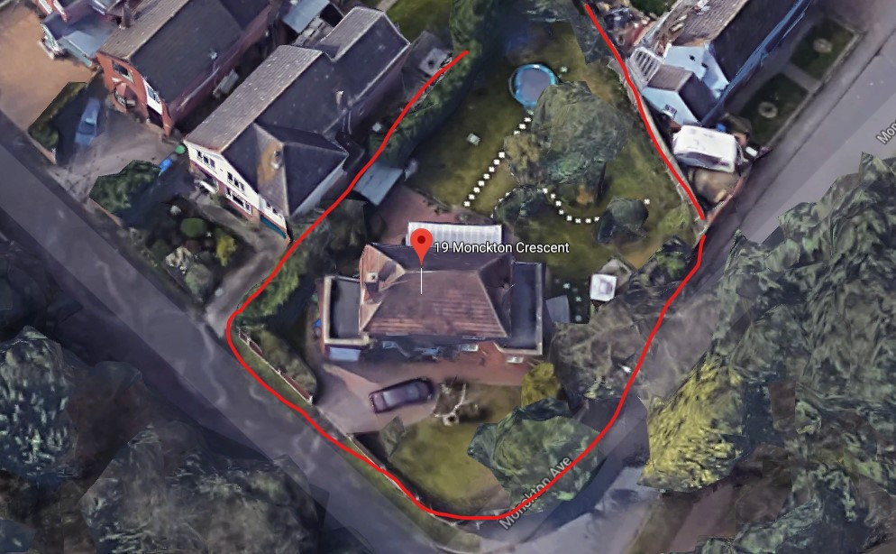
A significant extension to the left and right of the property, enlarging rooms to take up full width of the plot.
Note that the agenda has the incorrect application number. The correct application is DC/19/4713/FUL.
19 Monckton Crescent Lowestoft Suffolk NR32 2QY  Single storey extensions to side and rear, with front porch, new boundary wall to replace close boarded fencing.  Date Description Information 1 Information 2  03/12/2019 Application Form & Certificate  03/12/2019 Plans 2466.19.1C Existing and Proposed Floor and Elevations and Block Plan plus S  13/12/2019 Site Notice & Neighbourhood Notification SNOTQR  17/12/2019 Consultee Responses Environmental Health  02/01/2020 Consultee Responses SCC Highways | DC/19/4713/FUL  Public comments  Constraints  Related cases  Documents  Map

59 Normanston Drive
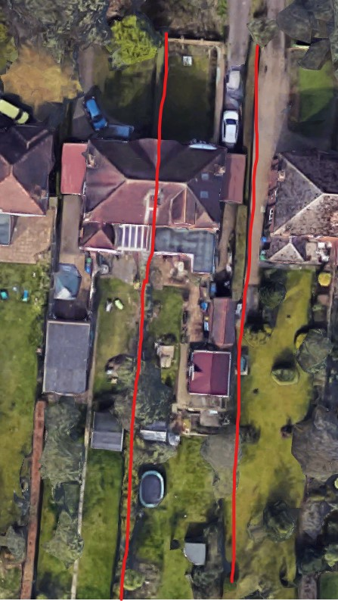
Replacement of existing garage with garden room.
Objection from neighbour at number 57. Key objections are loss of light and poor design. Neighbour has suggested some design changes that he believes would minimise the impact on his property.
59 Normanston Drive Lowestoft Suffolk NR32 2PU  Erection of Garden Room  Date Description Information 1 Information 2  13/12/2019 Plans 19/186/01 Rev A Existing and proposed plans  13/12/2019 Plans 19/186/01 Rev A Existing and proposed plans  16/12/2019 Site Notice & Neighbourhood Notification SNOTQR  27/12/2019 Neighbour Responses Denny 57 Normanston Drive  27/12/2019 Neighbour Responses Denny- Attachment 57 Normanston Drive | DC/19/4821/FUL  Public comments  Constraints  Related cases  Documents  Map

143 Oulton Road
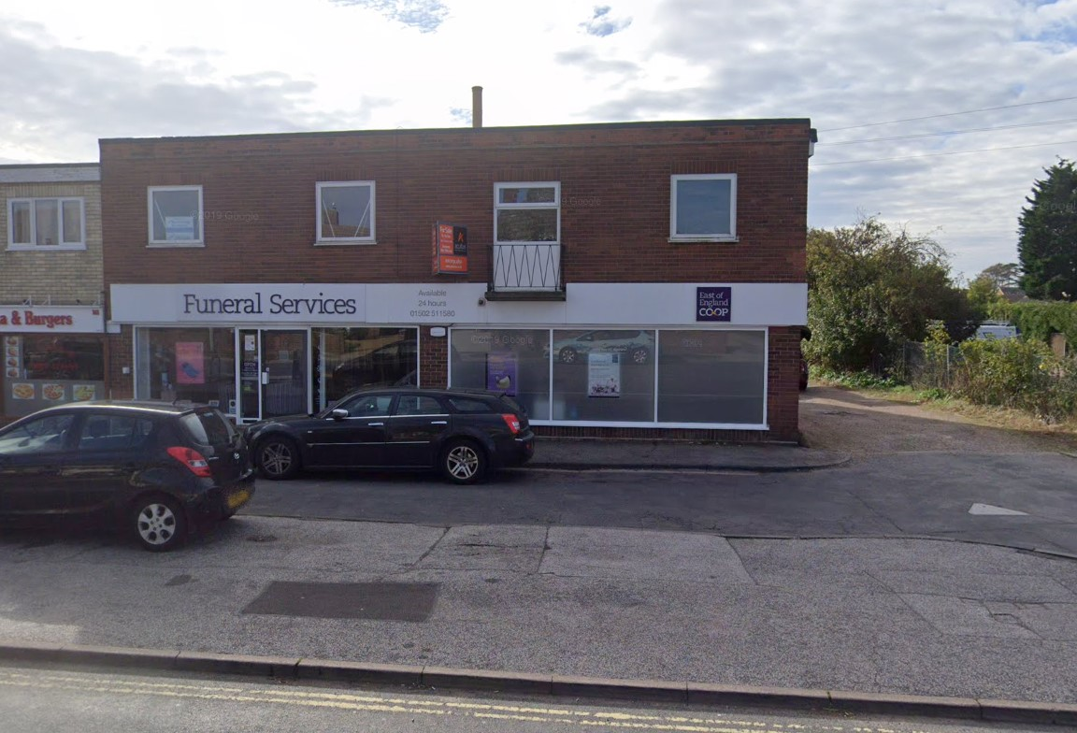
Addition of a step-free entrance for improved disabled access.
143 Oulton Road Lowestoft NR32 4QS  Elevational changes to provide new accessible customer entrance  Date Description Information 1 Information 2  18/12/2019 Application Form & Certificate Application form  18/12/2019 Design & Access Statement Design & Access Statement  18/12/2019 Plans 4869-PL1 Existing plans  18/12/2019 Plans 4869-PL2 Proposed plans  18/12/2019 Plans 4869-PL3 Site and block plan  20/12/2019 Site Notice & Neighbourhood Notification SNOTQR | DC/19/4866/FUL  Public comments  Constraints  Related cases  Documents  Map

6 Willow Road
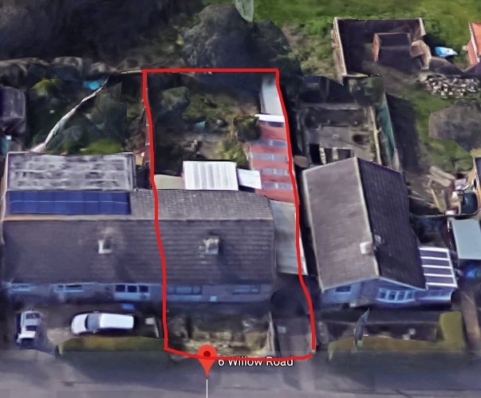
This is a rear extension that would replace the outbuildings to the right of the property.
6 Willow Road Lowestoft Suffolk NR33 7BJ  Proposed rear extension  Date Description Information 1 Information 2  18/12/2019 Plans 2546.19.1C Proposals  19/12/2019 Site Notice & Neighbourhood Notification SNOTQR | DC/19/4870/FUL  Public comments  Constraints  Related cases  Documents  Map

112 London Road North
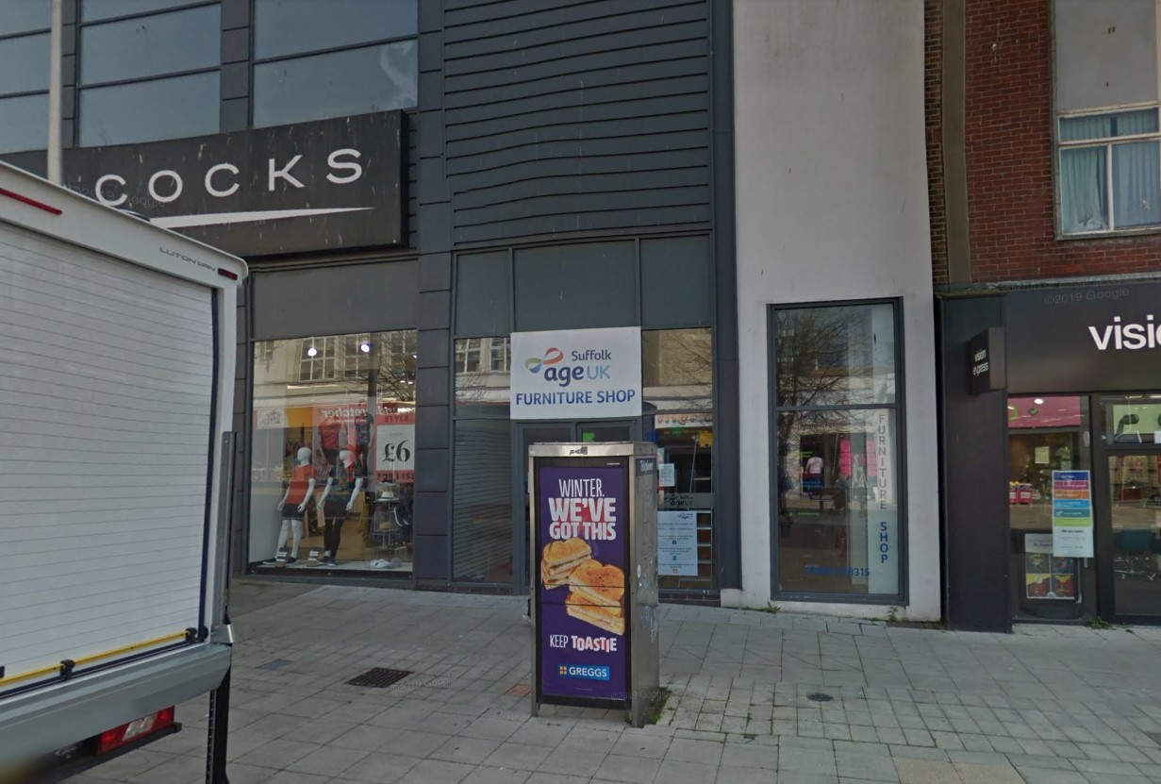
This has been brought back to us after the map and address were corrected.
112 London Road North Lowestoft Suffolk NR32 1ET  Non Illuminated and Illuminated Advertisement Consent - Installation of externally illuminated fascia and non illuminated projection and wall mounted panel  Date Description Information 1 Information 2  05/11/2019 Plans Proposed plans  05/11/2019 Plans Site plan  22/11/2019 Site / Location Plan  03/12/2019 Plans Elevations  04/12/2019 Consultee Responses SCC Highways  04/12/2019 Site Notice & Neighbourhood Notification SNOTQR  17/12/2019 Town/Parish Consultation Response Lowestoft Town Council  18/12/2019 Plans Elevations  18/12/2019 Plans Site plan  19/12/2019 Consultee Responses Street Lightening  19/12/2019 Site Notice & Neighbourhood Notification SNOTQR  23/12/2019 Site Notice & Neighbourhood Notification SNOTQR | DC/19/4324/ADN  Public comments  Constraints  Related cases  Documents  Map

11 Kirkley Park Road
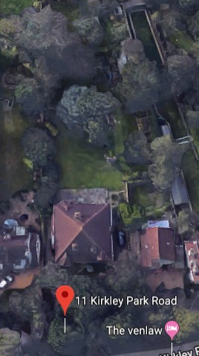
Replacement of an existing summerhouse (not described) with a new summerhouse on the same site. The new structure appears larger than the old, but no dimensions are given.
11 Kirkley Park Road Lowestoft Suffolk NR33 0LQ  Replacement of existing summerhouse  Date Description Information 1 Information 2  28/11/2019 Application Form & Certificate  04/12/2019 Photographs Existing and proposed  04/12/2019 Plans Floor plans and elevations  04/12/2019 Site / Location Plan  04/12/2019 Site / Location Plan  17/12/2019 Site Notice & Neighbourhood Notification SNOTQR  18/12/2019 Site Notice & Neighbourhood Notification SNOTQR | DC/19/4671/FUL  Public comments  Constraints  Related cases  Documents  Map

9 Sedlescombe Road
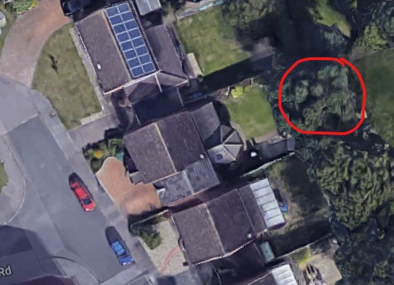
9 Sedlescombe Road Lowestoft Suffolk NR33 9NL  TPO 360 Rear garden 1 x Oak - Reduce to previous pruning points and crown lift up to 4m Reason: to allow more light into garden & maintain size of tree.  Date Description Information 1 Information 2  13/12/2019 Application Form & Certificate | DC/19/4817/TPO  Public comments  Constraints  Related cases  Documents  Map

Advertisement Site, Waveney Drive
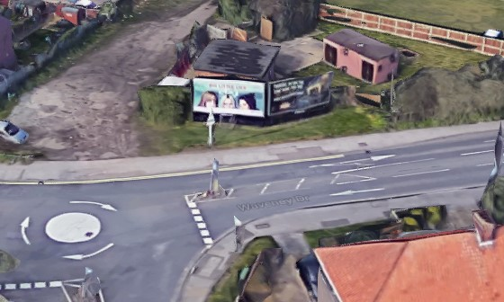
This is a replacement for the existing billboards that were previously demolished. No objections as yet from neighbours or Suffolk highways.
Advertisement Site Waveney Drive Lowestoft Suffolk  Advertising Billboards  Date Description Information 1 Information 2  12/12/2019 Application Form & Certificate  12/12/2019 Photographs  12/12/2019 Plans Site Plan, Elevations & Block  12/12/2019 Supporting Documents Cover Letter  16/12/2019 Site Notice & Neighbourhood Notification SNOTQR  02/01/2020 Consultee Responses SCC Highways | DC/19/4804/FUL  Public comments  Constraints  Related cases  Documents  Map

