Planning notes 25/2/2020

38 Kirkley Park Road
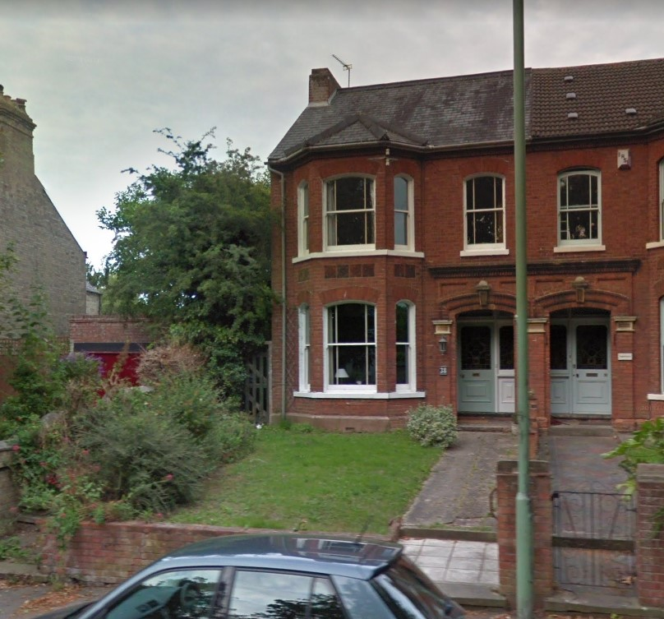
The tree to the left of the house.
38 Kirkley Park Road Lowestoft NR33 0LG  Front garden T1 Hawthorn - Removal to ground level reducing any damage, due to the close proximity to the house  Date Description Information 1 Information 2  29/01/2020 Site / Location Plan | DC/20/0345/TCA  Public comments  Constraints  Related cases  Documents  Map

Sea View, Arbour Lane
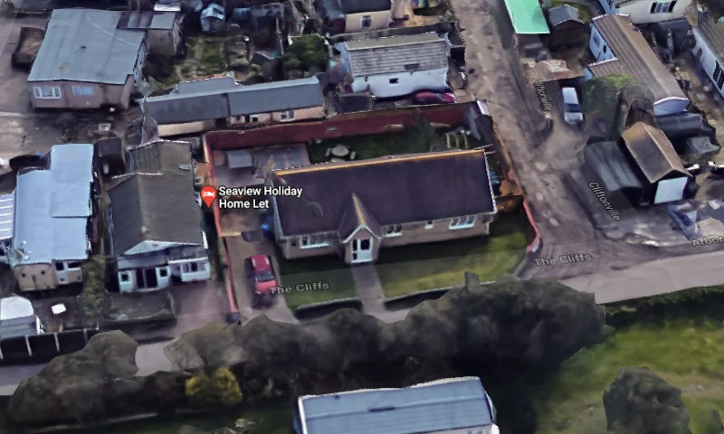
This is on Pakefield caravan park.
Sea View Arbor Lane Lowestoft NR33 7BQ  Construction of single storey side extension to form a garage/store  Date Description Information 1 Information 2  31/01/2020 Site Notice & Neighbourhood Notification SNOTQR  29/01/2020 Application Form & Certificate Application form  29/01/2020 Plans 140915 2A Proposed plans  29/01/2020 Plans 140915 3A Site and block plan | DC/20/0358/FUL  Public comments  Constraints  Related cases  Documents  Map

Shaftesbury Court, Rectory Road
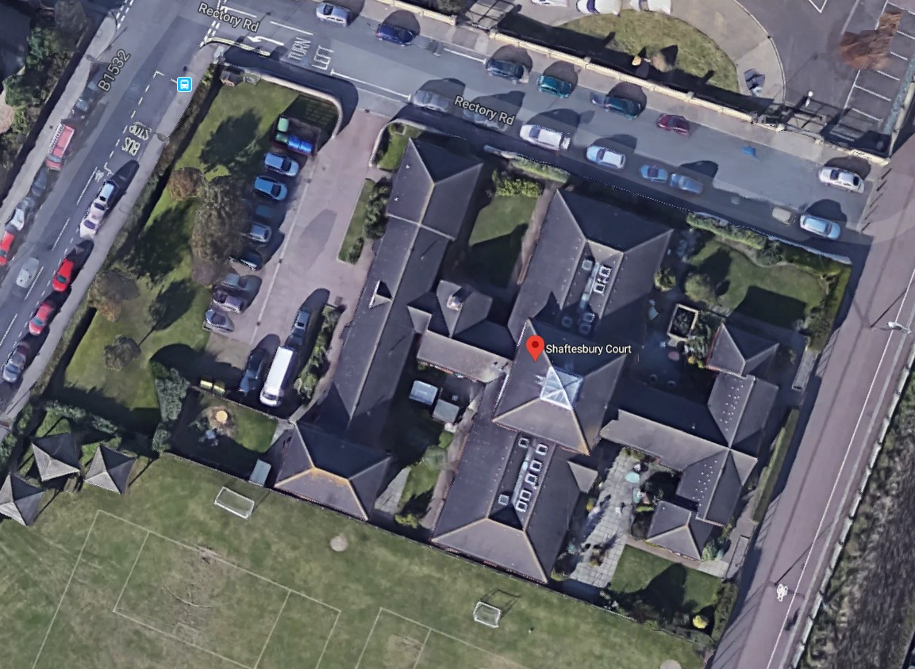
Felling of 7 trees. This plan only covers demolition, so there is no mention of how the trees will be replaced.
Shaftesbury Court Rectory Road Lowestoft Suffolk NR33 0BU  Whitebeam (1) fell as tree not retained in post demolition Landscape Plan Whitebeam (3) fell as tree not retained in post demolition Landscape Plan Whitebeam (4) fell as tree not retained in post demolition Landscape Plan Whitebeam (5) fell as tree not retained in post demolition Landscape Plan Whitebeam (6) fell as tree not retained in post demolition Landscape Plan Whitebeam (7) fell as tree not retained in post demolition Landscape Plan Cabbage Palm (11) fell as tree not retained in post demolition Landscape Plan  Date Description Information 1 Information 2  31/01/2020 Application Form & Certificate  31/01/2020 Plans Tree Constraints Plan | DC/20/0388/TCA  Public comments  Constraints  Related cases  Documents  Map

Hackbridge, 61 London Road
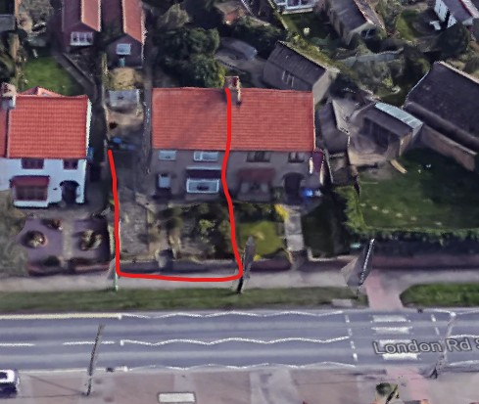
This is an application for a dropped kerb. This is in close proximity to a zebra crossing, and opposite Pakefield Primary School.
Neighbour objection highlighting issues of:
Parking is detrimental to the street scene. Concern over safety with two schools nearby. Concern the parking is too small to avoid overhanging into the footpath.

Hackbridge 61 London Road Pakefield Lowestoft Suffolk NR33 7AD  Provision of dropped kerb and parking to front garden space  Date Description Information 1 Information 2  19/02/2020 Neighbour Responses Graham Ben-Tan, 70 London Road  18/02/2020 Site Notice & Neighbourhood Notification SNOTQR  17/02/2020 Application Form & Certificate  17/02/2020 Design & Access Statement  17/02/2020 Plans AD-19-1157 existing/proposed street scene site/block/kerb  17/02/2020 Supporting Documents Planning statement | DC/20/0651/FUL  Public comments  Constraints  Related cases  Documents  Map

Boudreaux Lodge, 18 Whitton Close
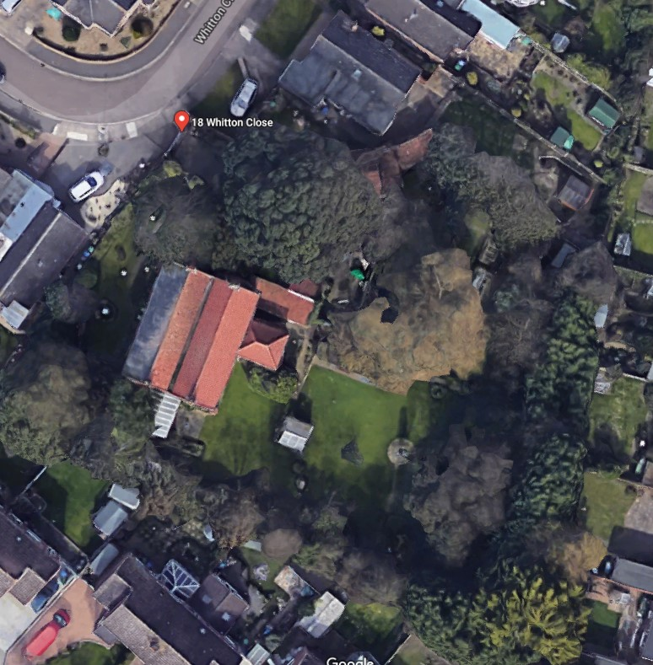
Boudreaux Lodge 18 Whitton Close Lowestoft Suffolk NR33 9RG  Tree Preservation Order: No.315 2001 (T5 and T2) Tree T1 Cherry and T5 Oak of MWA Arboricultural Report Works - Remove Reason: The above trees are considered to be responsible for root induced clay shrinkage subsidence damage to 18 Whitton Close, Lowestoft, NR33 9RG. Please see attached statement of reason for works Replacement planting of standard size tree with agreement of Local Authority. The following species are suggested: Hornbeam or Field maple.  Date Description Information 1 Information 2  06/02/2020 Application Form & Certificate  06/02/2020 Supporting Documents ADDENDUM TECHNICAL REPORT  06/02/2020 Supporting Documents Arboricultural Appraisal Report  06/02/2020 Supporting Documents Geo Serv - Monitoring Plus Report  06/02/2020 Supporting Documents SITE INVESTIGATION FACTUAL REPORT  06/02/2020 Supporting Documents TECHNICAL REPORT ON A SUBSIDENCE CLAIM  06/02/2020 Supporting Documents TREE PRESERVATION ORDER | DC/20/0493/TPO  Public comments  Constraints  Related cases  Documents  Map

243 Long Road
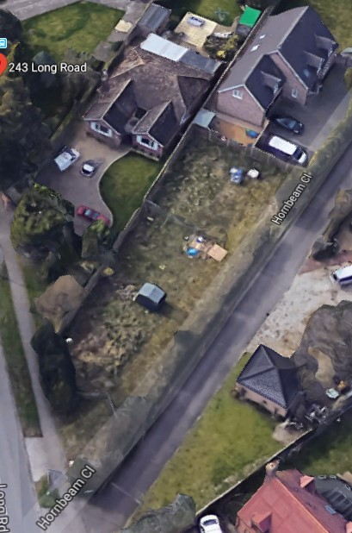
We were previously in support of this application. The plan has ben amended, so back it comes!
243 Long Road Lowestoft NR33 9DF  Variation of Condition No.2 of DC/10/0003/FUL - Construction of 3no. detached houses. Removal of Condition 2 - Alteration to the design and siting of plot 1.  Date Description Information 1 Information 2  07/02/2020 Plans 572/6A Proposed Elevations, Floor & Block Plans  04/02/2020 Consultee Responses Essex & Suffolk Water  22/01/2020 Town/Parish Consultation Response  17/01/2020 Consultee Responses Suffolk Highways  16/01/2020 Neighbour Responses Dye 245 Long Road  13/01/2020 Neighbour Responses Hutchings 2 Hornbeam Close  06/01/2020 Consultee Responses Environmental Protection  03/01/2020 Consultee Responses Anglian Water  02/01/2020 Site Notice & Neighbourhood Notification SNOTQR  30/12/2019 Application Form & Certificate | DC/19/5063/VOC  Public comments  Constraints  Related cases  Documents  Map

2 Farm Close
2 Farm Close Lowestoft Suffolk NR33 8RP  TPO62 G6 - Rear Garden 1 x Sycamore - Reduce to previous pruning points, to maintain size  Date Description Information 1 Information 2  06/02/2020 Application Form & Certificate | DC/20/0502/TPO  Public comments  Constraints  Related cases  Documents  Map

1 Hornbeam Close
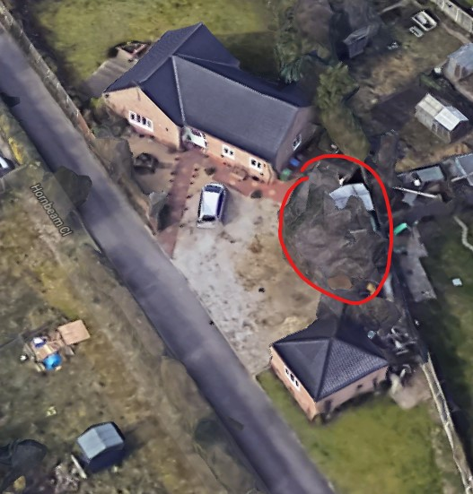
1 Hornbeam Close Lowestoft Suffolk NR33 9GD  TPO 341 T1 Hornbeam - Reshape laterals (garage side only) by 2.5m max. Reason - To reduce encroachment onto garages and caravan park.  Date Description Information 1 Information 2  03/02/2020 Application Form & Certificate  03/02/2020 Supporting Documents M1  03/02/2020 Supporting Documents T1 | DC/20/0413/TPO  Public comments  Constraints  Related cases  Documents  Map

112 Yarmouth Road
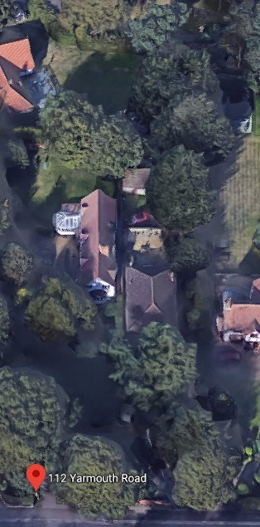
112 Yarmouth Road Lowestoft Suffolk NR32 4AQ  TPO 92 T1& T2 Macrocarpa - Fell to ground level. Reason - Trees have been in decline from damage caused by bad weather a few years ago. The upper canopy was removed leaving large wounds that haven't recovered causing peeling park and soft rot which is visible from 3m upwards (see photos). Multiple branches have failed due to this and with the location of the trees being on the neighbours boundary it has become a risk to both parties. The client is more than happy to replant 2 semi-mature trees in a more suitable section of garden.  Date Description Information 1 Information 2  02/02/2020 Application Form & Certificate  02/02/2020 Photographs | DC/20/0412/TPO  Public comments  Constraints  Related cases  Documents  Map

14-15 Waveney Road
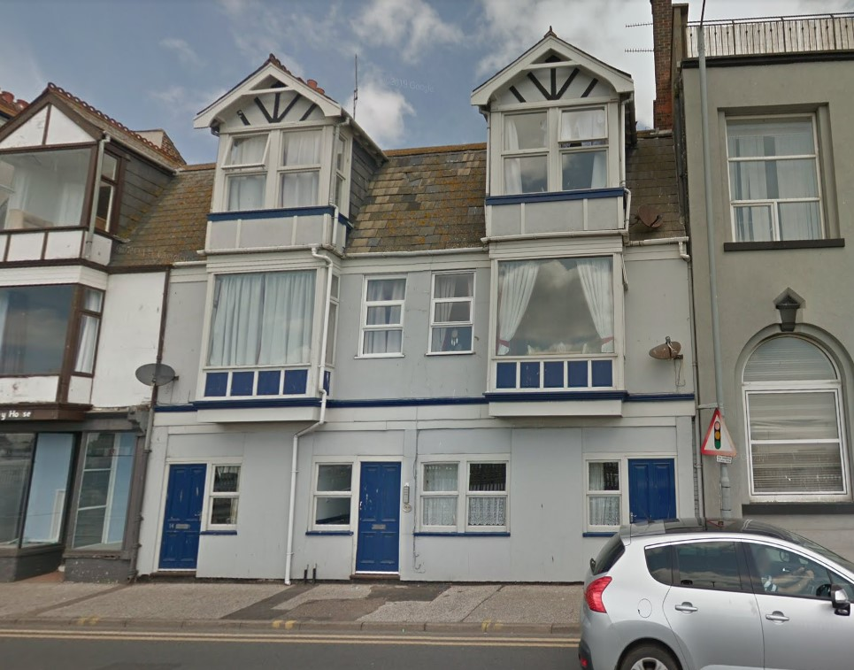
Replacement of the large first floor windows with two smaller panes to match the top floor.
14 - 15 Waveney Road Lowestoft Suffolk  Replacement of front elevation windows  Date Description Information 1 Information 2  14/02/2020 Site Notice & Neighbourhood Notification SNOTQR  07/02/2020 Site Notice & Neighbourhood Notification SNOTQR  06/02/2020 Application Form & Certificate  06/02/2020 Design & Access Statement  06/02/2020 Plans Existing & Proposed Side & Front Elevations  06/02/2020 Site / Location Plan | DC/20/0492/FUL  Public comments  Constraints  Related cases  Documents  Map

6 Holton Avenue
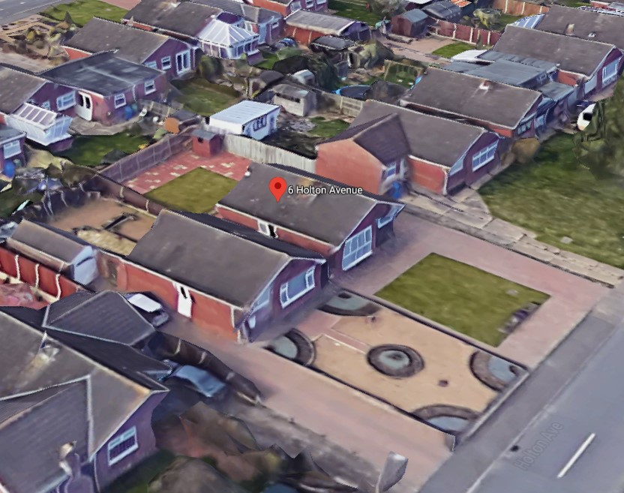
Two neighbour responses, both objections.
Outerside: Loss of light, and loss of view.
Palmer: Loss of light, loss of general view, detrimental to street scene. Out of character for the area.
6 Holton Avenue Lowestoft Suffolk NR32 4RR  Proposed front extension & car port.  Date Description Information 1 Information 2  18/02/2020 Neighbour Responses Outterside 40 Broad Road  17/02/2020 Neighbour Responses Palmer 4 Holton Avenue  17/02/2020 Neighbour Responses Palmer (Photos) 4 Holton Avenue  17/02/2020 Neighbour Responses Palmer (Photos) 4 Holton Avenue  17/02/2020 Neighbour Responses Palmer (Photos) 4 Holton Avenue  06/02/2020 Site Notice & Neighbourhood Notification SNOTQR  05/02/2020 Application Form & Certificate  05/02/2020 Plans Existing & Proposed -1B FP, Elevations, Site & Block Plan | DC/20/0487/FUL  Public comments  Constraints  Related cases  Documents  Map

