Planning notes 10/3/2020 Coronavirus edition

The East Suffolk planning portal has been dropping offline occasionally. If any of the links don’t work, try them again later.

Jd Power Tools, Alexandra Road
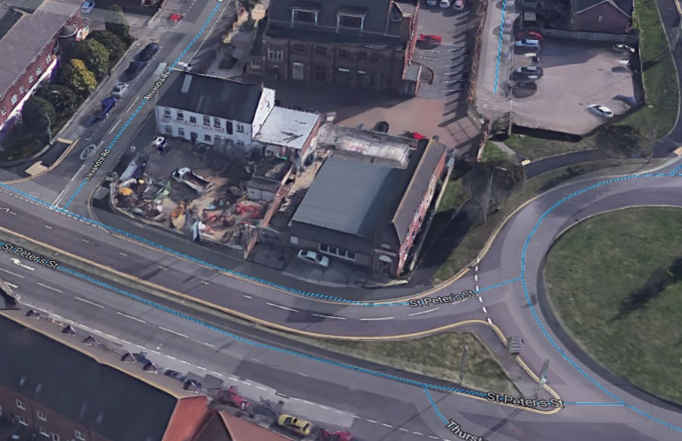
We’ve an application this site previously in DC/19/3520/FUL. That application was later withdrawn. Our comments then recommended refusal due to the density of the proposed development and overdevelopment of the area, its poor standard of environmental design and environmental impact, including lack of green space, and its lack of accessibility above the ground floor.

Jd Power Tools Alexandra Road Lowestoft NR32 1PL  The demolition of existing commercial buildings and the construction of a residential development of 31-one bedroom flats over 3/4 storeys with under croft parking and associated works.  Date Description Information 1 Information 2  12/03/2020 Consultee Responses SCC Flooding Authority  09/03/2020 Consultee Responses CIL  09/03/2020 Site Notice & Neighbourhood Notification SNOTQR  09/03/2020 Site Notice & Neighbourhood Notification SNOTQR  06/03/2020 Site Notice & Neighbourhood Notification SNOTQR  02/03/2020 Application Form & Certificate  02/03/2020 Design & Access Statement  02/03/2020 Plans WTH-SK201 B Existing site layout and location plan and proposed roof plan  02/03/2020 Proposed Elevations Proposed visualisations  02/03/2020 Proposed Elevations WTH-SK105-1-A Option 1 proposed front and rear elevations  02/03/2020 Proposed Elevations WTH-SK106-1-A Proposed side elevations option 1 and sections  02/03/2020 Proposed Elevations WTH-SK107-B Proposed inner front and rear elevations  02/03/2020 Proposed Elevations WTH-SK108-1-A Option 1 proposed inner, front and rear elevations and sections  02/03/2020 Proposed Floor Plan WTH-SK101 C Ground floor  02/03/2020 Proposed Floor Plan WTH-SK101 C Ground floor  02/03/2020 Proposed Floor Plan WTH-SK102 C First floor  02/03/2020 Proposed Floor Plan WTH-SK103 C Second floor  02/03/2020 Proposed Floor Plan WTH-SK104 C Third floor  02/03/2020 Supporting Documents Archaeological Assessment  02/03/2020 Supporting Documents AW Pre-planning assessment report  02/03/2020 Supporting Documents AW Waste water  02/03/2020 Supporting Documents BT Utility enquiry  02/03/2020 Supporting Documents Desk study and risk assessment part 1  02/03/2020 Supporting Documents Desk study and risk assessment part 2  02/03/2020 Supporting Documents Desk study and risk assessment part 3  02/03/2020 Supporting Documents Desk study and risk assessment part 4  02/03/2020 Supporting Documents Desk study and risk assessment part 5  02/03/2020 Supporting Documents Desk study and risk assessment part 5(1)  02/03/2020 Supporting Documents Desk study and risk assessment part 6  02/03/2020 Supporting Documents Drain survey plan  02/03/2020 Supporting Documents Energy statement  02/03/2020 Supporting Documents Essex Suffolk clean water map  02/03/2020 Supporting Documents Flood risk assessment and drainage strategy  02/03/2020 Supporting Documents Marketing information  02/03/2020 Supporting Documents Onsite drain survey  02/03/2020 Supporting Documents Pre app advice  02/03/2020 Supporting Documents Transport note | DC/20/0951/FUL  Public comments  Constraints  Related cases  Documents  Map

21 Yarmouth Road
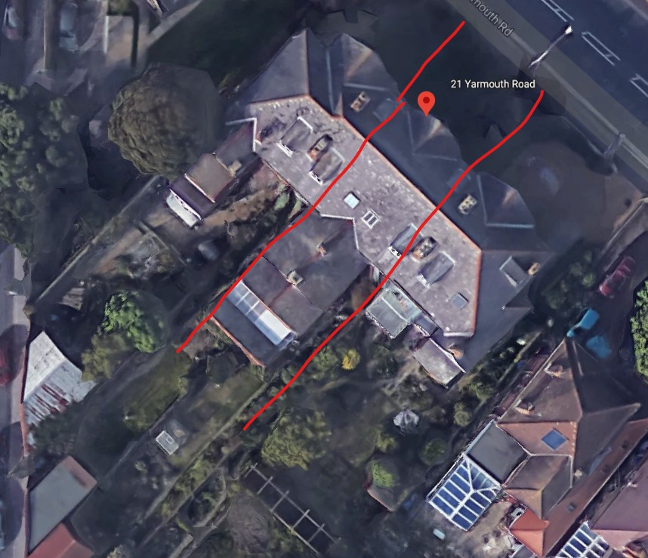
21 Yarmouth Road Lowestoft Suffolk NR32 4AW  Demolition of existing outside WC and Coal House to the rear of the property and replacement with new WC and garden room  Date Description Information 1 Information 2  05/03/2020 Application Form & Certificate  05/03/2020 Design & Access Statement  05/03/2020 Existing Elevations 003  05/03/2020 Existing Floor Plans 005  05/03/2020 Plans Proposed & Existing Site Plan, Block Plan, FP & Elevations  05/03/2020 Proposed Block / Layout Plan  05/03/2020 Proposed Elevations 004  05/03/2020 Proposed Floor Plan 006  05/03/2020 Site / Location Plan  05/03/2020 Site Notice & Neighbourhood Notification SNOTQR | DC/20/1051/FUL  Public comments  Constraints  Related cases  Documents  Map

Rear of 17 Yarmouth Road
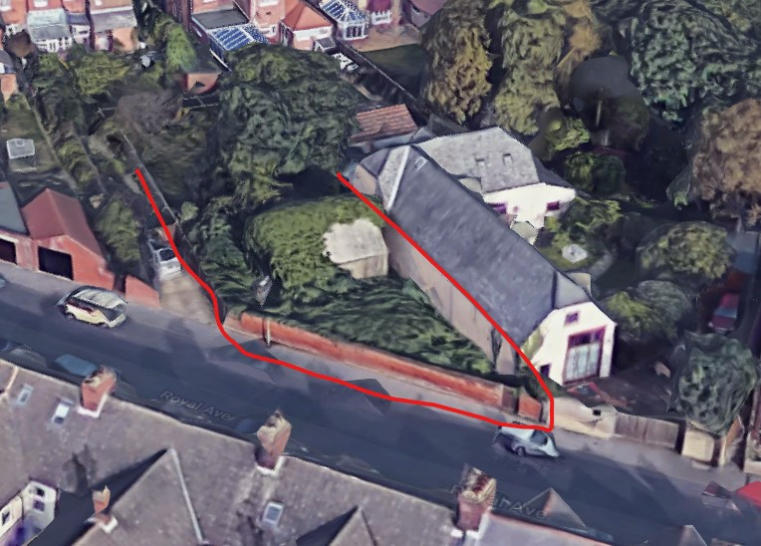
Seen this before. Consultee responses from environmental and highways raise no objection, but list relevant issues they would need to see addressed in the full application. The existing double garage is covered in foliage in the photo above.
Rear Of 17 Yarmouth Road Lowestoft Suffolk NR32 4AW  Outline Application (All Matters Reserved) - It is proposed to demolish the existing double garage on the independant plot of land to the rear of 17 Yarmouth Road Lowestoft and replace it with one single storey dwelling. Access to be provided from Royal Ave.  Date Description Information 1 Information 2  20/03/2020 Consultee Responses Environmental Protection  12/03/2020 Consultee Responses SCC Highways  05/03/2020 Site Notice & Neighbourhood Notification SNOTQR  17/02/2020 Application Form & Certificate  17/02/2020 Contaminated Land Assessment Questionnaire  17/02/2020 Design & Access Statement  17/02/2020 Plans 1/GS/19 Site plan and block plan  17/02/2020 Supporting Documents Cover letter  17/02/2020 Supporting Documents Environmental survey | DC/20/0648/OUT  Public comments  Constraints  Related cases  Documents  Map

113-114 High Street
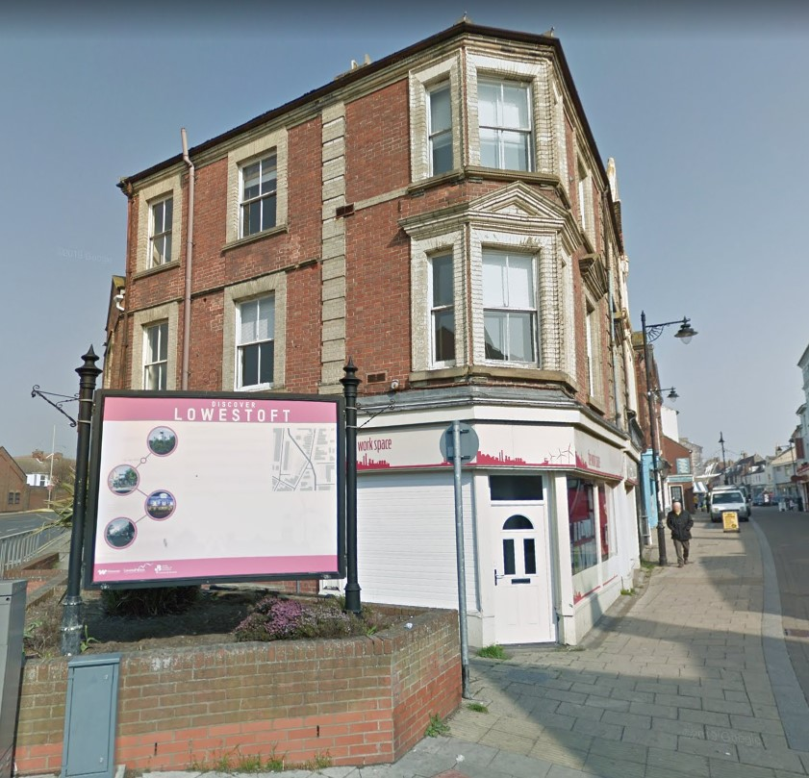
Former Access Community Trust “The Workspace”. Note that the majority of the historic High Street area is commercial below with residential above. Building is not listed, but is within the Heritage Action Zone.
113 - 114 High Street Lowestoft Suffolk NR32 1HN  Change of Use - Upper floors - office to flats/residential.  Date Description Information 1 Information 2  20/03/2020 CIL Additional Questions form  17/03/2020 Site Notice & Neighbourhood Notification SNOTQR  12/03/2020 Plans 2528.19.2 Existing gound, first and second floor plan, proposed and existi  12/03/2020 Plans 2528.19.3 Site location plan, proposed second floor plan, first floor plan  11/03/2020 Application Form & Certificate  11/03/2020 Contaminated Land Assessment  11/03/2020 Contaminated Land Assessment Contaminated Land  11/03/2020 Contaminated Land Assessment Envirosearch  11/03/2020 Contaminated Land Assessment Envirosearch Residential Risk Assessment  11/03/2020 Contaminated Land Assessment Misc  11/03/2020 Contaminated Land Assessment Questionnaire  11/03/2020 Design & Access Statement  11/03/2020 Flood Risk Assessment | DC/20/1125/FUL  Public comments  Constraints  Related cases  Documents  Map

31 Ontario Road
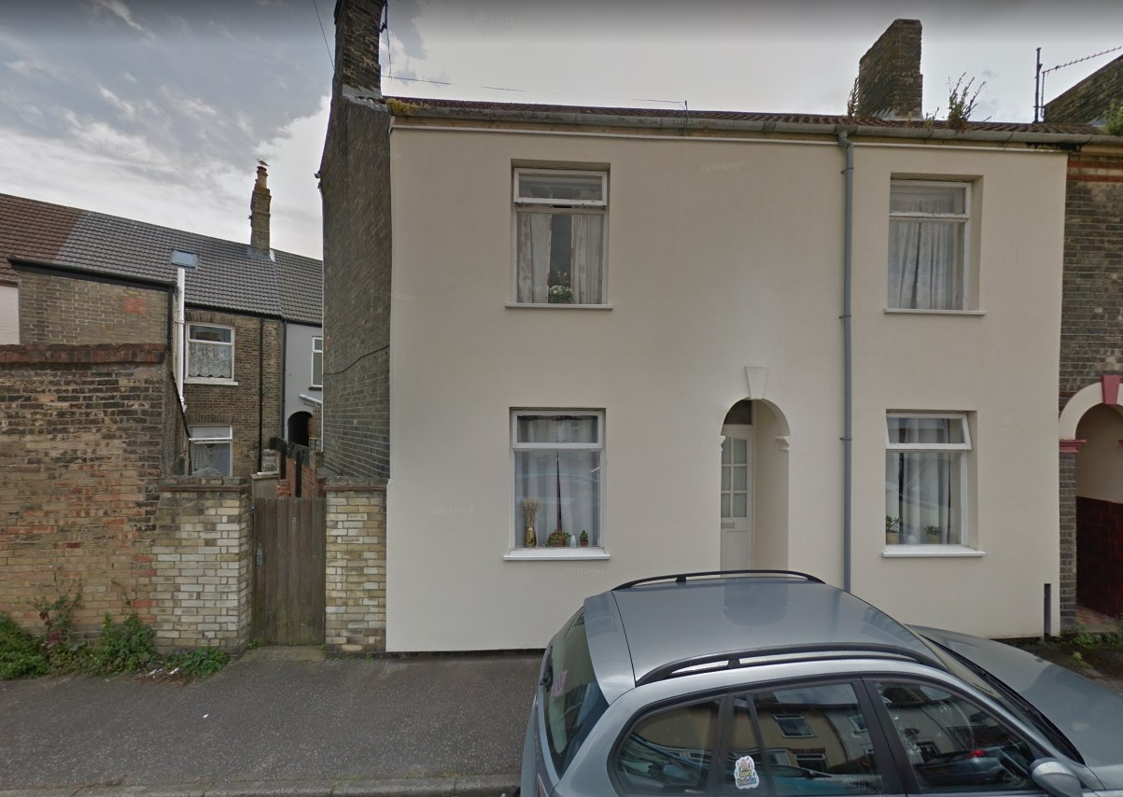
3 neighbour objections
Ms Green: Concern over sewerage capacity, where additional bins would be stored, car parking and additional noise.
Mrs Neve: Loss of privacy due to access at rear of the property. Concern over sewerage capacity. Insufficient free street car parking. Allowing this development would result in further similar applications in the area. Concern over property values in the area.
Mrs Coult: Concern over sewerage capacity. Disturbance due to increased access to rear of the property. Insufficient street car parking facilities. Allowing this development would result in further similar applications in the area. Concern over property values.

31 Ontario Road Lowestoft Suffolk NR33 0EU  Convert house into a small two bedroom house and a one bedroom bedsit  Date Description Information 1 Information 2  17/03/2020 Neighbour Responses Green 6 St Leonard's Road  17/03/2020 Neighbour Responses Neve 8 St Laonards Road, Lowestoft  13/03/2020 Neighbour Responses Coult 10 St Leonards Road, Lowestoft  12/03/2020 Consultee Responses SCC Highways  06/03/2020 Site Notice & Neighbourhood Notification SNOTQR  06/03/2020 Site Notice & Neighbourhood Notification SNOTQR  04/03/2020 Application Form & Certificate Application form  04/03/2020 Design & Access Statement Design & Access Statement  04/03/2020 Plans Block plan  04/03/2020 Plans Existing plans  04/03/2020 Plans Proposed elevations  04/03/2020 Plans Proposed floor plans  04/03/2020 Plans Site plan | DC/20/1041/FUL  Public comments  Constraints  Related cases  Documents  Map

316 London Road South
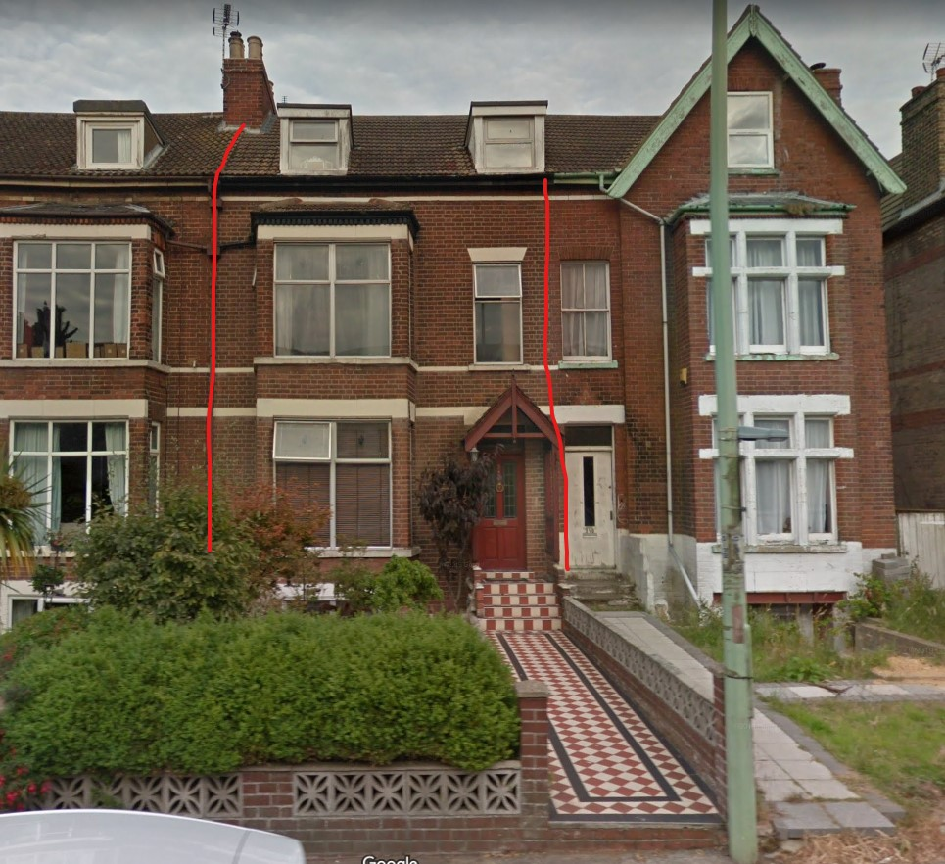
316 London Road South Lowestoft Suffolk NR33 0BG  Change Front Windows  Date Description Information 1 Information 2  09/03/2020 Site Notice & Neighbourhood Notification SNOTQR  06/03/2020 Site Notice & Neighbourhood Notification SNOTQR  19/02/2020 Application Form & Certificate  17/02/2020 Proposed Block / Layout Plan  17/02/2020 Site / Location Plan  17/02/2020 Supporting Documents Existing Windows  17/02/2020 Supporting Documents Heritage, Design & Access Statement  17/02/2020 Supporting Documents Proposed Windows  17/02/2020 Supporting Documents Window Details | DC/20/0654/FUL  Public comments  Constraints  Related cases  Documents  Map

81 Pakefield Street
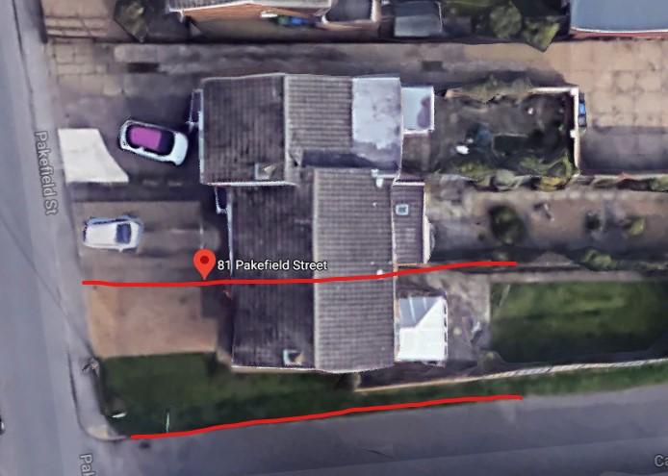
Rear single storey extension on the site of the existing conservatory.

81 Pakefield Street Lowestoft Suffolk NR33 0JT  Proposed rear extension  Date Description Information 1 Information 2  09/03/2020 Site Notice & Neighbourhood Notification SNOTQR  03/03/2020 Plans All Proposed & Existing Plans 2578 - 1C | DC/20/1022/FUL  Public comments  Constraints  Related cases  Documents  Map

1 Hornbeam Close
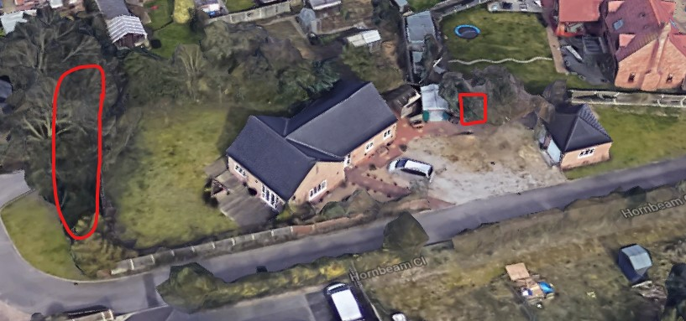
We saw this application recently as a TPO to trim back the tree. This is planning permission for a carport under that tree.
1 Hornbeam Close Lowestoft Suffolk NR33 9GD  Proposed sunroom and carport  Date Description Information 1 Information 2  16/03/2020 Amended Plans & Documents 2602.20.2B Initial proposals- carport  13/03/2020 Site Notice & Neighbourhood Notification SNOTQR  12/03/2020 Application Form & Certificate  12/03/2020 Plans 2602.20.1 Initial proposals- extension | DC/20/1152/FUL  Public comments  Constraints  Related cases  Documents  Map

Birds Eye Ltd, Whapload Road
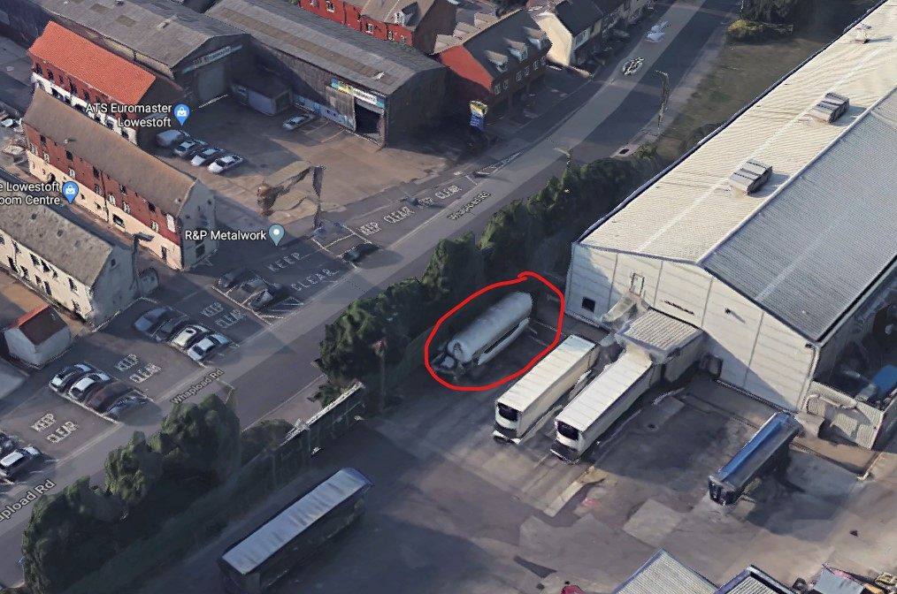
This is related to a CO2 gas tank behind a hedge, opposite ATS Euromaster by Whapload Road.
Birds Eye Ltd Whapload Road Lowestoft NR32 1XQ  This proposal seeks planning permission to remove the existing horizontal vessel and install an insulated vertical Co2 Vessel adjacent to the South West elevation of Denes 4 production building.  Date Description Information 1 Information 2  19/03/2020 Site Notice & Neighbourhood Notification SNOTQR  18/03/2020 Existing Floor Plans 214699-100-P1 RC Concrete Base design for BOC Vessel RC details and sections  18/03/2020 Existing Floor Plans 214699-101-P1 RC Concrete Base design for BOC Vessel  18/03/2020 Photographs Existing elevations  18/03/2020 Photographs Existing elevations  18/03/2020 Photographs Existing elevations  18/03/2020 Proposed Block / Layout Plan AG-00-LA-0093-0001  16/03/2020 Flood Risk Assessment  16/03/2020 Proposed Elevations 01  16/03/2020 Proposed Floor Plan Linde Vessels  16/03/2020 Site / Location Plan  16/03/2020 Supporting Documents Linde Vessels | DC/20/1173/FUL  Public comments  Constraints  Related cases  Documents  Map

118-119 Bevan Street East
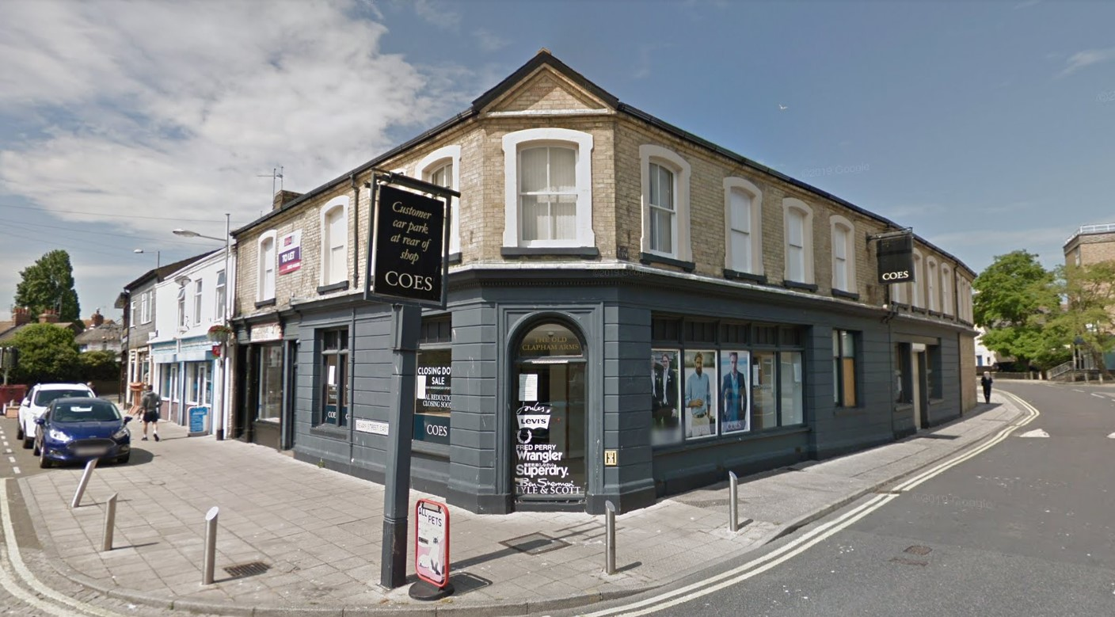
The former Coes building.
118-119 Bevan Street East Lowestoft Suffolk NR32 2AG  Change of use from shop to flats sub-division of existing shop into 2 smaller units  Date Description Information 1 Information 2  20/03/2020 CIL Additional Questions form  19/03/2020 Site Notice & Neighbourhood Notification SNOTQR  13/03/2020 Application Form & Certificate  13/03/2020 Contaminated Land Assessment Envirosearch  13/03/2020 Contaminated Land Assessment Questionnaire  13/03/2020 Design & Access Statement  13/03/2020 Flood Risk Assessment 2452/RE/01-20/01  13/03/2020 Plans 2550.19.1 Existing & Proposed Floor Plans  13/03/2020 Plans 2550.19.2 Proposed & Existing Block & Site Plans | DC/20/1169/FUL  Public comments  Constraints  Related cases  Documents  Map

22 Belmont Gardens
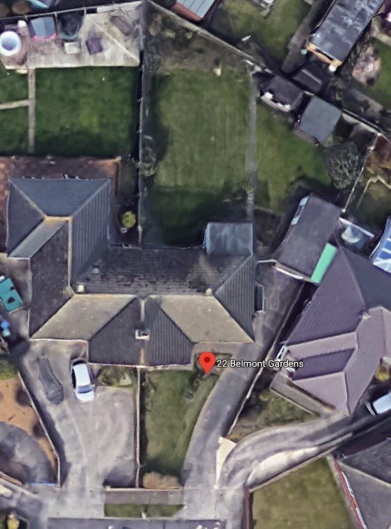
A rear extension of similar size and shape to the neighbour (left in photo).
22 Belmont Gardens Lowestoft NR32 4EJ  Rear single storey extension  Date Description Information 1 Information 2  19/03/2020 Existing Elevations  19/03/2020 Site Notice & Neighbourhood Notification SNOTQR  09/03/2020 Application Form & Certificate  09/03/2020 Existing Floor Plans 03  09/03/2020 Plans 02 Existing & Proposed Block  09/03/2020 Proposed Elevations 05 Side Elevation  09/03/2020 Proposed Elevations 06 Rear Elevation  09/03/2020 Proposed Floor Plan 04  09/03/2020 Site / Location Plan | DC/20/1077/FUL  Public comments  Constraints  Related cases  Documents  Map

11 Sedlescombe Road
11 Sedlescombe Road Lowestoft NR33 9NL  TPO 360 rear garden 1 x Oak - Reduce laterals extending over garden by max 3m, reshape upper canopy to create more symmetrical crown Reason: Reduce encroachment onto garden and increase light transmission  Date Description Information 1 Information 2  10/03/2020 Application Form & Certificate  10/03/2020 Photographs | DC/20/1106/TPO  Public comments  Constraints  Related cases  Documents  Map

1 Hornbeam Close

Address and Description | Planning portal
1 Hornbeam Close Lowestoft NR33 9GD  TPO 341 Tree belt (shared ownership) - Reshape all laterals extending over property back to the boundary fence line. Reason - Reduce encroachment.  Date Description Information 1 Information 2  10/03/2020 Application Form & Certificate | DC/20/1107/TPO  Public comments  Constraints  Related cases  Documents  Map

