Planning notes 17/12/19

Wilkinsons, Gordon Road
Note that this application is on the planning portal as DC/19/4324/ADN, not /ADI.
The site/location plan shows 1 Gordon Road, the CAB building. This does not match the elevation, which shows the former Age UK shop on London Road South. The application title implies the Wilkinsons shop on Gordon Road.
As the elevations are clearly inconsistent with the address and block plan, at this point the application probably should be rejected. However, assuming the application is for the shop face on London Road South, the illumination looks consistent with other shops in the area.
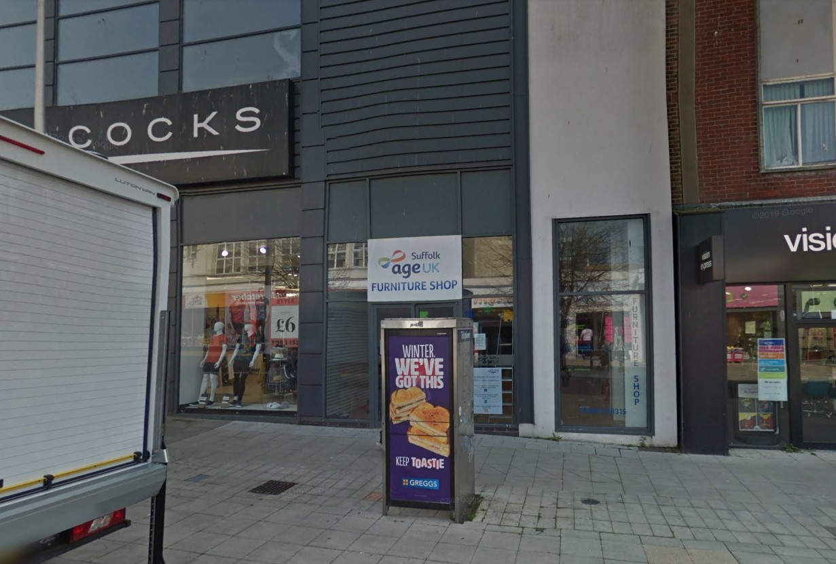
Wilkinsons Gordon Road Lowestoft Suffolk NR32 1HA  Non Illuminated and Illuminated Advertisement Consent - Installation of externally illuminated fascia and non illuminated projection and wall mounted panel  Date Description Information 1 Information 2  05/11/2019 Plans Proposed plans  05/11/2019 Plans Site plan  22/11/2019 Site / Location Plan  03/12/2019 Plans Elevations  04/12/2019 Consultee Responses SCC Highways  04/12/2019 Site Notice & Neighbourhood Notification SNOTQR | DC/19/4324/ADN  Public comments  Constraints  Related cases  Documents  Map

107 Park Road
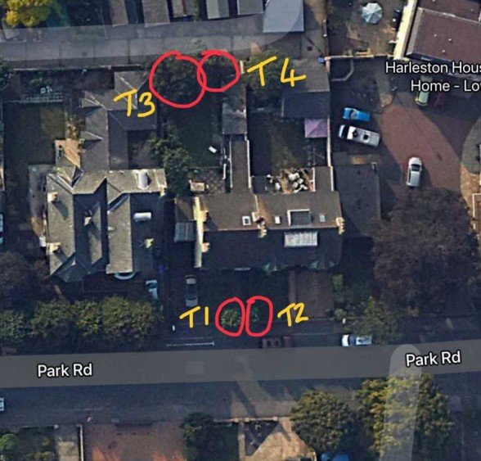
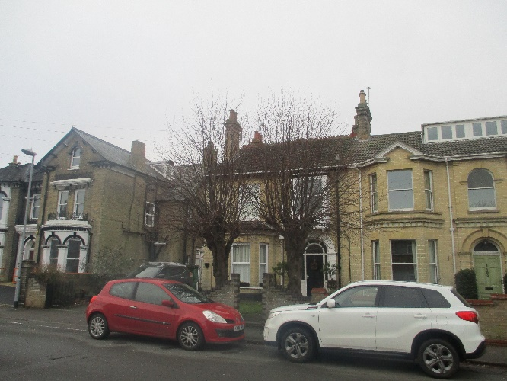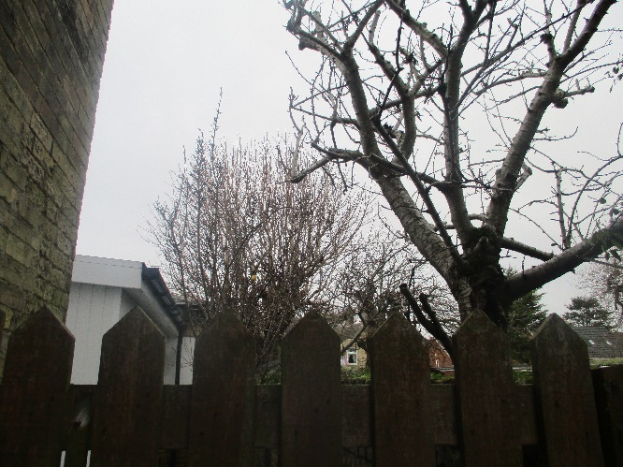

107 Park Road Lowestoft NR32 4HU  T1 & T2 Lime - Re-pollard to previous points for general maintenance Rear garden, T3 Lime Horse Chestnut (showing some signs of decline) - Cut back to previous pollard points to try and stimulate growth, T4 Horse Chestnut - Reduce the overextended branch along the fence line by 50% to reduce the lever  Date Description Information 1 Information 2  26/11/2019 Application Form & Certificate  26/11/2019 Photographs | DC/19/4631/TCA  Public comments  Constraints  Related cases  Documents  Map

34-36 London Road North
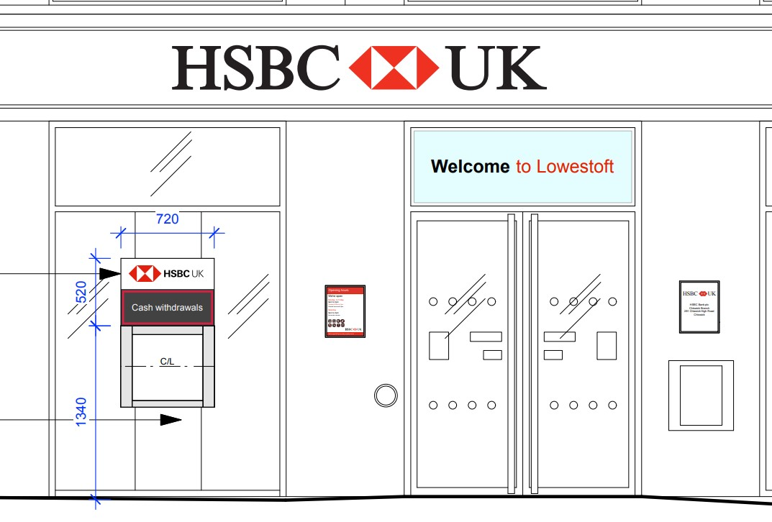
34 - 36 London Road North Lowestoft Suffolk NR32 1EW  Illuminated Advertisement Consent - Replacement of existing ATM header signage to comply with new HSBC branding.  Date Description Information 1 Information 2  06/12/2019 Application Form & Certificate  06/12/2019 Heritage Statement  06/12/2019 Plans 19230 363 PA 05 Existing london road north elevation  06/12/2019 Plans 19230 363 PA 15 Proposed london road north elevation  06/12/2019 Site / Location Plan And block plan  09/12/2019 Consultee Responses SCC Highways  09/12/2019 Site Notice & Neighbourhood Notification SNOTQR | DC/19/4748/ADI  Public comments  Constraints  Related cases  Documents  Map

1 Ashness Close
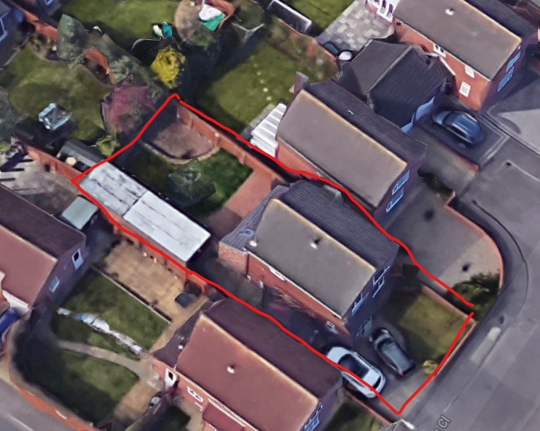
A rear extension. Note the next-door neighbour already has a house of similar size to the final size of the proposed development.
Address and Description | Planning portal
1 Ashness Close Lowestoft Suffolk NR32 4UW  Proposed first floor rear extension  Date Description Information 1 Information 2  09/12/2019 Application Form & Certificate  09/12/2019 Plans 102 Existing elevation/floor/block  09/12/2019 Plans 201A Proposed elevation/floor/block  09/12/2019 Site / Location Plan  09/12/2019 Site Notice & Neighbourhood Notification SNOTQR | DC/19/4755/FUL  Public comments  Constraints  Related cases  Documents  Map

