Report for LTC from The Ness 2019
Jo Leverett - 10 September 2019
The Ness successful events

The Audience Development plan developed with Tricolor Ltd and LTC/ESC contained the research which fed into the Activity plan.
Different areas were identified and in order to engage as much of the community, holiday makers, and visitors to the area as possible, this was further broken down into various age groups.
Environment
Heritage
Play & Create
Wellbeing

This short report concentrates on successes so far for discussion by LTC. A full report in all the activity will be available in December 2019.
More will follow next month.

PAGE 2 Beach School
PAGE 5 Rise & Shine photography Competition and Exhibition
PAGE 8 Secret Cinema
PAGE 10 Small Fry

BEACH SCHOOL

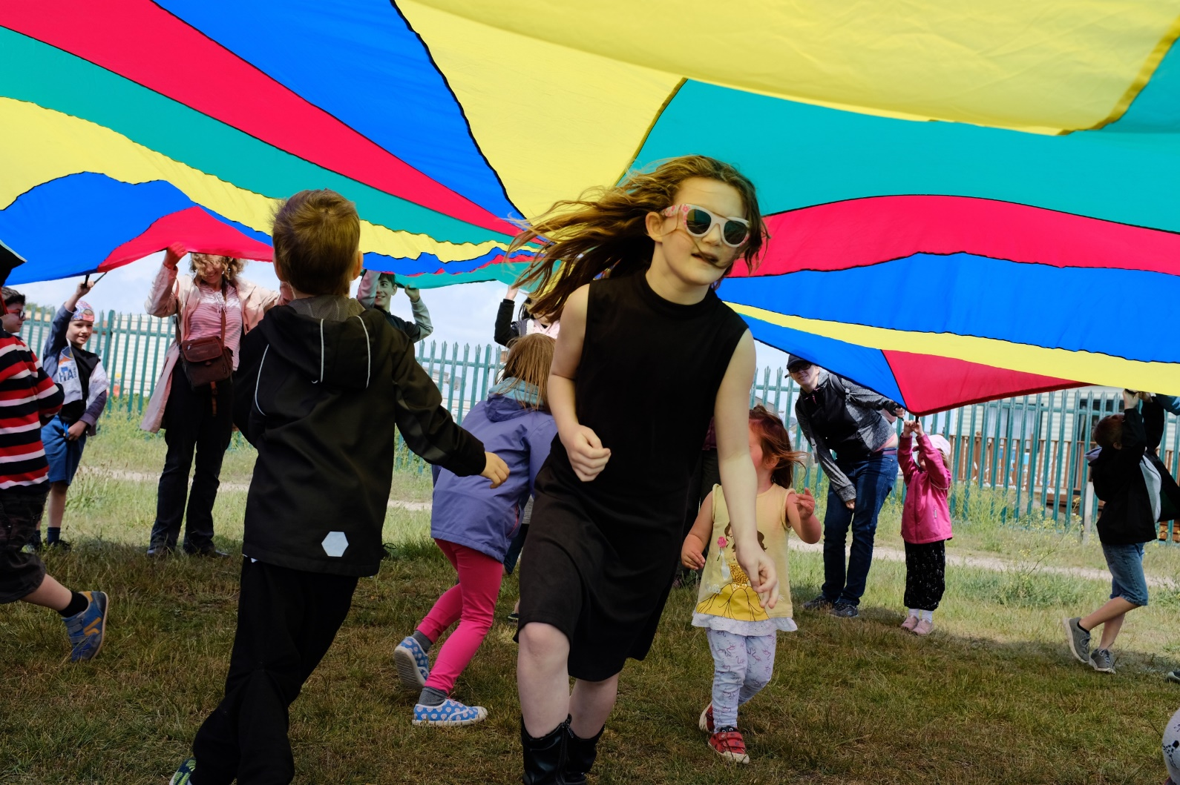

Beach School has been a collaboration between The Ness and East Coast College to deliver a series of 3 outdoor learning experiences for children.

The first was held in May and saw 75 children and adults meet at Ness Point to discuss the most easterly point, orient themselves in relation to the rest of the world and take brass rubbings from the Euroscope. We then travelled along the sea wall to The Ness, playing a pre prepared game of I Spy and spent some time talking about emotions and wellbeing. The children were encouraged to manage emotions by taking time out, using breathing techniques, and thinking about their place in the environment. The session ended at The Ness where we talked about the new park and what used to be there – The Grit beach village, a place where rope was made and the heyday of the herring trade. The children then did group art workshops.

The second Beach School in July saw 80 attendees starting from Lowestoft Maritime Museum where we looked at the new site for the park, travelled along the sea wall to the North Denes beach where the children looked at beach safety and flags, rocks and geology, wellbeing, Rock pooling and nets, Identifying the sea life and using magnifying glasses, Drawing, Group Art and Rock painting
The final one, scheduled for October, will centre around Lighthouses with a free visit to the Lowestoft Maritime Museum for attendees, storytelling, lantern crafting, and a possible visit to Movie Makers.

BENEFITS
East Coast College are using students to help deliver Beach School which contributes to their teaching training qualification
Following the second Beach School East Coast College have a decided to look at running similar schemes in communities across East Anglia and are looking for funding streams to develop the ideas further.

Feedback
Will defo come to the next one!
My son is 10 and autistic and having a tough time at the moment. There’s nothing else like this in Lowie, it’s all in Ipswich. Really pleased and we will definitely come again.
I’d have had 8 people including the kids round at mine so it’s great to get them out!
More please!
Both the kids loved it. We will come to the next one.
I saw it on Lowestoft Journal website and Facebook.
Thanks for a lovely morning! My children thoroughly enjoyed it, as did I!! Hats off to you all!

2020 Actions
Book 4 Schools with East Coast College – 1 for each season

MAY BEACH SCHOOL – FACEBOOK JULY BEACH SCHOOL - FACEBOOK

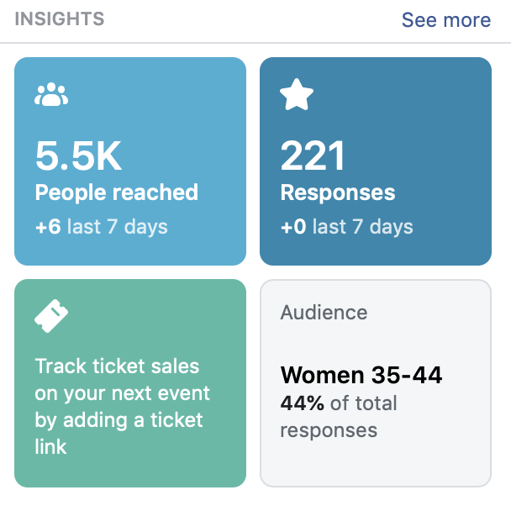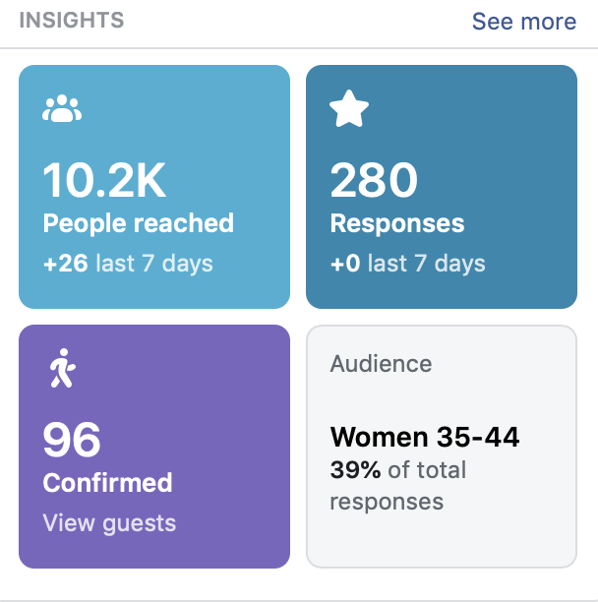

BEACH SCHOOL COSTS

Beach School | attendees | Family beach schools at Ness Point/Denes | COSTS | Projected | Actual
29/05/2019 | 75 | EAST COAST COLLEGE;  2 trainee teachers/3 experienced teachers | East Coast College £300 x 3 | £900.00 | £900.00
24/07/2019 | 80 | EAST COAST COLLEGE;  2 trainee teachers/4 experienced teachers/1 art consultant | PA hire | £100.00 | £100.00
23/10/2019 | TBC | 2 trainee teachers/4 experienced teachers/1 art consultant – partner with LMM | Facebook | £50.00 | £26.00
 |  |  | LMM entry |  | 50.00
 |  |  | Posters/Fliers | £100.00 | £50.00
 |  |  | TOTAL | £1150.00 | £1126.00

RISE & SHINE
Photo Competition and exhibition

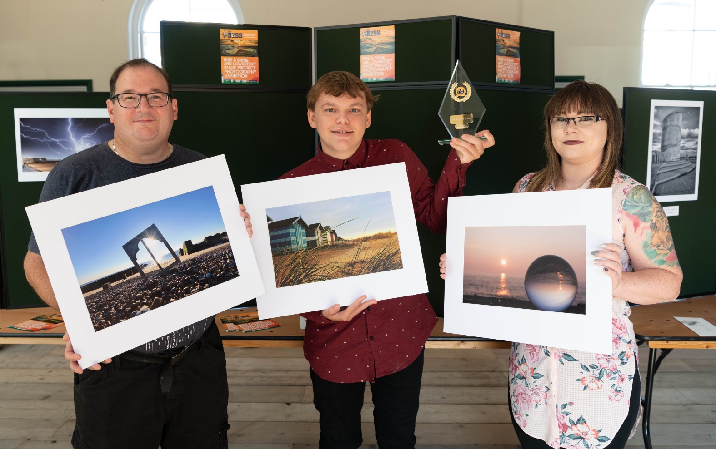

The Rise & Shine Competition was run in conjunction with Lowestoft Photographic Club (LPC) as part of their wider project to gather contemporary images of Lowestoft during 2019.

Entries were encouraged with the heading ‘Rise & Shine’, emailed to LPC and were uploaded onto a dedicated section of the website (https://lowestoftimageprojec.photoshelter.com/gallery/Rise-and-Shine-Competition/G0000VXE5hoSEbU8/) and from there uploaded on to Facebook for judging by the public. LTC wanted it to be a public vote and Facebook was the easiest way to deliver this.
The photos with the most ‘likes’ were the winners.

The winners were
Joshua Freemantle – 151 likes
Jenifer Everett-Day – 114
Andrew Lees – 74

The exhibition was made up of images from the Lowestoft Image Project chosen by the Mayor, Alice Taylor and the winners of the competition.

BENEFITS
Using Facebook to find the winners the competition self publicises itself and the exhibition.
Joshua’s photo was shared 89 times, there were 177 visitors to the exhibition, over 10k people engaged with the Exhibition online.
The exhibition and photos were publicised in the Lowestoft Journal with a full page.
Lowestoft doesn’t have a photo competition.
LPC has seen a boost in numbers – they will confirm how many after the AGM in Sept.
Andrew Lees photo and comments have been included in the Cultural Strategy which is in development for Lowestoft.
Traffic for Lowestoft Station Parcel Office – a new exhibition space.

FEEDBACK
Andrew Lees: I took up photography as a hobby about 2 years ago after moving to the coast. My partner brought me a camera to help me cope with the severe depression and anxieties that I have suffered with for the last 30 years.
I like to spend at least 5 minutes of every day on the beach as it helps me to relax and sets me up for the daily struggles I face within myself.
My partner Tracy encouraged me to enter the competition as she believes in me and knew it would be a huge confidence boost for me.
I am overwhelmed with 3rd place, it means a lot to me and I hope it will inspire others with depression and confidence issues to get out there and just try something... you may surprise yourself.

Jenifer Everett-Day: Placing 2nd means so much to me, having never had my photography in an exhibition is all very exciting for me.
I entered the competition on a whim, not expecting to get anywhere but thought my photo captured the beauty of the most easterly point in Britain perfectly.

Joshua Freemantle: It was great to see that finally a pretty significant photography competition had been created in Lowestoft, as I've been wanting to enter one for ages.
So, it was great to finally have one to enter and share my photos of our beautiful town that is Lowestoft and to be announced as the winner of the competition is a great honour!

LOWESTOFT PHOTOGRAPHIC CLUB
The exhibition rejuvenated their membership. They had 10 new enquiries about membership and at the latest meeting 3 returning members who hadn’t been back for some time and 3 brand new members came along.

2020 Actions
Get LPC on board – Uploading to Facebook is time commitment which they will need to take on
Get better signage for the exhibition space – or encourage Martin Halliday to invest in this
Reach of Facebook post for the Exhibition
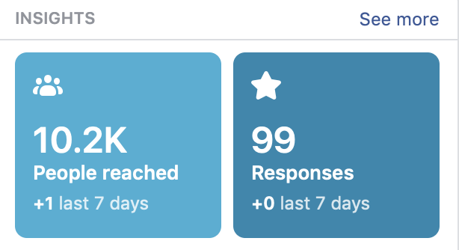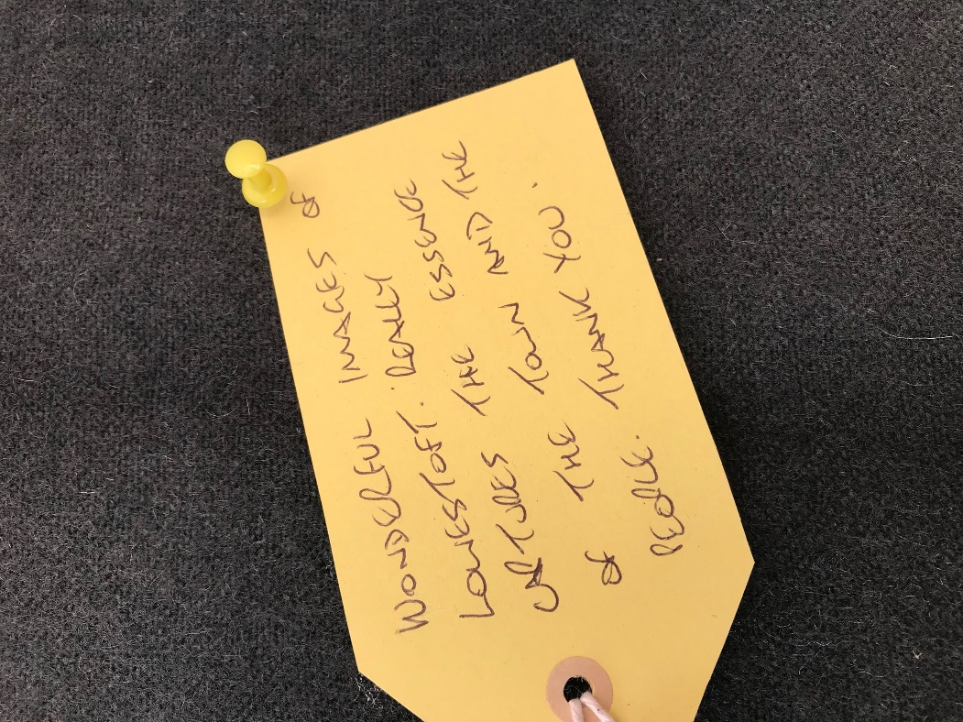

RISE & SHINE | Attendees | Photo Competition and exhibition | Lowestoft Railway station
 | 140 competition entries | Competition | COSTS | Projected | Actual
 | 177 visitors to exhibition | Event launch | Launch | £150.00 | £71.00
 |  |  | Trophy |  | £26.98
 |  |  | Pic framing |  | £12.00
 |  | Exhibition | Printing and mounting | £500.00 | £500.00
 |  | (YET TO BE INVOICED) | Station hire | £100.00 | £100
 |  |  | Facebook exhibition ad | £50.00 | £31.24
 |  |  | Posters Fliers | £300.00 | £159.00
 |  |  | TOTAL | £1100 | £800.22

SECRET CINEMA
The Ness presents; The Greatest Showman

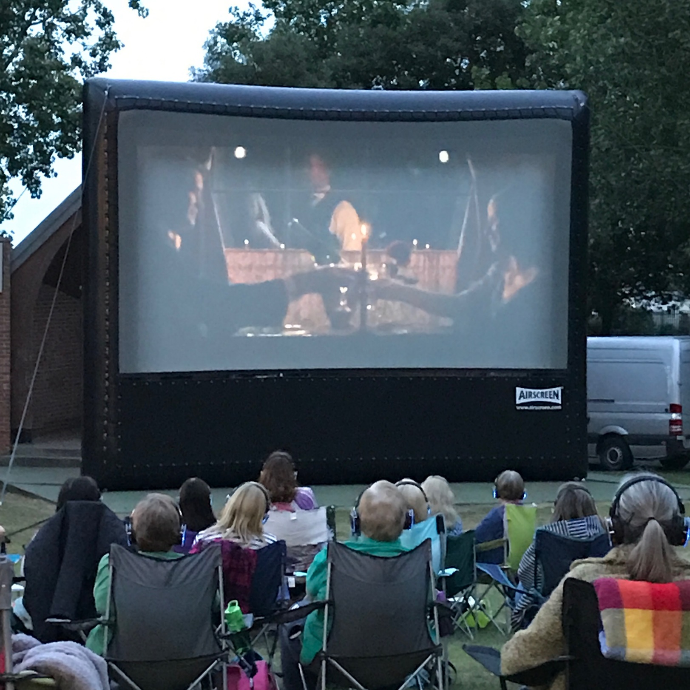

An outdoor cinema event was high on the list of those recommended in the Audience Development plan.
It was thought that The Ness would be under construction and without electricity, so Sparrow s Nest was the best alternative.
There were also concerns about noise from the park – a noise survey would take some time to commission - so a Secret Cinema, with headphones for all attendees was the best solution.

BENEFITS
First ever Outdoor Cinema event in Lowestoft
Free event for 200 residents

FEEDBACK
Enchanted Cinema had zero loss of headphones which is VERY unusual. They thought 500 people at The Ness with a different film would be very easy to manage.
A customer survey asked if attendees would pay next time;
£3 – 35 voted yes
£5 – 30 voted yes
£0 – 2 voted yes
No Reply - 3

2020 Actions
Book Enchanted Cinema to do 500 at The Ness in June – Cost £2000 (2019 prices)
Make payable - £5pp = revenue £2500

Outdoor Cinema | Attendees | Outdoor screening of popular film The Greatest Showman | Sparrows Nest | COSTS | Predicted | Actual
10/07/2019 | 197 tickets issued |  |  | Enchanted Cinema Screen/tech/film rights etc | £1,600.00 | £1,600.00
 | 167 attended | Too many no shows and no way to run waiting list – suggest paid for in 2020 |  | TEN licence | £26.00 | £26.00
 |  |  |  | TOTAL | £1626.00 | £1626.00

SMALL FRY
Summer Holiday Club

A little-known Lowestoft tradition if you don’t have children and live in Lowestoft was ‘Little Sparrows’, a Thursday Summer club which for 26 years has been run by K-Syl-R in partnership with Keable & Flowers Ltd who run Martello’s and Giardino’s in Sparrows Nest.
As K-Syl-R, a husband and wife team, retired this year the Summer club was due to finish. It was a great addition to the suite of events for The Ness Park ad meant that the area could continue the tradition.
Extended from 4 to 6 Thursday afternoons sessions the events ran for the whole Summer holidays from 12 – 3pm

Replacing K-Syl-R seemed nearly impossible. They seemed to offer a cross between a dance workshops, kids disco and children’s entertainer in one session, so a series of events was used to gauge response to another offer.

BENEFITS
Engaging up to 2000 people in movement, games and dance
Lowestoft Maritime Museum – Saw huge uplift in numbers as ran crafting sessions at same time. On events where no PA was used by small Fry they saw far less footfall
Suffolk Wildlife Trust – One session ran alongside SWT’s Marsh in the Move. They saw significant uplift in numbers with 167 visiting their stall against a usually 25-40.

FEEDBACK
Loved it! I used to come and now I bring my kids.
Andy was the best!
We’ve been to every single one with the family and a picnic and made a day of it.

2020 Actions
Book Andy the Clown to cover at least 2 events on The Ness

Summer Holiday Club - Small Fry | Attendees | Sparrows Nest | COSTS | Predicted | Actual
25/07/2019 | 750 |  | Summer Stomp | £250.00 | £250.00
01/08/2019 | 1500 |  | Andy the Clown | £240.00 | £240.00
08/08/2019 | 2000 |  | Andy the Clown | £240.00 | £240.00
15/08/2019 | 2000 |  | Andy the Clown | £240.00 | £240.00
22/08/2019 | 1500 |  | Summer Stomp | £250.00 | £250.00
29/08/2019 | 750 |  | Dance East – yet to be invoiced | £175.00 | £175.00
 |  |  | PA – yet to be invoiced | £250.00 | £100.00
 |  |  | Prizes | £50.00 | £60.00
 |  |  | Facebook | £60.00 | £0.00
 |  |  | Posters/fliers | £300.00 | £120.00
 |  |  | TOTAL | £2055.00 | £1675.00

