Conference and Meeting Room Facilities to Hire

Based on the first floor of Hamilton House on Battery Green Road in the centre of Lowestoft, Lowestoft Town Council has a range of modern meeting rooms available to hire. Parking is available at close by pay and display car parks (Whapload Road and Battery Green Road) or roadside in surrounding streets.

The rooms are fully accessible and some disabled parking spaces are available on site.

The COUNCIL CHAMBER
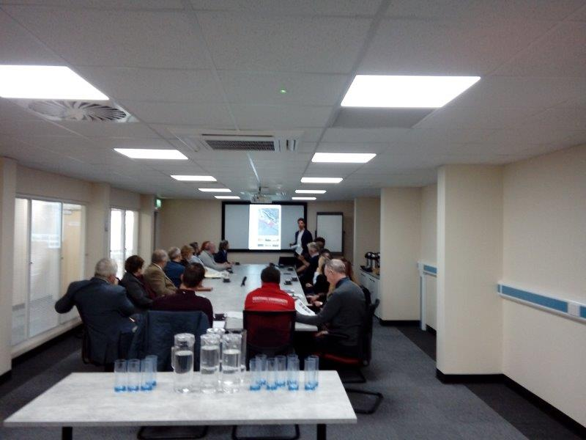

A large meeting room ideally set out Boardroom style but can be adapted to suit your requirements. Capacity to seat up to 22 delegates boardroom style or 60 theatre style. Large screen at front of room with additional HDMI TV screens, at rear for ease of viewing. Hearing Loop. Wifi. Microphone. Flipchart. Air conditioning and heating. The room can be screened with window blinds.
The room can be further extended to incorporate the Lowestoft Room with a hire charge for the whole space.
The LOWESTOFT ROOM
A medium sized meeting room which can seat 15 people boardroom style around a configuration of four or five tables. HMDI TV screen. Hearing Loop. Wifi. Microphone. Flipchart. Air conditioning and heating.

The PLAISIR ROOM
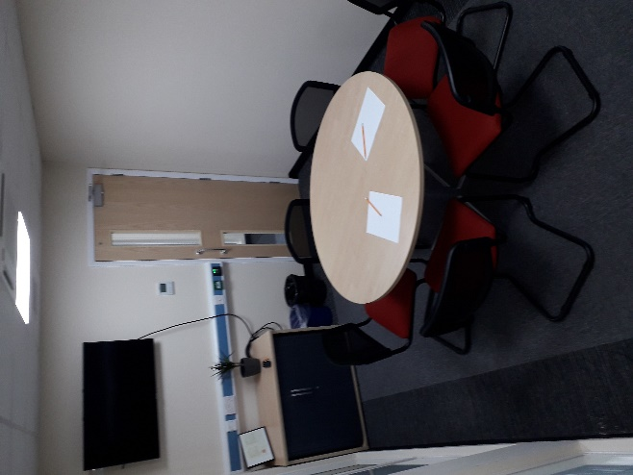
A smaller meeting room with HDMI TV for presentation of documents. A round table can seat six people or the room can be extended to seat eight people at an oblong table. The room can be screened with window blinds.
CHARGES
Room | Full Day | Half Day
Council Chamber | £100.00 | £60.00
Lowestoft Room | £50.00 | £30.00
Extended Council Chamber | £150.00 | £90.00
Plaisir Room | £50.00 | £30.00
The full day rate is based on hire from 9 am to 5 pm. Hire outside of these hours may be possible but will be subject to additional fees and can be confirmed on application.

REFRESHMENTS
Cold water and glasses are provided. Fair Trade Tea and Coffee is charged at £1.50 + VAT per person per serving. Lunch can be organised and is provided by local suppliers on request.
BOOKINGS and CONDITIONS of HIRE
Please complete the attached booking form and return to admin@lowestofttowncouncil.uk or post to Lowestoft Town Council, Hamilton House, Battery Green Road, Lowestoft NR32 1DE.
The Town Council reserve the right to cancel any booking if we have to close the building due to fire, power loss or any other circumstances beyond our control or, if in the Town Council’s opinion, the meeting you are planning to hold could damage the reputation of the Council. If you have failed to pay a previous room hire invoice your booking would also be subject to cancellation.
It is expected that all hirers will leave the room in the condition it is found. The Town Council reserve the right to hold the hirer liable for any loss or damage to Town Council property caused by your or anyone attending your meeting. The Town Council reserves the right to invoice you for the full cost of reparatory or clean-up work.

Conference and Meeting Room Facilities Booking Form

Name

Organisation

Email Address

Postal Address
Telephone Number

Details for invoicing if different to above to be inserted here

I would like to hire the following rooms on
Room | Insert date of hire and start and end time of hire
Council Chamber

Lowestoft Room

Extended Council Chamber

Plaisir Room

Refreshments required YES/NO. If yes, please detail your requirements and what time you would like what served.

What equipment do you need to be provided in your room?

I have read and accepted the conditions of hire and confirm that at the start of my period of hire, the Fire Evacuation Procedure (Appendix One) will be read to all delegates. I accept that all hirers are responsible for the safety of their delegates for the duration of the hire period.
Signed: …………………………………………………………… Date ……………………………………………………..
On Behalf of: ……………………………………………………………………………………………………………………………….+

Appendix One
FIRE EVACUATION PROCEDURE FOR HAMILTON HOUSE

The fire alarms are tested at 9.30 every Monday morning.

There are no fire alarm tests planned for today and so should the fire alarm sound it will be for real

In the event of a fire, please follow the instructions that will be given and congregate on the grass verge to the side of the Kwik Fit Building.

The fire exits are the main stairwell to the reception area and a separate flight of stairs in the ‘Ness Point’ break out area.

