Community Safety – Lighting in Parks

Site visits have been completed at Belle Vue Park (with Cllr Brooks), Fen Park (with Cllr Pearce and Shelley Goddard from Fens of Fen Park) and Normanston Park (with Cllr Lang) regarding lighting in these 3 parks.
On Monday 9th May 2022, a Parks and Open Spaces meeting was held via Zoom. Due to the existing lighting along Yarmouth Road, it was agreed that Belle Vue Park would be left out of future considerations, with an emphasis upon Fen Park and Normanston Park.

Fen Park

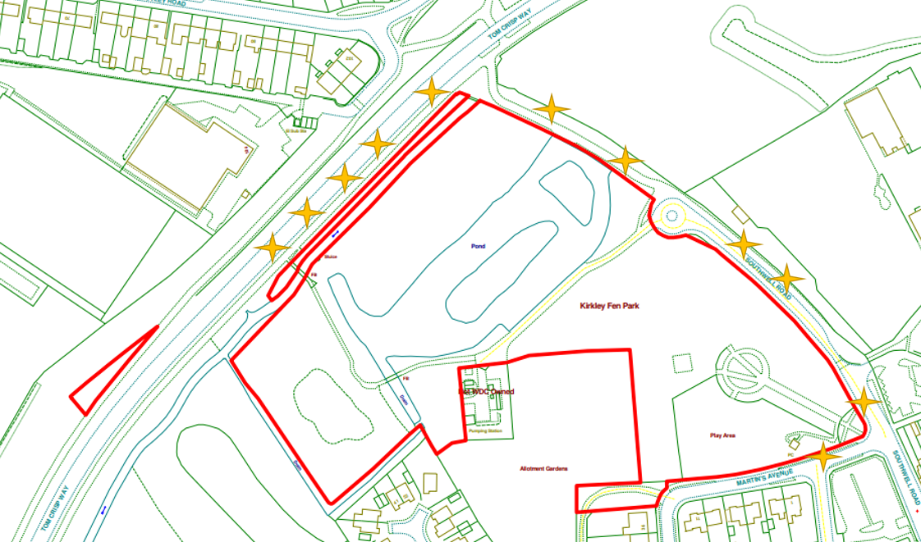
There is sufficient LED lighting along Southwell Road through to Tom Crisp Way. The lighting along Tom Crisp Way is blocked by the trees in the park.
Friends of Fen Park were asked to give their suggestions for additional lighting in the park. The blue dots signify these locations on the illustration below;

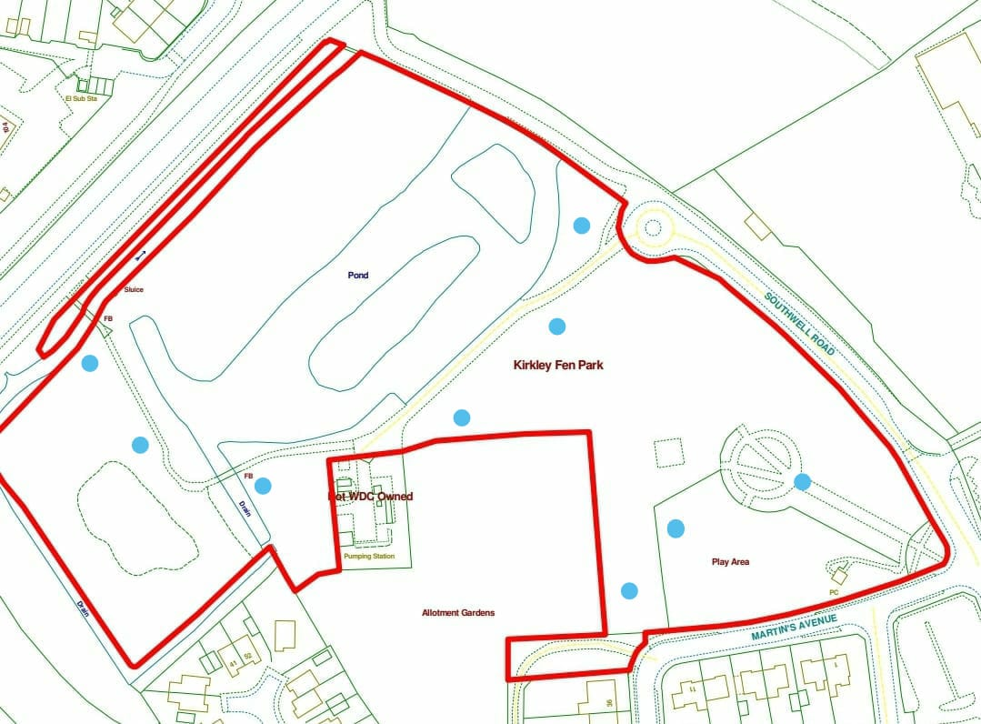

It was suggested that Red Oak Primary should be approached by LTC to discuss any ideas/concerns regarding lighting. I have contacted the school regarding the possibilities of additional lighting and I am awaiting a reply.

Normanston Park

The illustration below shows the lighting which is already installed in and around the park.
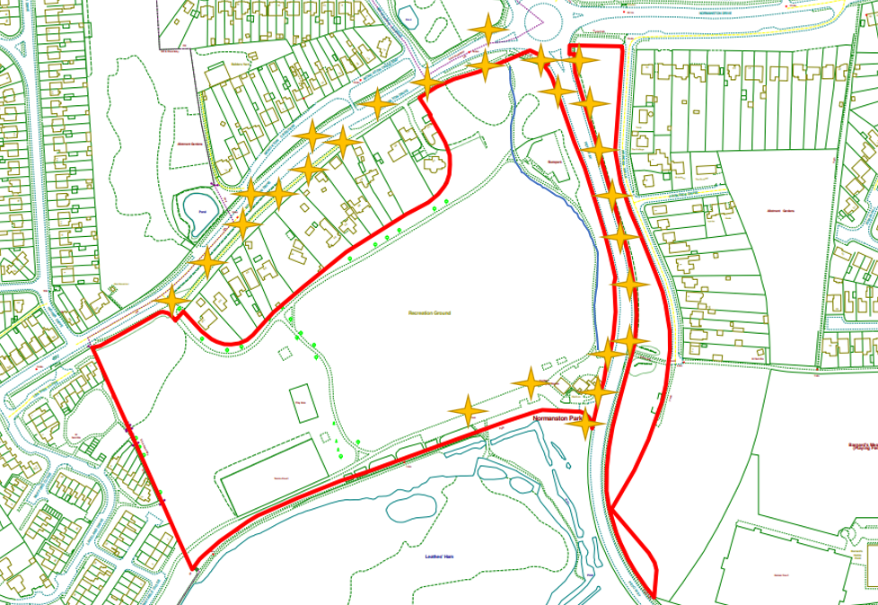

The possibilities of having the established running circuit lit was discussed.
The blue line on the illustration highlights the existing cycle/footpath that links the established paths at the north and south of the park.
I have contacted Suffolk Highways regarding the possibility of installing lighting on this path as a reference to whether it is possible and also the cost implications.
I have also asked them to consider The Fen. I am a waiting a reply and will follow this up in due course.

Jonny Hawes – Community Warden

