BOOKING AGREEMENT
Date: ________________

(1) Lowestoft Town Council

(2)

PARTIES

- The Town Council named in clause 1.1 acting by its management committee (“Town Council”).

Lowestoft Town Council Contact

- Authorised Representative Town Clerk

Address Lowestoft Town Council, Hamilton House, Battery Green Road, Lowestoft
NR32 1DE

Telephone Number 0330 053 6019
Email admin@lowestofttowncouncil.gov.uk

Hirer

- Name

- Organisation

- Name of Organisation’s Authorised Representative

Address

Contact Telephone Numbers
Email Address

Hire Fee

Only fill out section(s) that apply to your hire/event:

- Individual Events (single-use/one-off event)
Date of hire: ____________________
Time:_____________________ hours @ £14 per hour = £ ________________
Deposit (refundable if hall left in good condition – see below) £ ________________
Due one week before hire
BALANCE £ _____________
Commercial Use? Yes/No
This deposit will be refunded within 28 days of the termination of the period of hire provided that no damage or loss has been caused to the premises and/or contents nor complaints made to the Town Council about noise or other disturbance during the period of the hiring as a result of the hiring.

- Regular Events
Date(s) of hire: ____________________
Time:_____________________ hours @ £14 per hour = £ ________________
Deposit (refundable if hall left in good condition – see below) £ ________________
Non-refundable deposit (50% of the cost of the booking) £ ________________
Due by ___________
BALANCE £ _____________
Due by _________
Commercial Use? Yes/No

Premises
Please specify which areas of the building will be used during this event:

Main Hall

Kitchen

Storage of equipment

Purpose/description of hiring

Will this be a public/private event?

Will food be provided at the event?

Premises License & Special Circumstances
The Town Council does not have a premises licence for Whitton Hall, therefore, certain activities such as the sale of alcohol or the performance or playing of amplified music may not be permitted without the hirer obtaining a Temporary Events Notice from East Suffolk Council. At the building is classed as a community hall it may only be open for hire from 8 am to 11 pm. Outside of these hours, licences may also be required for any activities at the hall. The playing of films is only permissible on a not-for profit basis, even film screening to raise funds for a charity are not permitted without a licence.
As part of your application, please indicate if you wish to carry out any of the following as part of your hire:

Activity | Confirm if any of  The following will  take place at your  event
a. The performance of plays
b. The exhibition of films
c. Indoor sporting events
d. Boxing or wrestling entertainment
e. The performance of live music
f. The playing of recorded music
g. The performance of dance
h. Sale of alcohol – even if alcohol is provided as part of an admission fee or by way of charitable donation
i. The provision of hot food/drink after 11pm
j. One-to-one activities with children or vulnerable adults

The hirer agrees not to exceed the maximum permitted number of people per room including the organisers/performers.

Main Hall | 150

Premises Plan – Whitton Hall

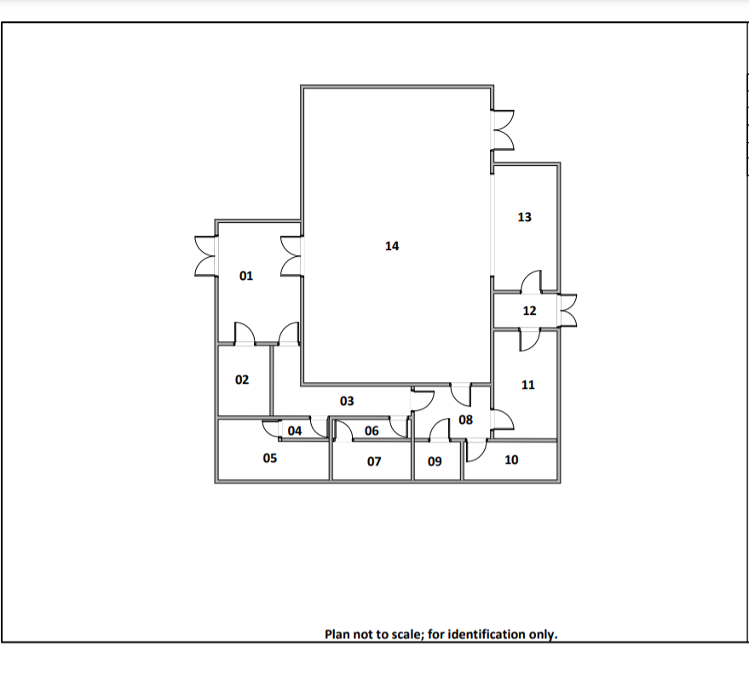

TERMS & CONDITIONS OF HIRE
Agreements with Lowestoft Town Council for the hire of Whitton Residents’ Hall or any part thereof (“the Premises”) are subject to these Terms and Conditions of Hire (“the Hire Conditions”). If the Hirer is in any doubt as to the meaning of the following, the Town Council should immediately be consulted (Tel: 0330 053 6019

Undertaking of the Hirer
The Hirer undertakes to ensure that they have an understanding of the Hire Conditions in force.

Supervision by the Hirer
The Hirer undertakes to be present, or arrange for sufficient adult representatives to be present, throughout the hiring to ensure compliance with the provisions and stipulations contained or referred to in these Hire Conditions and any relevant licenses.

Responsibility of the Hirer
The Hirer shall be responsible during the period of hire for:-
- Complying with, the terms and conditions of hire Hall
- Ensuring that the Premises are kept secure for the duration of the hire
- Supervision of the use of the Premises and the care of its fabric and contents
- Ensuring that the Premises (including foyer, kitchen, kitchen appliances and toilets) are left clean and tidy (and in the condition found). ALL RUBBISH MUST be removed from the site at the end of the hire
- Ensuring that all equipment, chairs and tables have been returned to their storage positions safely, the building is vacant, all lights switched off, and the building secured
- Ensuring that any temporary fittings and fixtures comply with Health and Safety guidance, and in particular ensuring that any decorations used are not a fire hazard
- Ensuring that any equipment or electrical appliances brought onto the Premises and used there shall be certified safe and in good working order, and used in a safe manner.
- Ensuring that no animals (including birds), except assist dogs are brought into the building, without written permission of the Town Council on the occasion of a special event or hire agreed to
- Ensuring that NO animals whatsoever enter the kitchen at any time
- Ensuring that no Barbeques, LPG appliances or highly flammable substances are brought onto the Premises
- Ensuring that they and their attendees recognise the fact that the Premises are situated in a residential neighbourhood and conduct themselves accordingly by, for example, taking care not to slam car doors, especially late at night, and not playing music or making other sounds at inappropriate levels
- Returning keys to key store. Failure to do so will result in non-return of deposit.

Bookings which may be refused
Lowestoft Town Council has the right to refuse any booking for whatever reason, including concern over potential noise levels and potential anti-social behaviour.
Note that intended use for one-to-one activities with children or vulnerable adults is unlikely to be permitted. Any such use should be declared in the booking agreement.
The Residents’ Hall is booked on a first come first serve basis and the Town Council will uphold all pre-existing bookings.

Cancellation
- No charge if cancelled four weeks or more before a booking
- 50% of booking charge is due if cancellation is between four weeks and one week before a booking
- 100% of booking charge is due if cancellation is one week or less before a booking

Payment terms
- For a single booking, payment is due before the event. Payment for the hire of the Residents’ Hall is estimated at an hourly rate of £14
- For any single booking open to the public, which covers its costs by ticket sales or other fund-raising activities at the event, payment is due 30 days after the event.
- When an event, open to the public and covering its costs by ticket sales, requires additional bookings for rehearsal or setup time, then payment for those additional bookings is not due until 30 days after the final fundraising event.
- For a series of bookings, payment is due 30 days after each event.

Deposit
A deposit is required for all events, parties and occasions. If the hall is not left in an acceptable state (the same condition you found it in) deductions will be made before the deposit is returned.

Fire Regulations
The Hirer shall:
- Ensure that the ‘Emergency Exit’ signs are kept illuminated
- Ensure that the Fire Brigade is called to any outbreak of fire, however slight, and details given to the Town Council
- Prior to the start of an event indicate the Fire Exits, Evacuation Meeting Place and Evacuation Procedure to the persons attending the event
- Ensure that all Fire Exits in the Residents’ Hall are kept clear at all times, however if any equipment, e.g. tables or chairs, is positioned close to an exit, the user of the equipment is made responsible for moving it rapidly out of the way of the exits in the event of an emergency
- Ensure that the hall foyer entrance is not blocked with items such as buggies, wheelchairs or mobile scooters

The Evacuation Meeting Place is located at the car park at the front of the building, opposite to the Entrance and adjacent to Whitton Court. No person may re-enter the Residents’ Hall without the permission of the Fire Brigade.

Use of Premises
The Hirer shall not:-
- Sub-let or use the Premises for any purpose other than that described in this documentation
- Use the premises or allow the Premises to be used for any unlawful purpose or in any unlawful way
- Do anything or bring onto the Premises anything which may endanger the Premises or render invalid any insurance policies in respect thereof
- Allow the use of drugs on the Premises
- Allow smoking in the Premises or in the vicinity of the entrances.

Car Parking
Vehicles are parked at owner’s risk and should be parked in marked bays to the front of the hall or at other suitable parking locations in the vicinity. At no times should vehicles be parked on the pavement or block fire exits.

Premises Licence and other relevant legislation
The Hirer is responsible for:
- Ensuring that Alcohol is not served on these premises without prior consent of the Town Council and the necessary TEMPORARY EVENTS NOTICE being obtained from the Licensing Authority (East Suffolk Council).
- Ensuring no excessive noise occurs, particularly late at night or early morning, with a minimum of noise being made by any person on arrival or departure

The Hirer shall ensure that the users:
- Do not contravene the law relating to gaming, betting, and lotteries
- Comply with all conditions and regulations required by the Licensing Act, particularly in connection with events which include public dancing or music, or stage plays, or films, or similar entertainment taking place at the premises.

A breach of this condition may lead to prosecution by the local authority.

Compliance with legislation relating to children or vulnerable adults
For all bookings involving children or vulnerable adults, except private parties where the Hirer is a family member, the Hirer is required to have their own safeguarding policy and must ensure that those who work with young people or vulnerable adults hold a current DBS certificate.
The Hirer shall ensure that any activities at the Premises for children or vulnerable adults comply with current legislation in that regard and that only fit and proper persons have access to children or vulnerable adults. Child Protection Policies are the responsibility of the Hirer.

Indemnity
The Hirer shall indemnify and keep indemnified the Town Council and their employees, volunteers, agents and invitees against:
- the cost of repair of any damage done to any part of the Premises including the curtilage thereof or the contents of the Premises
- against all actions, claims, and costs of proceedings arising from any breach of the Hall Conditions
- all claims in respect of damages, including damage for loss of property or injury to persons, arising as a result of the use of the Premises (including the storage of equipment) by the Hirer
As directed by the Residents’ Hall, the Hirer shall make good or pay for all damage (including accidental damage) to the Premises or to the fixtures, fittings or contents and for loss of contents

Insurance
The Hirer is responsible for ensuring that any catering company or operator hired to bring equipment onto the Premises has relevant and appropriate insurance, which shall include public liability insurance. All other liabilities which may result from the hire must be covered by the hirer and relevant risk assessments must be carried out.
Commercial hirers must provide Public Liability insurance (£5,000,000 minimum indemnity).

Accidents and Dangerous Occurrences
The Hirer must report all accidents involving injury to the public to an officer of the Town Council as soon as possible, and complete the relevant section in the Residents’ Hall’s Accident Book. The hirer shall ensure the appropriate medical assistance is sought, or an ambulance is called.
Any failure of equipment, either that belonging to the Residents’ Hall, or brought in by the Hirer must also be reported as soon as possible.

Stored equipment
The Residents’ Hall accepts no responsibility for any property brought onto or left at the premises and all liability for loss or damage is hereby excluded. All equipment and other property, other than that stored on the premises by agreement, must be removed at the end of each hiring or storage period. The Residents’ Hall may dispose of any such items 7 days thereafter at its discretion, by sale or otherwise on such terms and conditions as it thinks fit, and charge the Hirer daily storage fees and costs incurred in storing and selling or otherwise disposing of the same.

No alterations
Decorations may be hung but no Blu-tack, drawing pins, adhesive tape or similar may be used.
No other alterations or additions may be made to the Premises, and no fixtures may be installed, or placards, or other articles be attached in any way to any part of the Premises without the prior written approval of the Residents’ Hall.
Any alteration, fixture or fitting, or attachment, so approved, shall, at the discretion of the Residents’ Hall, remain in the Premises at the end of the hiring and become the property of the Residents’ Hall or be removed by the Hirer. The Hirer must make good to the satisfaction of the Residents’ Hall any damage caused to the Premises by such removal.

Interruption of Regular Bookings
If a Hirer is a regular weekly user, the Residents’ Hall reserves the right to cancel all, or part of, certain bookings in favour of one-off bookings. Such cancellations shall not occur more than once a month, and at least six weeks’ notice shall be given of such cancellation.
The Residents’ Hall reserves the right to nominate a specified weekday evening as not being available for regular weekly bookings, so that priority can be given to monthly, or less frequent, bookings.

Cancellation by the Hirer
If the Hirer cancels the booking before the date of the event and the Residents’ Hall is unable to conclude a replacement booking, the Residents’ Hall may, at their discretion, require a further payment of hire fees or withhold part of the deposit and hire charge already paid.

Cancellation by the Residents’ Hall
The Town Council reserves the right to cancel a hiring by written notice to the Hirer in the event of a national emergency, or similar force majeur situation that requires the Premises to be closed, or of the Premises being required for use as a Polling Station for a Parliamentary or Local Government election or bye-election or referendum or if the Town Council reasonably consider that:

- such hiring may lead to a breach of the licensing conditions, or other legal or statutory requirements, or
- unlawful or unsuitable activities may take place at the Premises as a result of the hiring, or
- the Premises have become unfit for the use intended by the Hirer
In any such case the Hirer shall be entitled to a refund of any deposit or hire fees already paid, but the Residents’ Hall shall not be liable for any resulting direct or indirect loss or damages whatsoever.

Acceptance
These Terms and Conditions will have been made available to the Hirer at the time of making the booking. By proceeding with your booking you are deemed to have accepted the above terms and conditions for the hire of the hall.

Signed by the person named above, duly authorised, on behalf of the Town Council;

Signature:
Print Name:
Date:

Signed by the person named above, duly authorised, on behalf of the organisation named at above, where applicable;

Signature:
Print Name:
Date:

