Key
Purple dots – proposed new bin
Red dot – existing bin

Belle Vue Park
2 bins listed
1 needed - at the bottom of the Ravine entrance
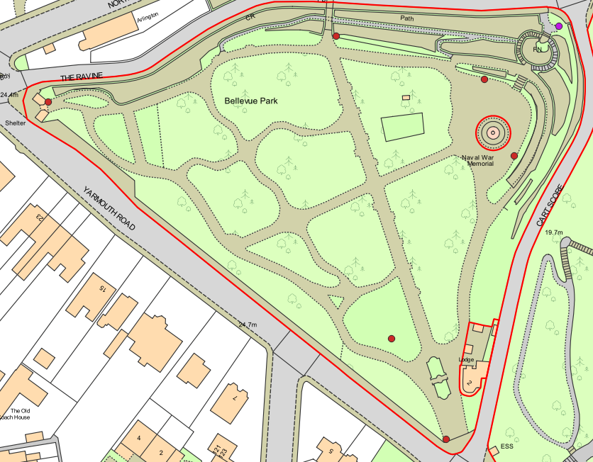

Sparrows Nest
4 bins listed
One at Yarmouth road entrance, one at Cart Score entrance, one at Arnolds Bequest entrance, replacement opposite carpark entrance
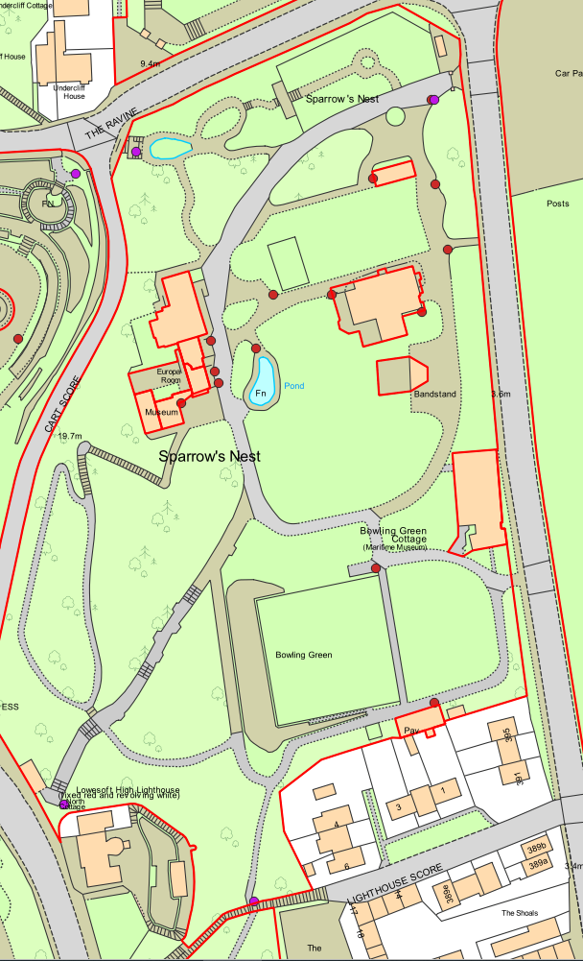

Arnolds Bequest
3 bins listed
One on the fence at Yarmouth Road entrance, one at Whapload Road entrance, one at Lighthouse Score entrance
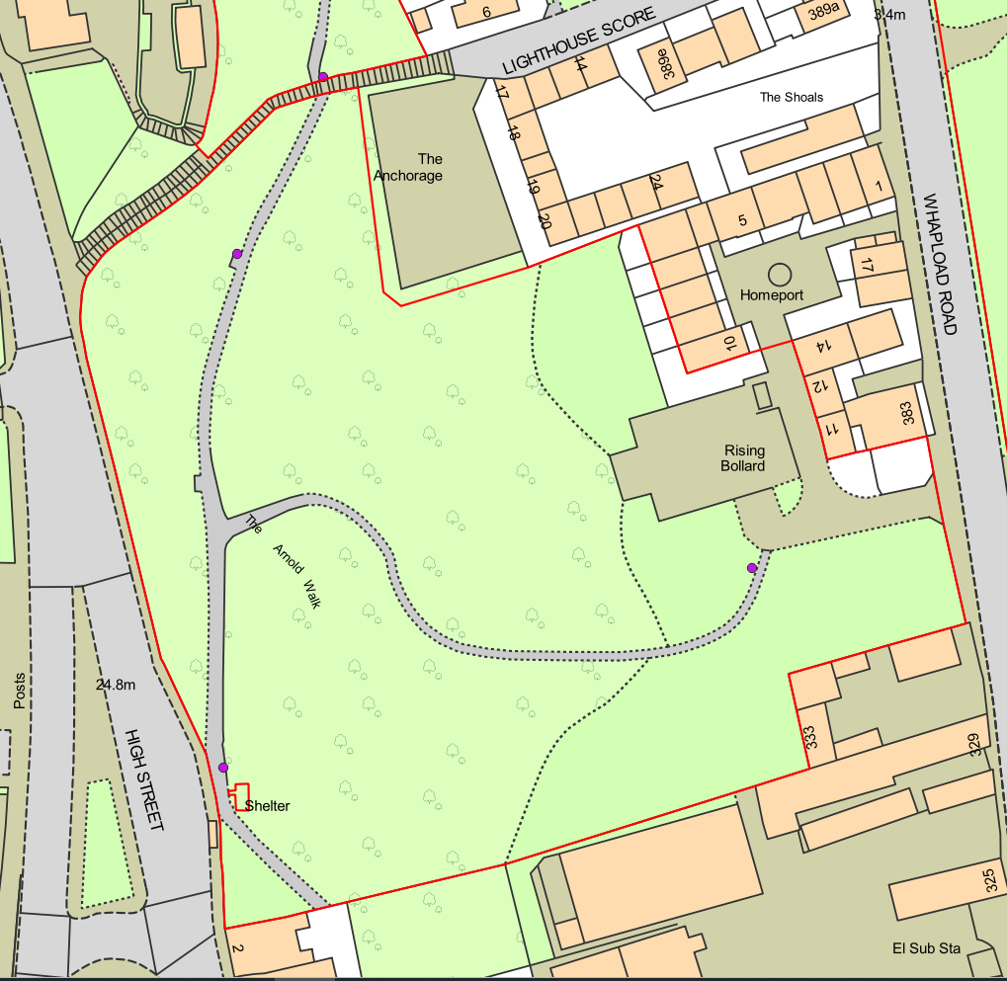

Gunton Community Park
1 bin listed
2 needed - One at Gunton Residents Meeting Hall entrance, one in the park
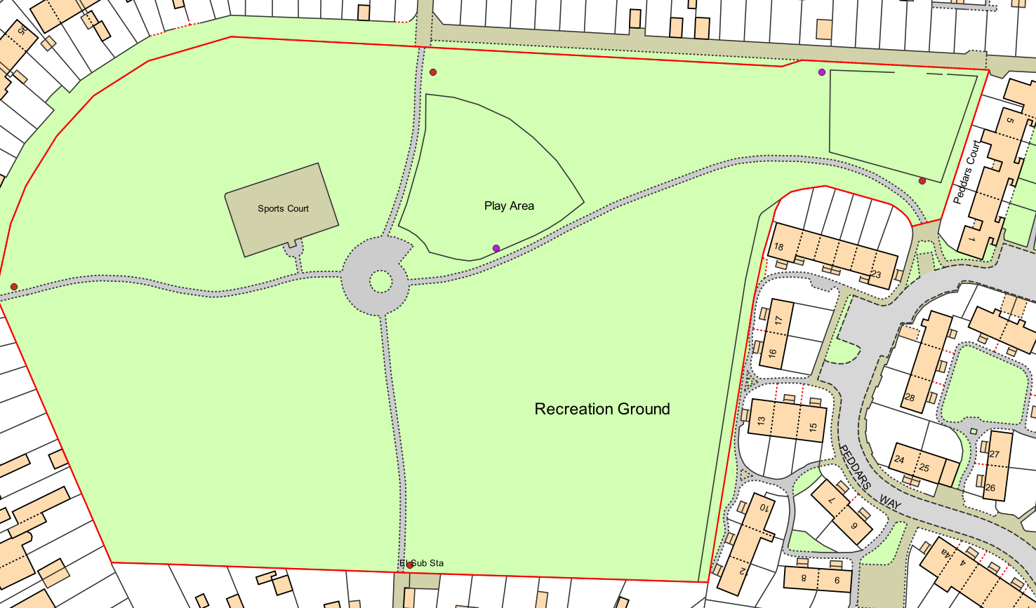

Normanston Park
2 bins listed
3 needed - one at roundabout entrance, one at Normanston Drive entrance, 1 at Constable Close entrance
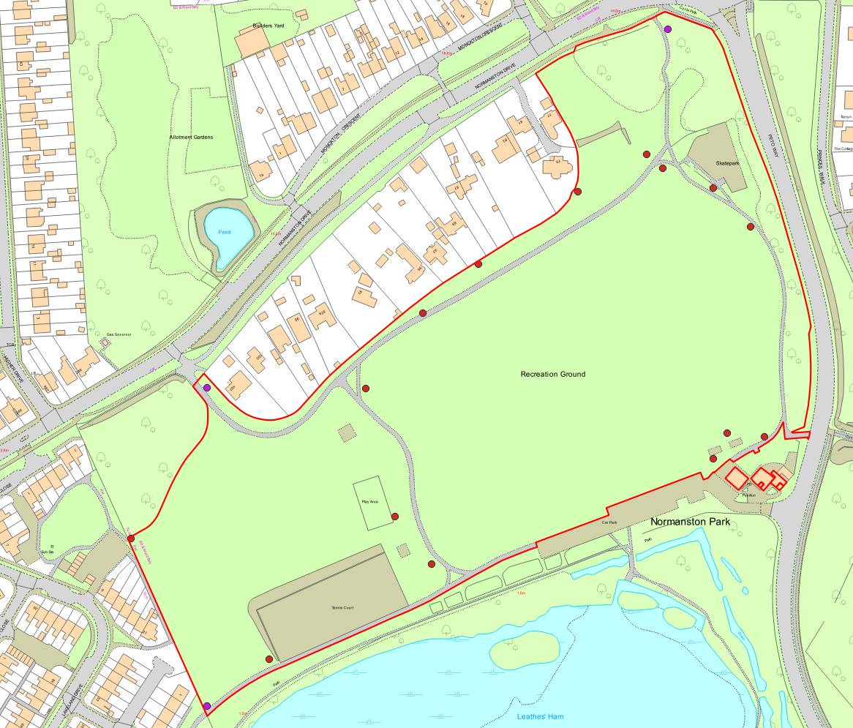

Fen Park
3 bins listed
2 needed - one at Martin’s Avenue, one at Southwell Entrance,
Note – there is a previously unmarked bin at the Tom Crisp Way entrance
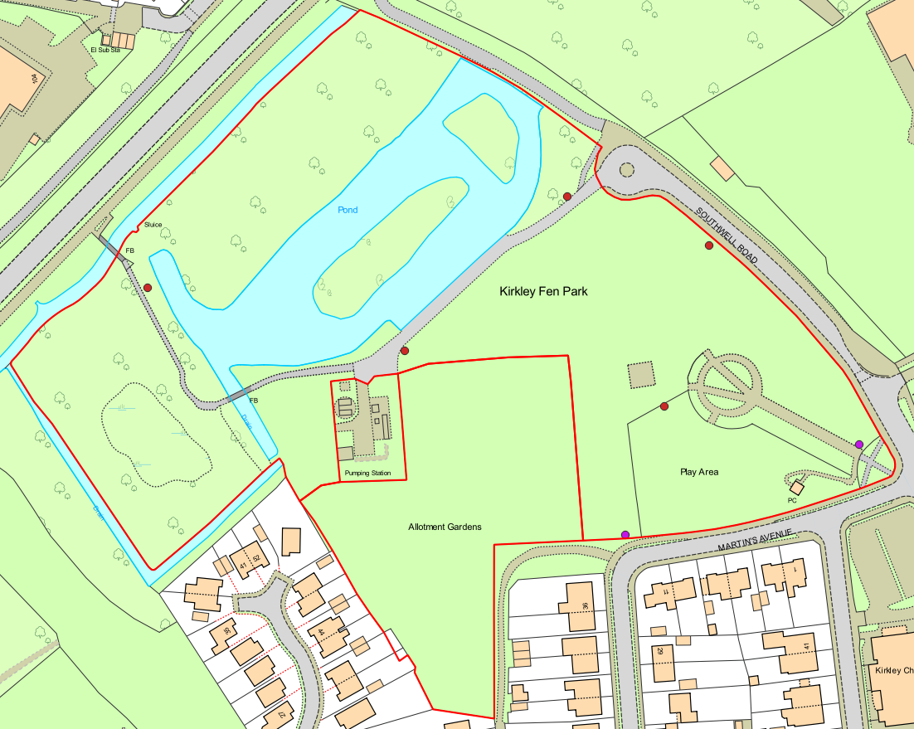

Britten Road
2 bins listed, one at each entrance
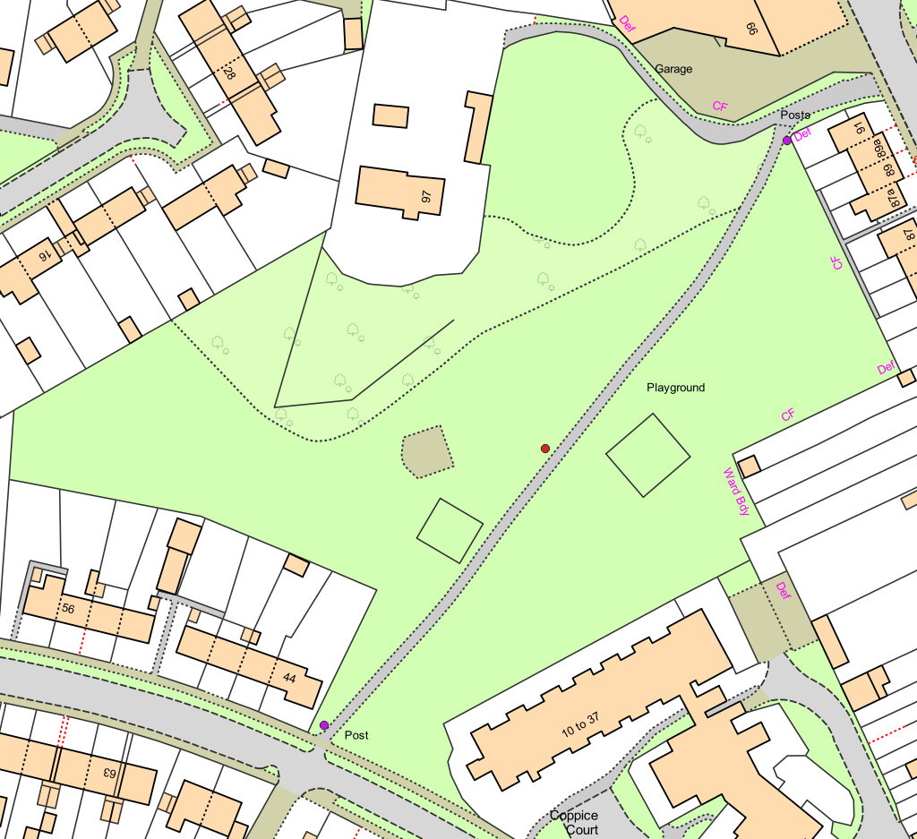

Clarkes Lane
5 bins listed, one at each entrance
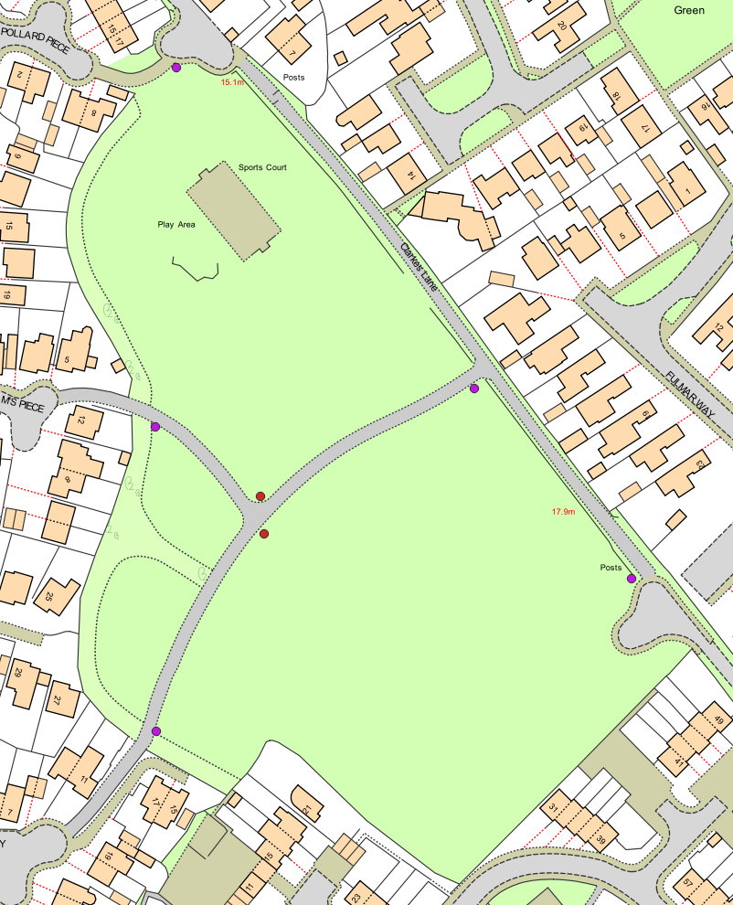

Rosedale Park
2 bins listed
One at Elm tree Road entrance, one at intersection of Elm Tree Road and Long Road entrances
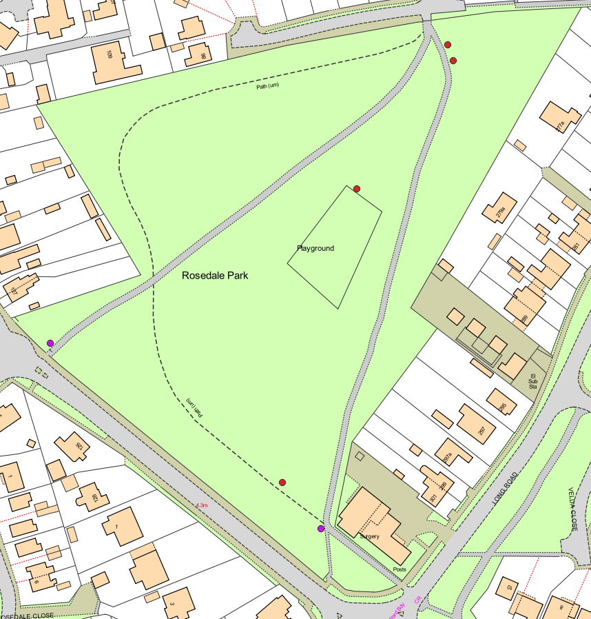

Pakefield Green (Wellington Green Play area)
4 bins listed
1 needed - by the gate separating the play area and green
Note – the Town Council does not own the green itself, only the play area
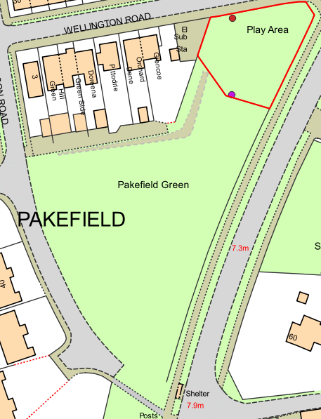

Kensington Gardens
2 bins listed
One needed - at obelisk entrance
Note – there is a previously unlisted bin at the Kensington Road entrance
