Planning notes 9/6/2020

54 London Road North
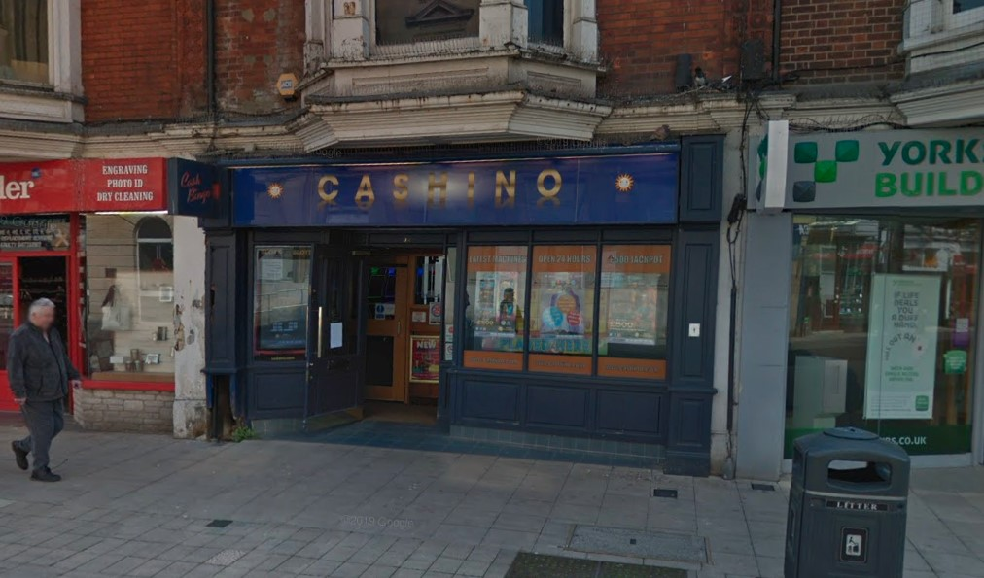
A similar application was previously approved by this committee: DC/19/4486/ADI This proposal makes typographical changes to that approved signage, placing “MERKUR CASHINO” on a single line instead of two lines.
54 London Road North Lowestoft Suffolk NR32 1EP  Illuminated Advertisement Consent - Replacement sign panel with internally illuminated individual letters and logo and replacement projecting sign  Date Description Information 1 Information 2  22/05/2020 Consultee Responses SCC Street Lighting  16/03/2020 Application Form & Certificate  16/03/2020 Existing Elevations 2281 00 Section  16/03/2020 Proposed Block / Layout Plan 2281 04  16/03/2020 Proposed Elevations 2281 01A Section  16/03/2020 Site / Location Plan 2281 03  16/03/2020 Supporting Documents Sign Spec | DC/20/1191/ADI  Public comments  Constraints  Related cases  Documents  Map

87 Normanston Drive
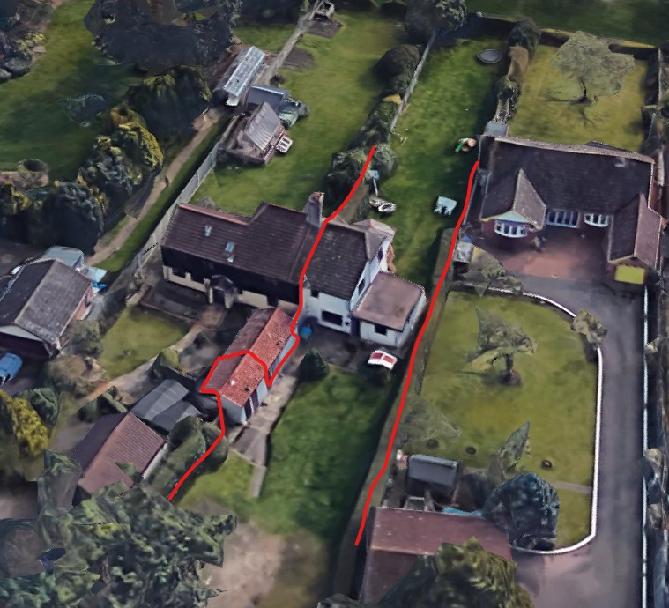
Extending the house to a similar size of neighbouring properties. No neighbour objections received to date.
87 Normanston Drive Lowestoft Suffolk NR32 2PX  Construction of a two storey side and front extension  Date Description Information 1 Information 2  21/05/2020 Info Sheet INFO  20/05/2020 Application Form & Certificate  20/05/2020 Plans 2184.17.1D Existing & Proposed Elevations, FP & Site Plan | DC/20/1852/FUL  Public comments  Constraints  Related cases  Documents  Map

Post Office, 51 London Road North

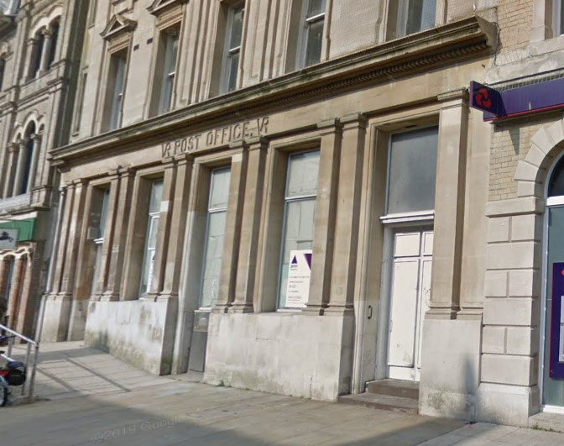
This proposal is back with a revised heritage statement.
Public comments:
Objection from Mr King: Heritage Impact Statement is factually incorrect, particularly 4.4, 4.7.2, 5.5 - he provides historic background. Incompatible with HAZ. Requests that Historic England should prepare a heritate assessment report before demolition commences.
Objection from Mr Castleton: Development not appropriate for area and will harm listed building. Not consistent with design style of the area.
Objection from Ms Brooks:
Other bodies:
Sufffolk Highways: Objection on the grounds of insufficient parking provision, requesting a minimum of 9 spaces.
Historic England: Serious concerns on heritage grounds (submitted 29/4/2020). On 8/6/2020 Cllr Sue Barnard queried if the rear of the building was part of the listing. Melissa Thompson from Historic England has confirmed that “the rear building was specifically excluded from the listing which mean it cannot be considered as curtilage listed.”, which implies Historic England may be reconsidering their objection.
Post Office 51 London Road North Lowestoft Suffolk NR32 1AA  Demolition of existing shed buildings and 3/4 storey brick building to rear of Post Office, including adjoining structures to rear of Post Office. Repair & adaptation to the ground floor of the Post Office building including a new extension to the west and re-fenestration at ground floor level. Erection of flats and houses comprising 9 dwellings, with associated landscaping works.  Date Description Information 1 Information 2  04/06/2020 Consultee Responses SCC Highways  01/06/2020 Consultee Responses Env Protection  01/06/2020 Neighbour Responses King 294 London Road South  21/05/2020 Neighbour Responses Castleton 24 York Road, Lowestoft  15/05/2020 Design & Access Statement  15/05/2020 Existing Elevations Existing Front Elevation LBC-200  15/05/2020 Existing Elevations Existing Rear Elevation LBC-202  15/05/2020 Existing Floor Plans Existing Ground Floor LBC-100  15/05/2020 Plans Existing Section LBC-300  15/05/2020 Plans Proposed Section LBC-301  15/05/2020 Proposed Elevations Proposed Front Elevation LBC-201  15/05/2020 Proposed Elevations Proposed Rear Elevation LBC-203  15/05/2020 Proposed Floor Plan Proposed Ground Floor LBC-101  15/05/2020 Site / Location Plan LBC-001  05/05/2020 Heritage Statement Rev 2  29/04/2020 Consultee Responses Historic England  30/03/2020 Consultee Responses Ecologist  25/03/2020 Neighbour Responses Castleton 24 York Road  24/03/2020 Consultee Responses Historic England  24/03/2020 Ecology Report  24/03/2020 Ecology Report  23/03/2020 Consultee Responses Lowestoft Civic Society  18/03/2020 Consultee Responses Historic England  18/03/2020 Site Notice & Neighbourhood Notification SNOTQR  16/03/2020 Consultee Responses Design  12/03/2020 Town/Parish Consultation Response  10/03/2020 Consultee Responses Environmental  05/03/2020 Consultee Responses SCC Highways  04/03/2020 Neighbour Responses Brooks 40 Melbourne Road  19/02/2020 Site Notice & Neighbourhood Notification SNOTQR  17/02/2020 Existing Elevations EX-200 ELEVATIONS 2 & 3  17/02/2020 Existing Elevations EX-200 EXISTING ELEVATION 1  17/02/2020 Plans DM-001 SITE PLAN DEMOLITIONS  17/02/2020 Proposed Block / Layout Plan PL-002  17/02/2020 Site / Location Plan EX-001 Existing Location plan  17/02/2020 Site / Location Plan EX-100 AS EXISTING SITE GROUND FLOOR PLAN  17/02/2020 Supporting Documents Planning Supporting Statement  17/02/2020 Supporting Documents Sequential Assessment Report  17/02/2020 Supporting Documents Site Investigation Report  14/02/2020 Application Form & Certificate  14/02/2020 CIL Additional Questions form  14/02/2020 Flood Risk Assessment  14/02/2020 Flood Risk Assessment Part 2 of 3  14/02/2020 Flood Risk Assessment Part 2 of 3 - Part 1  14/02/2020 Flood Risk Assessment Part 2 of 3 - Part 2  14/02/2020 Flood Risk Assessment Part 2 of 3 - Part 3  14/02/2020 Flood Risk Assessment Part 2 of 3 - Part 4  14/02/2020 Flood Risk Assessment Part 2 of 3 - Part 5  14/02/2020 Flood Risk Assessment Part 3 of 3  14/02/2020 Heritage Statement Superseded  14/02/2020 Plans PL-009 AS PROPOSED SITE LOWER GROUND FLOOR PLAN  14/02/2020 Plans PL-300 AS PROPOSED PROPOSED SITE SECTION A  14/02/2020 Plans PL-301 AS PROPOSED PROPOSED SITE SECTIONS B & C  14/02/2020 Plans PL-400 AS PROPOSED PROPOSED FLAT PLANS  14/02/2020 Plans PL-401 AS PROPOSED PROPOSED HOUSE PLANS  14/02/2020 Plans PL-450 AS PROPOSED PROPOSED LANDSCAPING  14/02/2020 Proposed Elevations PL- 200 AS PROPOSED PROPOSED ELEVATION 1  14/02/2020 Proposed Elevations PL- 201 AS PROPOSED PROPOSED SITE ELEVATION 2 & 3  14/02/2020 Proposed Elevations PL-402 AS PROPOSED PROPOSED FLAT ELEVATIONS 1  14/02/2020 Proposed Elevations PL-403 AS PROPOSED PROPOSED FLAT ELEVATIONS 2  14/02/2020 Proposed Elevations PL-404 AS PROPOSED PROPOSED HOUSE ELEVATIONS  14/02/2020 Proposed Elevations PL-405 AS PROPOSED PROPOSED HOUSE ELEVATIONS  14/02/2020 Proposed Elevations PL-406 AS PROPOSED PROPOSED HOUSE ELEVATIONS  14/02/2020 Proposed Elevations PL-407 AS PROPOSED PROPOSED HOUSE ELEVATIONS  14/02/2020 Proposed Floor Plan PL-100 AS PROPOSED SITE GROUND FLOOR PLAN  14/02/2020 Proposed Floor Plan PL-101 AS PROPOSED SITE FIRST FLOOR PLAN  14/02/2020 Proposed Floor Plan PL-102 AS PROPOSED SITE SECOND FLOOR PLAN  14/02/2020 Proposed Floor Plan PL-103 AS PROPOSED SITE THIRD FLOOR PLAN  14/02/2020 Proposed Floor Plan PL-104 AS PROPOSED SITE ROOF PLAN  14/02/2020 Supporting Documents  14/02/2020 Supporting Documents Asbestos Report Pre-Refurbishment Survey | DC/20/0653/FUL  Public comments  Constraints  Related cases  Documents  Map
Lowestoft Post Office 51 London Road North Lowestoft NR32 1AA  Listed Building Consent - Repair & adaptation to the ground floor of the Post Office building including a new extension to the west, new roof to ground floor extension and re-fenestration at ground floor level.  Date Description Information 1 Information 2  04/06/2020 Neighbour Responses 40 Melbourne Road W. Brooks  15/05/2020 Application Form & Certificate  15/05/2020 Design & Access Statement  15/05/2020 Existing Elevations Existing Front Elevation LBC-200  15/05/2020 Existing Elevations Existing Rear Elevation LBC-202  15/05/2020 Existing Floor Plans Existing Ground Floor LBC-100  15/05/2020 Heritage Statement Heritage Impact Statement  15/05/2020 Plans Existing Section LBC-300  15/05/2020 Plans Proposed Section LBC-301  15/05/2020 Proposed Elevations Proposed Front Elevation LBC-201  15/05/2020 Proposed Elevations Proposed Rear Elevation LBC-203  15/05/2020 Proposed Floor Plan Proposed Ground Floor LBC-101  15/05/2020 Site / Location Plan LBC-001 | DC/20/1783/LBC  Public comments  Constraints  Related cases  Documents  Map

97B Elm Tree Road
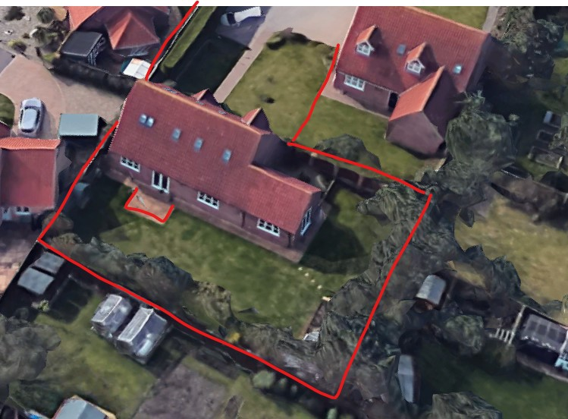
A rear extension on the site of the existing patio.
97B Elm Tree Road Lowestoft Suffolk NR33 9ES  Orangery rear garden of property  Date Description Information 1 Information 2  19/05/2020 Plans 2630.20.1 Existing & Proposed Elevations & Floor Plans + Site & Block Plan  07/05/2020 Application Form & Certificate  07/05/2020 Photographs Block Plan  07/05/2020 Plans 3D Plan Sheet 5 of 5  07/05/2020 Plans Dimensions Sheet 2 of 5  07/05/2020 Plans Elevations Sheet 3 of 5  07/05/2020 Plans Existing & Proposed Floor Plans + Site & Block Plans  07/05/2020 Plans Floor Plan Sheet 4 of 5  07/05/2020 Plans Roof Layout Sheet 1 of 5 | DC/20/1709/FUL  Public comments  Constraints  Related cases  Documents  Map

4 Farm Close
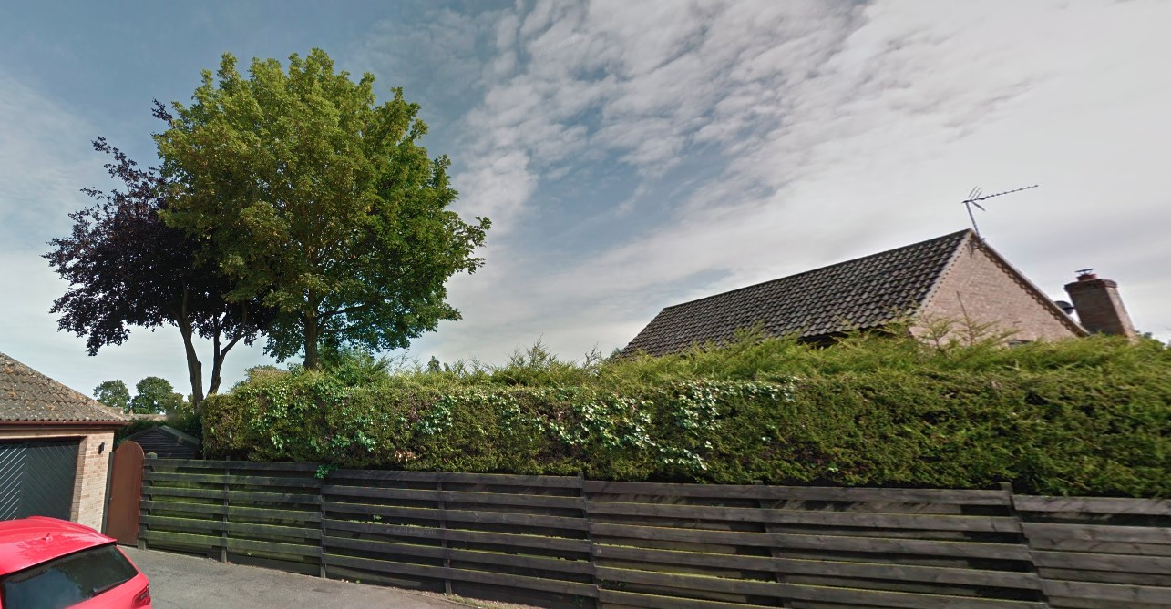
4 Farm Close Lowestoft Suffolk NR33 8RP  TPO 62 G6 Rear Garden 1 x Beech - Reduce back to previous pruning points max 2m Reason: general maintenance  Date Description Information 1 Information 2  18/05/2020 Application Form & Certificate | DC/20/1818/TPO  Public comments  Constraints  Related cases  Documents  Map

