Planning notes 8/9/2020

466a: To consider the following planning applications and decide the recommendations of the Council:

25 Sandringham Road
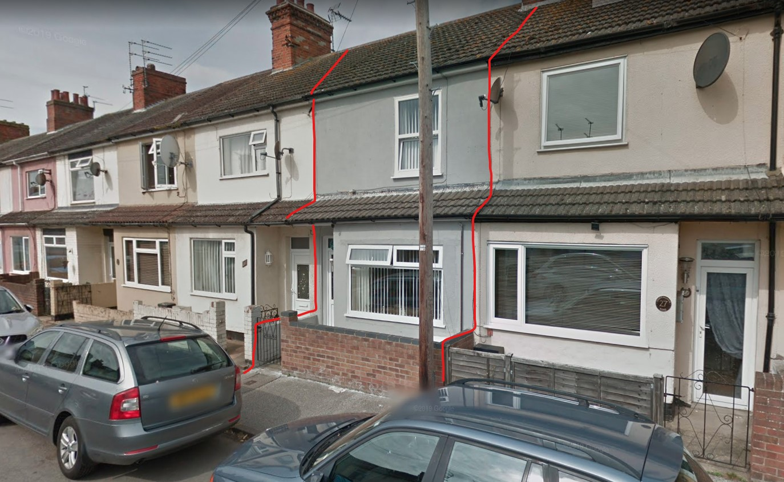
This house is part of a long terrace. As proposed, the porch would become part of the front wall.
25 Sandringham Road Lowestoft Suffolk NR32 2BU  Construction of a porch (residential)  Date Description Information 1 Information 2  02/09/2020 Consultee Responses Environmental  02/09/2020 Info Sheet INFO  29/08/2020 Plans Existing Elevations & Floor plans  25/08/2020 Plans Site & Block plan  25/08/2020 Proposed Elevations Proposed elevations | DC/20/3275/FUL  Public comments  Constraints  Related cases  Documents  Map

Port House, Station Square
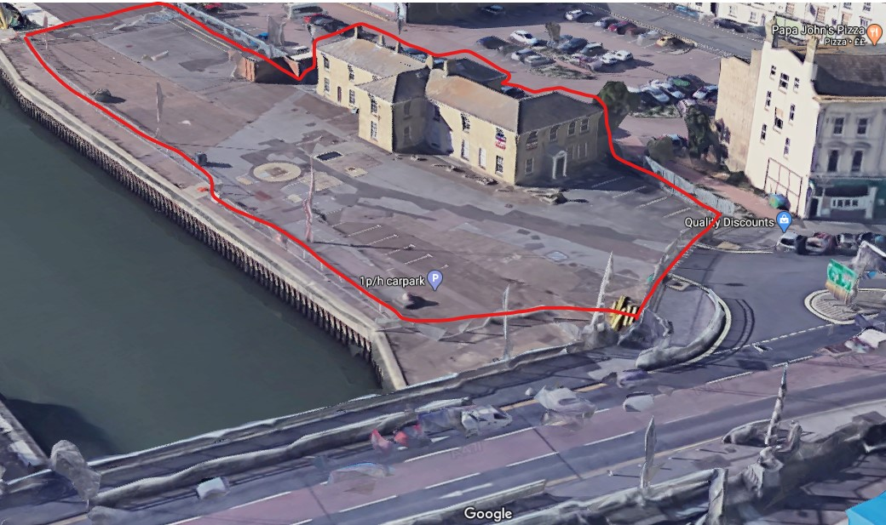
This is described as a change of use, but is entered as full planning permission. The plans do not include apartment details we usually see – layout of flats, bin storage, cycle provision, driveways, location of kitchen etc. Level of detail is more appropriate for change of use or outline planning permission.
Port House Station Square Lowestoft Suffolk NR32 1BA  Change of use from first floor offices to apartments & doors at ground floor access . Associated works to surrounding external areas.  Date Description Information 1 Information 2  07/09/2020 Consultee Responses suffolk fire and rescue sprinkler letter  07/09/2020 Consultee Responses Suffolk Fire and Rescue Service  04/09/2020 Consultee Responses Historic England  27/08/2020 Consultee Responses Environmental  27/08/2020 Info Sheet INFO  17/08/2020 Application Form & Certificate  17/08/2020 Contaminated Land Assessment Envirosearch  17/08/2020 Contaminated Land Assessment Questionnaire  17/08/2020 Design & Access Statement  17/08/2020 Existing Floor Plans 2558.19.1A Existing & Proposed Site Location Plan  17/08/2020 Existing Floor Plans 2558.19.2 Existing Ground Floor Plan  17/08/2020 Existing Floor Plans 2558.19.3 Existing First Floor Plan  17/08/2020 Flood Risk Assessment  17/08/2020 Heritage Statement  17/08/2020 Plans 2558.19.6A Existing & Proposed Elevations & Site Survey & Existing Block Pl  17/08/2020 Proposed Floor Plan 2558.19.4A Proposed Ground Floor  17/08/2020 Proposed Floor Plan 2558.19.5A Proposed First Floor  17/08/2020 Proposed Floor Plan 2558.19.7 Sketch Proposals GF Plan | DC/20/3136/FUL  Public comments  Constraints  Related cases  Documents  Map

64 London Road North
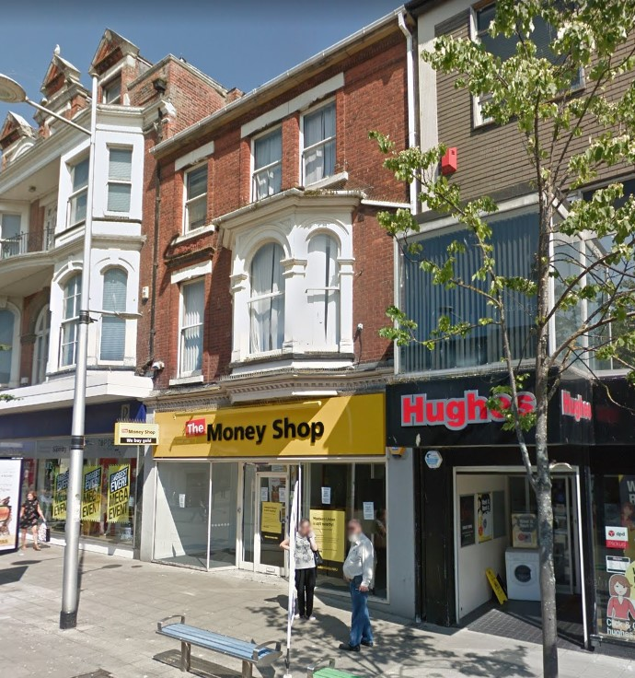
One neighbour comment asking ESC to clarify their flood risk criteria.
Proposal to place a 1 bedroom flat to the rear of the shop.
Attached flood risk assessment covers the first and second floor, but not the ground floor.
64 London Road North Lowestoft Suffolk NR32 1ET  Change of use of part of ground floor from commercial unit to 1-bed residential flat with erection of single storey infill rear extension following the demolition of part of single storey rear extension and removal of external stairs at rear.  Date Description Information 1 Information 2  04/09/2020 Neighbour Responses Brooks 40 Melbourne Road  28/08/2020 Info Sheet INFO  26/08/2020 Application Form & Certificate  26/08/2020 CIL Additional Questions form  26/08/2020 Design & Access Statement AUG/GS/20-DAS  26/08/2020 Existing Block / Layout Plan AUG/GS/20-002  26/08/2020 Flood Risk Assessment QFRA 1675 V 1.0  26/08/2020 Heritage Statement AUG/GS/20-HS  26/08/2020 Plans AUG/GS/20-003 Existing & Proposed Ground Floor  26/08/2020 Plans AUG/GS/20-004 Existing & Proposed Roof Plan  26/08/2020 Plans AUG/GS/20-005 Existing & Proposed Rear Elevation  26/08/2020 Plans AUG/GS/20-006 Existing & Proposed Rear Elevation (View From Grove Road)  26/08/2020 Plans AUG/GS/20-007 Existing Section A-A  26/08/2020 Plans AUG/GS/20-008 Proposed Section A-A  26/08/2020 Site / Location Plan AUG/GS/20-001  26/08/2020 Supporting Documents Appendix A Collection of Figures  26/08/2020 Supporting Documents Appendix B Existing Site & Proposed Plans | DC/20/3279/FUL  Public comments  Constraints  Related cases  Documents  Map

East Point Pavilion, Royal Plain
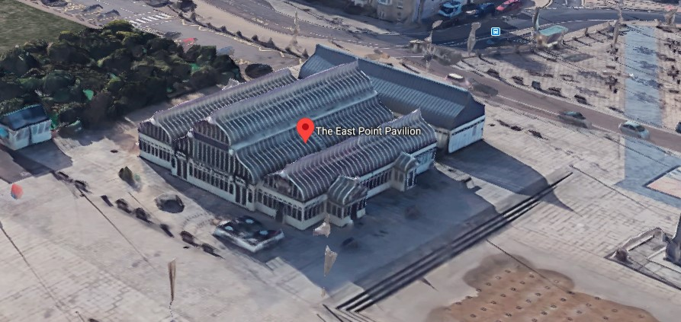
A proposal to restyle the pavilion as a food court / market style space. Some infill to the rear adjoining the toilet block.
East Point Pavilion Royal Plain Lowestoft Suffolk NR33 0AP  Works include internal strip out/reconfiguration of interiors, insertion of sliding folding doors, infill extensions, new door to PC block, proposed louvres and vents and proposed signage.  Date Description Information 1 Information 2  04/09/2020 Consultee Responses Historic England  17/08/2020 Design & Access Statement Design & Access Statement  17/08/2020 Existing Elevations Existing Elevations  17/08/2020 Existing Floor Plans Existing floor plan  17/08/2020 Plans Block plan  17/08/2020 Proposed Elevations Proposed elevations  17/08/2020 Proposed Floor Plan Proposed floor plan  17/08/2020 Site / Location Plan Site plan | DC/20/3175/FUL  Public comments  Constraints  Related cases  Documents  Map

Royal Court Hotel, 146 London Road South
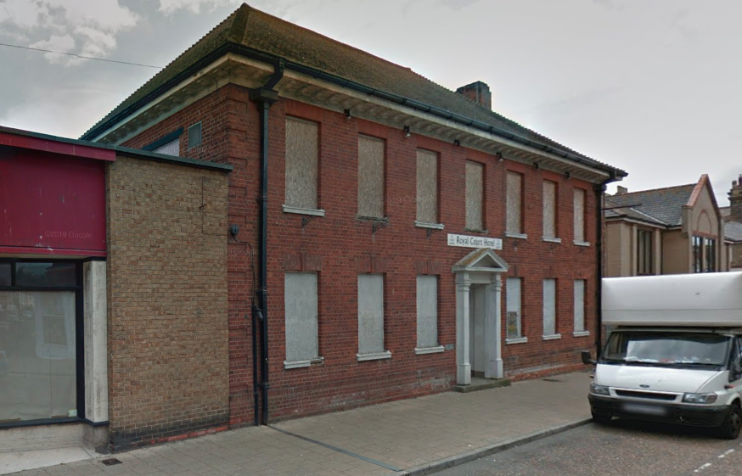
This has been resubmitted with amended plans. One new public objection, highlighting density of accommodation, insufficient parking and insufficient bin space.
In May this committee recommended rejection with a proposal of a café and 29 flats. There was considerable public objection to that proposal too. This has since been reduced to a café and 16 flats.

Royal Court Hotel 146 London Road South Lowestoft NR33 0AZ  Redevelopment and extension of the former Royal Court Hotel to provide a café (A3) at ground level and 16 residential flats  Date Description Information 1 Information 2  04/09/2020 Consultee Responses ESC Infrastructure Team  02/09/2020 Neighbour Responses Brooks 40 Melbourne Road, Lowestoft  28/08/2020 Consultee Responses Historic England  27/08/2020 Consultee Responses SCC Archaeology Service  25/08/2020 Consultee Responses SCC Flooding  24/08/2020 Consultee Responses Environmental Protection  21/08/2020 Supporting Documents Proposed Cycle Store  20/08/2020 Consultee Responses Environmental Agency  20/08/2020 Supporting Documents Ex hotel - Grade II document  20/08/2020 Supporting Documents Marketing Information  18/08/2020 Amended Plans & Documents 1854-00-10 Proposed site plan  18/08/2020 Amended Plans & Documents 1854-00-11 Proposed ground floor plan  18/08/2020 Amended Plans & Documents 1854-00-12 Proposed first floor plan  18/08/2020 Amended Plans & Documents 1854-00-13 Proposed second floor plan  18/08/2020 Amended Plans & Documents 1854-00-14 Proposed roof plan  18/08/2020 Amended Plans & Documents Supporting statement  18/08/2020 Heritage Statement  18/08/2020 Plans 1854-10-20 A1 Layout  06/07/2020 Consultee Responses Design & Conservation  26/06/2020 Neighbour Responses Broughton 26 Grosvenor Road, Lowestoft  26/06/2020 Neighbour Responses Gregory 39 Cleveland Road, Lowestoft,  26/06/2020 Neighbour Responses Wright 15 Grosvenor Road, Lowestoft  25/06/2020 Consultee Responses Environment Agency  25/06/2020 Consultee Responses Historic England  25/06/2020 Neighbour Responses Manship Waterloo Road, Lowestoft  18/06/2020 Neighbour Responses Harmer 5 The Meads, Lowestoft  16/06/2020 Neighbour Responses Boyce 7 Dell Road, Lowestoft  11/06/2020 Consultee Responses SCC Flooding  11/06/2020 Neighbour Responses King Unit 8, Riverside Business Centre, Riverside Road  11/06/2020 Neighbour Responses Taylor 19 - 21 Station Square  08/06/2020 Neighbour Responses Parker Kirkley Hall, 157 London Road South  04/06/2020 Supporting Documents Supporting Statment  02/06/2020 Neighbour Responses Khan 185 London Road North, Lowestoft  02/06/2020 Supporting Documents Agent correspondence with Highways Authority  02/06/2020 Supporting Documents Agent correspondence with Highways Authority  02/06/2020 Supporting Documents Agent correspondence with Highways Authority  26/05/2020 Neighbour Responses Trelawny-Gower 12 Windsor Road  18/05/2020 Consultee Responses SCC Highways  18/05/2020 Supporting Documents Additional information  18/05/2020 Supporting Documents Sustainability Statement  14/05/2020 Town/Parish Consultation Response Lowestoft Town Council  13/05/2020 Neighbour Responses Williams 335a Thorpe Road, Peterborough  30/04/2020 Consultee Responses Economic Development  29/04/2020 Consultee Responses Environmental protection  29/04/2020 Consultee Responses Essex and Suffolk Water  24/04/2020 Neighbour Responses Parker  23/04/2020 Contaminated Land Assessment Phase 1 Part 1  23/04/2020 Contaminated Land Assessment Phase 1 Part 2  23/04/2020 Contaminated Land Assessment Phase 1 Part 3  23/04/2020 Design & Access Statement  21/04/2020 Consultee Responses Police  17/04/2020 Consultee Responses CIL  16/04/2020 Existing Floor Plans 25427ea-03  31/03/2020 Application Form & Certificate  31/03/2020 Existing Block / Layout Plan  31/03/2020 Existing Block / Layout Plan 1854-003  31/03/2020 Existing Elevations 25427 02  31/03/2020 Flood Risk Assessment  31/03/2020 Plans 25427 03 Existing roof plan  31/03/2020 Proposed Elevations 1854-008  31/03/2020 Proposed Floor Plan 1854-004 Ground floor plan  31/03/2020 Proposed Floor Plan 1854-005 First floor plan  31/03/2020 Proposed Floor Plan 1854-005 Second floor plan  31/03/2020 Proposed Floor Plan 1854-007 Third floor plan  31/03/2020 Site / Location Plan  31/03/2020 Site / Location Plan 1854-002  31/03/2020 Supporting Documents Cover letter  31/03/2020 Supporting Documents Planning Statement | DC/20/1352/FUL  Public comments  Constraints  Related cases  Documents  Map

485 London Road South
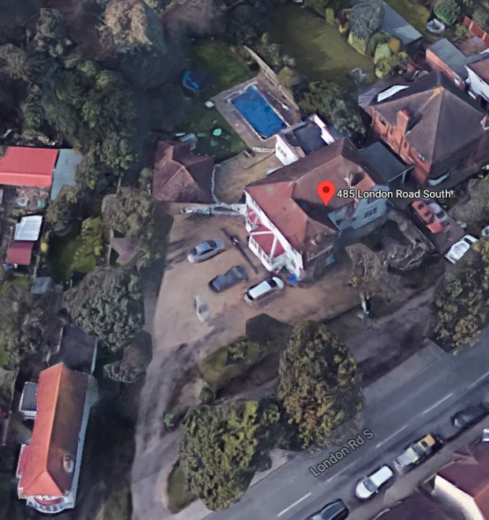
Large isolated property in a residential area.
485 London Road South Lowestoft Suffolk NR33 0PD  Change of use of one room in dwelling from solicitors office to part of the residential accommodation (Planning permission W5724/5 granted for use on 15 July 1997  Date Description Information 1 Information 2  28/08/2020 Consultee Responses Environmental Protection  28/08/2020 Info Sheet INFO  21/08/2020 Application Form & Certificate  21/08/2020 Plans Ground floor plan  21/08/2020 Site / Location Plan | DC/20/3233/COU  Public comments  Constraints  Related cases  Documents  Map

11 Uplands Road North
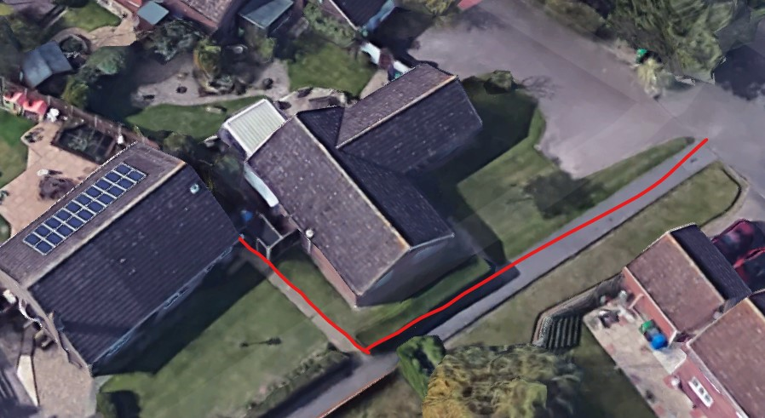
One neighbour comment highlighting a side extension that is not covered by these proposals. Concerns about overhanging of property boundary and privacy concerns.
There does appear to be a discrepancy in the South East elevation as the utility/WC appears not to be shown.
11 Uplands Road North Lowestoft Suffolk NR33 8AZ  Construction of a single storey front and rear extensions  Date Description Information 1 Information 2  07/09/2020 Amended Plans & Documents 031219 2 Proposed Floor and Elevations  07/09/2020 Amended Plans & Documents 031219 3A Site Plan and Proposed Block plan  01/09/2020 Neighbour Responses Peck 8 Thistledown Lowestoft  25/08/2020 Info Sheet INFO  19/08/2020 Application Form & Certificate  19/08/2020 Plans 031219 1 Existing Floor and Elevations  19/08/2020 Plans 031219 2 Proposed Floor and Elevations  19/08/2020 Site / Location Plan 031219 3 Plus Proposed Block Plan | DC/20/3167/FUL  Public comments  Constraints  Related cases  Documents  Map

190 Yarmouth Road
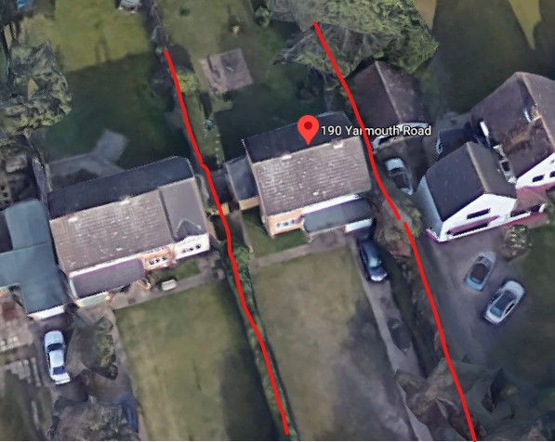
Squaring off existing extension to form a rectangular building. Similar to neighbour. No public objections.
190 Yarmouth Road Lowestoft Suffolk NR32 4AB  Extensions  Date Description Information 1 Information 2  21/08/2020 Info Sheet INFO  18/08/2020 Application Form & Certificate  18/08/2020 Plans 2603.20.1 Existing floor/elevations & Site/block plans  18/08/2020 Plans 2603.20.2 Proposed floor/elevations | DC/20/3154/FUL  Public comments  Constraints  Related cases  Documents  Map

9 Gunton Church Lane
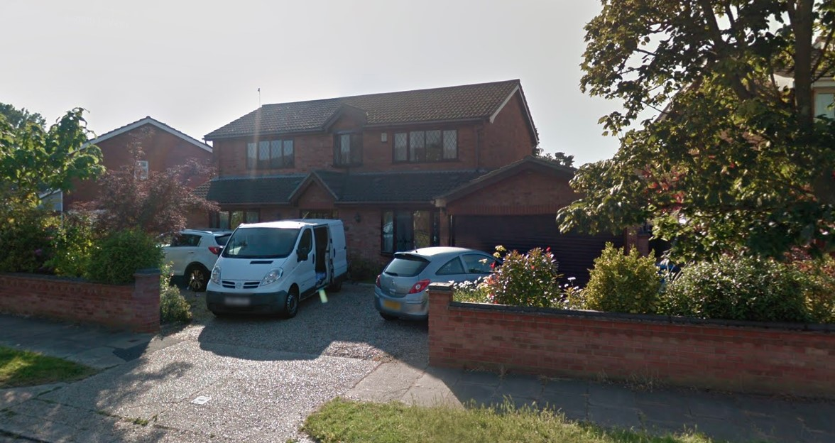
A proposed garden room to the rear of the house.
9 Gunton Church Lane Lowestoft Suffolk NR32 4LE  Proposed single storey rear extension.  Date Description Information 1 Information 2  25/08/2020 Info Sheet INFO  25/08/2020 Info Sheet INFO  20/08/2020 Application Form & Certificate  20/08/2020 Plans 2659.20.1B All plans - block plan, site plan, extensions and alterations | DC/20/3195/FUL  Public comments  Constraints  Related cases  Documents  Map

The Lake Lothing (Lowestoft) Third Crossing Order 2020 Schedule 2 (Works Provisions) Planning Act 2008

This has been sent as a mass of planning maps with no guides or summaries. 356 uniquely named documents are provided.
The Lake Lothing Third Crossing | SCC/0040/20/DOR356712

