Friends of Fen Park
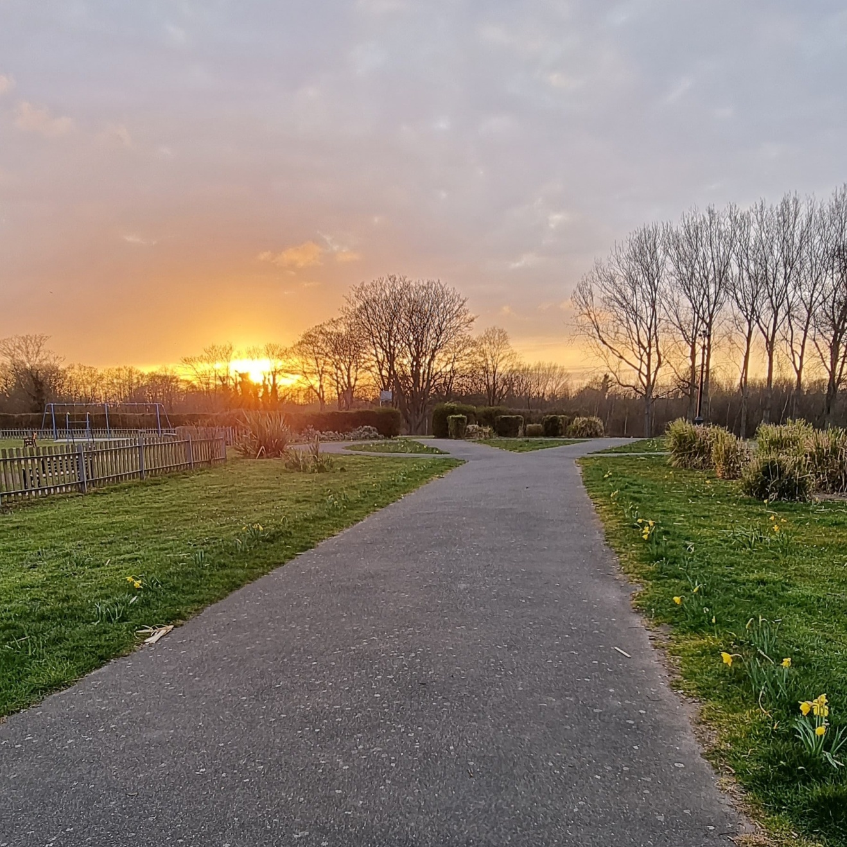
Formal proposal for raised beds and rose garden

By Shelley Goddard
14th May 2021
My name is Shelley Goddard and I am the secretary for Friends of Fen Park.
The group are seeking permission from Lowestoft Town Council to install two raised beds within the park, one of which would be a community fruit, veg and herb garden and a rose garden. We have full funding from the Kirkley People`s Forum for this project. The watering and maintenance of this project would be carried out by the Friends of Fen Park. A risk assessment with added details about legionnaire’s disease will be in place.
The aim of this project would be to brighten up the park when the flowers are in bloom. With the herb/fruit/ veg garden, this would be for the community to be able to use to add to their cooking after foraging in the raised beds. The flowers that will go into the raised bed are of a variety that will feed bees and butterflies. The raised beds will be made from recycled plastic and come in a kit form from Britishrecycledplastic.co.uk. They have a 25 year guarantee and the recycled plastic does not degrade or rot so this would be the best option we believe for durability and sustainability.
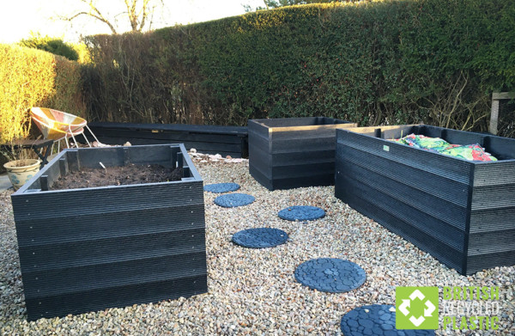
(PICTURE CREDIT: BRITISH RECYCLED PLASTICS)
The first bed.
The first bed will be situated on the grass between the children’s play area and the pathway on Russell’s Walk which is on the left side as you enter the park. It will be 3500mm long, 1000mm width and 750mm in height. It would be in black.
In this bed, there would be a variety of plants that are bee and butterfly friendly these include: hydrangea, pom dahlia, aster, escallonia, hellebores, anemone, campanula, hosta, fuchsia hibiscus, lupin, mahonia, lily, skimma, hollyhocks, delphiniums, peony, verbena, catmint, Echinacea and other wild flowers such as poppies.
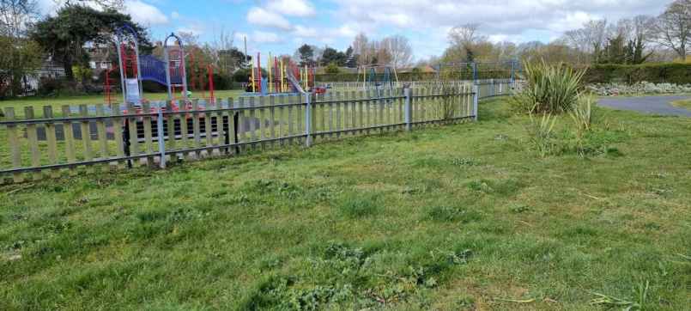

The second bed
The second raised bed will be on the right hand side as you enter the park. It will be 2000mm length, 1000mm wide and 750mm high and again, in black to match the first bed. This bed would be the community herb garden. By having this raised, it would be better for the local community to access the free herbs, fruit and veg so they don’t need to bend if they are disabled or have back issues and also so there is less chance of local dogs urinating on them. The plants would be labelled so that people can be familiar with what they are picking.
The herbs will consist of: thyme, oregano, peppermint, basil, bay tree, rosemary, heather, dill, parsley, mint, sage, chives, peppers, and strawberries.

The raised beds will both have a sufficient amount of compost to enrich the soil and provide natural fertiliser for the plant to get nutrients.
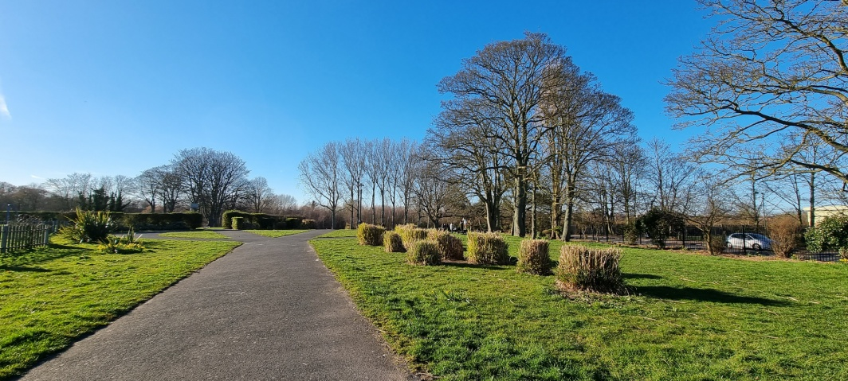

The rose garden
The rose garden will be located in the circle that has been divided into three sections. The friends group will dig out the grass within this circle and prepare the soil by adding a layer of compost to the top. The roses will be spread out so that the established rose bush has more space to grow as the plant matures. The group will water regularly, prune and remove dead flower heads. In amongst the roses, we are looking at planting: boxwood balls for the border, lupin, hollyhocks, dahlias, and delphiniums based on the theme of an old English rose garden such as that in Regents Park and Sommerlayton gardens. This would help create a row of striking colour within the park.
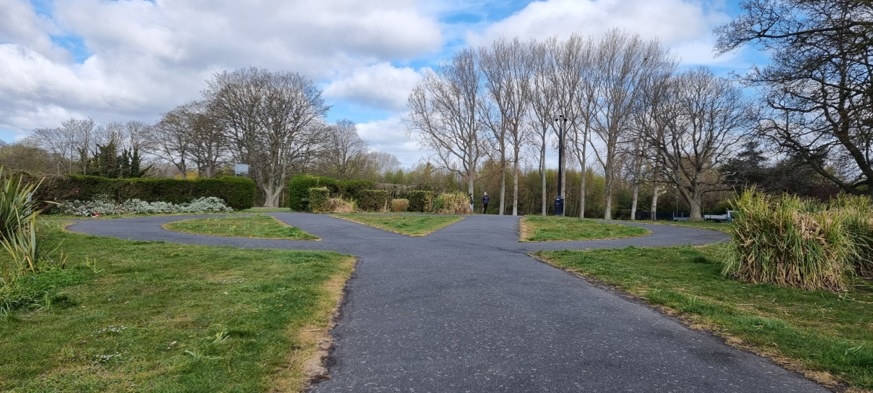

As stated above, we have the money available from Kirkley People`s Forum therefore we do not require any money from Lowestoft Town Council towards this project. All we are asking Lowestoft town council for is the go ahead to put these plans from paper to reality.

Thank you for reading,
Shelley Goddard
On behalf of Friends of fen park

