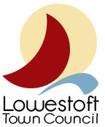

MEETING PAPER
Subject: NHS, Social Care & Frontline Workers Day
Meeting: Events and Communications Sub-Committee
Date: Wednesday 27th January 2021

NON CONFIDENTIAL

Background/Introduction
Lord Mayors, Lord Provosts, Mayors and Chairs of Councils in Local Authorities and Town Councils throughout the United Kingdom are being encouraged to play a leading role in NHS, Social Care & Frontline Workers Day on 5th July 2021, a unique day of celebration and commemoration. This special day is also being used to raise valuable funds for NHS Charities Together, the official organisation set up to support over 230 hospitals and their charitable trusts, with the money being equally divided to support the health and wellbeing of staff. The other charity to benefit is the National Care Association, which wishes to use this opportunity to raise £200,000 for the work they undertake in their care homes.

Details
A detailed guided structure of the running of the event and how to celebrate the day has been released – asking to do this by agreeing to raise a unique flag at 10 am; lead the Two-Minute Silence at 11 am and the Nation's Toast at 1 pm from within their local communities, to the Heroes of the NHS, Social Care. Followed by street, garden, village green and/or Hall parties. At 4 pm an opportunity to have afternoon tea. Lastly, at 8 pm taking to our doorsteps and clapping our heroes, with the ringing of church bells. These are all suggestions, however may alter dependant on Government restrictions and progress of Covid-19 vaccine rollout. Further details and ideas, visit: https://www.nhsfrontlineday.org/
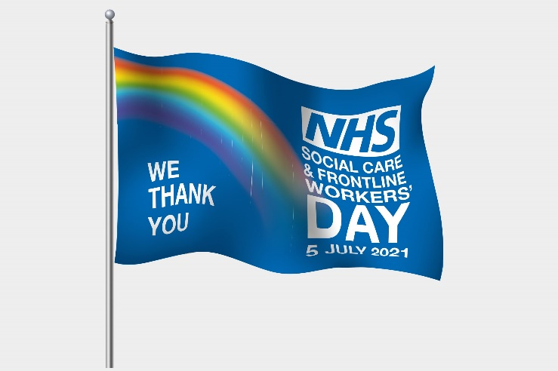
Recommendations/Decision
A special flag bearing the event logo – including the stylised rainbow that came to symbolise our nationwide appreciation of those working on the frontline has been developed. Encouraging councils, voluntary groups, professional bodies, companies, churches and cathedrals, hotels, hospitals, schools and other organisations, to purchase a flag and proudly fly it or display it from their windows. £5 from every flag sold will be equally divided between the two chosen good causes. Participants will be asked to raise or display the flags at 10am on July 5th to signal the official start the day’s celebrations, and to leave them flying for seven days. Three sizes are available, including one for Government buildings. Flags can be obtained from official supplier J. W. Plant & Co Ltd.

