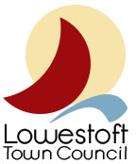

MEETING PAPER
Subject: Lowestoft Place Branding Masterclass
Meeting: Events and Communications Sub-Committee
Date: 17.12.2020

NON CONFIDENTIAL

Background/Introduction
East Suffolk Council took part in a place-making programme, at the end of 2018, through the 'Making Waves Together' project. This work aimed to fully understand the public perception of Lowestoft and the priorities of businesses, stakeholders, and the community and to tell the “story” of Lowestoft through identifying the qualities that make the place. Following this, East Suffolk Council and its partners started development of a Place Board and the Lowestoft story. The Place Board and Ambassador programme will help to raise the profile and promote all of the positive things happening in Lowestoft.

For further information on the Lowestoft Place Making, use the following link: https://www.eastsuffolk.gov.uk/business/regeneration-projects/lowestoftplacemaking/

Details
Key Themes
- Lowestoft: The Leading Light
- Explore the Eastscape
- Harnessing and celebrating the energy of the sea
Place
- Photography and a consistent narrative is key – (Visual language)
- Collaborating with businesses, organisations and Councils is the best way forward
- To develop existing and new activity within the town

Place/Story

Environment Products
Communications Behaviour

Branding Toolkit
Everyone can use the branding toolkit that has been designed for Lowestoft, businesses, councils and organisations all working together to develop the image of the town.
The branding toolkit includes typography, designs and images, all catered to this vision of Lowestoft.
>The Lowestoft Place Branding Masterclass is available now on YouTube to watch:
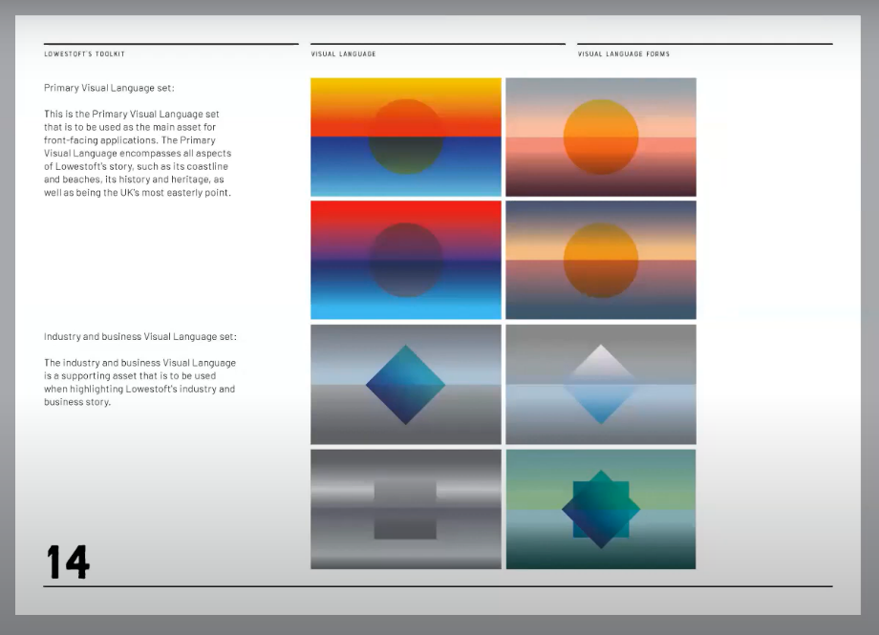
Lowestoft Place Branding Masterclass - YouTube
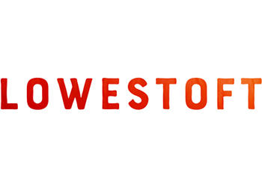

Recommendations/Decision
To note launch of Lowestoft Place Branding (The Lowestoft Story) and how the Town Council will build this into its communications. Discussions with ECO who attended the masterclass open during this meeting.

