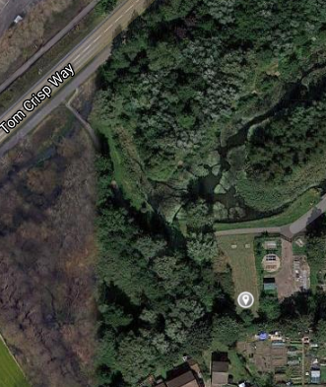

Suggested site for the mulching area in Fen Park

This is adjacent to the Water treatment plant, is not much used save for blackberry picking, is easily accessible but can be fenced to detract from the public gaze.

