Planning notes 4/2/2020

Rugby Club House, Old Lane
Note this application is DC/19/4368/FUL, not DC/19/4368/FUL as described in agenda.
This has been before us before. As the application only covered the access road, our verdict was “It was agreed to recommend approval of the application subject to comments from the Highways Authority. The Committee would ask that the proposed development has minimal impact on existing tress and that new trees are planted as necessary. Lowestoft Town Council has declared a Climate Emergency. To support this declaration, the Planning and Environment Committee requests that when recommending approval of a planning application the following measures are taken into account: Consideration of biodiversity, Support for new or improved renewable energy. Support for alternatives to car use e.g. walking, cycling and public transport, and encourage efficient car use, including through appropriate car parking provision, carsharing, differential car-parking charges, and the use of electric cars. Encouragement for the management of land for nature and an increase in tree cover. Resistance of the use of natural open space for development and encourage reuse of brownfield sites. Support homes which are energy efficient, nature friendly and located close to public transport and amenities.”
Plans were amended on 9 January, accompanied by a letter from the rugby club.
Note there are now 63 public comments including 57 objections.
Be mindful that this is only an application for an access road only.
Rugby Club House Old Lane Lowestoft NR32 5HE  Change of access arrangements to the entrance to Gunton Park.  Date Description Information 1 Information 2  28/01/2020 Neighbour Responses Bland 3 Old Lane, Lowestoft  28/01/2020 Neighbour Responses Galloway 17 Old Lane, Lowestoft  27/01/2020 Neighbour Responses McMeekin 9 Old Lane, Lowestoft  27/01/2020 Neighbour Responses Oliver 5 The Shires, Lowestoft  23/01/2020 Neighbour Responses Pallant 1 Gunton Park Mews, Lowestoft  22/01/2020 Neighbour Responses Knights 14 Old Lane, Lowestoft  21/01/2020 Consultee Responses Suffolk Highways  21/01/2020 Neighbour Responses Yates 1 Gunton Park Mews, Lowestoft  20/01/2020 Neighbour Responses Cooper 24 Corton Long Lane, Lowestoft  20/01/2020 Neighbour Responses Dalrymple 10 The Woodlands, Lowestoft  16/01/2020 Neighbour Responses Watson 35 The Woodlands, Lowestoft  15/01/2020 Neighbour Responses Jones Hillcroft, 334 Yarmouth Road, Lowestoft  09/01/2020 Plans 1939-100-P3 Highway Access  09/01/2020 Supporting Documents Supporting Comments  17/12/2019 Neighbour Responses Smith 6 Corton Long Lane, Lowestoft  17/12/2019 Town/Parish Consultation Response  16/12/2019 Neighbour Responses C.N. Dobson 326 Yarmouth Road Lowestoft  16/12/2019 Neighbour Responses Cooper 24 Corton Long Lane  16/12/2019 Neighbour Responses Tucker 6 Old Lane, Lowestoft  13/12/2019 Neighbour Responses Christie 10 Old Lane, Lowestoft  12/12/2019 Neighbour Responses Keatley 3 The Woodlands, Lowestoft  12/12/2019 Neighbour Responses Woods 7 Larkspur Close, Lowestoft  10/12/2019 Neighbour Responses Cossey 8 Culley Way, Hopton  10/12/2019 Neighbour Responses Shiers 20 Corton Long Lane, Lowestoft  09/12/2019 Neighbour Responses Cassidy 7 Old Lane, Lowestoft  09/12/2019 Neighbour Responses Cassidy 7 Old Lane, Lowestoft  09/12/2019 Neighbour Responses Cave 38 Corton Long Lane, Lowestoft  09/12/2019 Neighbour Responses Cooper 24 Corton Long Lane, Lowestoft  09/12/2019 Neighbour Responses Cossey 29 The Woodlands, Lowestoft  09/12/2019 Neighbour Responses Croker 2A Old Lane, Lowestoft  09/12/2019 Neighbour Responses Davies 32 The Woodlands, Lowestoft  09/12/2019 Neighbour Responses Doddington 13 Old Lane, Lowestoft  09/12/2019 Neighbour Responses Drury 14 The Woodlands, Lowestoft  09/12/2019 Neighbour Responses Durrant 2 Larkspur Close, Lowestoft  09/12/2019 Neighbour Responses Freeman 4 Larkspur Close, Lowestoft  09/12/2019 Neighbour Responses Galloway 17 Old Lane, Lowestoft  09/12/2019 Neighbour Responses Harris 16 The Woodlands, Lowestoft  09/12/2019 Neighbour Responses Martin 12 Corton Long Lane, Lowestoft  09/12/2019 Neighbour Responses Matthews 4 Gunton Park Mews, Lowestoft  09/12/2019 Neighbour Responses Miles 1 The Shires, Lowestoft  09/12/2019 Neighbour Responses Oliver 5 The Shires, Lowestoft  09/12/2019 Neighbour Responses Palmer 30 The Woodlands, Lowestoft  09/12/2019 Neighbour Responses Pickess The Old Stables, Old Lane, Lowestoft  09/12/2019 Neighbour Responses Rodgers 3 The Shires, Lowestoft  09/12/2019 Neighbour Responses Smith 28 The Woodlands, Lowestoft  09/12/2019 Neighbour Responses Smith 28 The Woodlands, Lowestoft  09/12/2019 Neighbour Responses Wade 3 Larkspur Close, Lowestoft  09/12/2019 Neighbour Responses Watson 35 The Woodlands, Lowestoft  09/12/2019 Town/Parish Consultation Response  06/12/2019 Neighbour Responses Bradfield 19 The Woodlands, Lowestoft  06/12/2019 Neighbour Responses Dobney 8 Old Lane, Lowestoft  06/12/2019 Neighbour Responses Hemmings 1 The Woodlands, Lowestoft  06/12/2019 Neighbour Responses Leonard 8 The Woodlands, Lowestoft  06/12/2019 Neighbour Responses McMeekin 9 Old Lane, Lowestoft  05/12/2019 Neighbour Responses Carter 5 Larkspur Close, Lowestoft  05/12/2019 Neighbour Responses Cossey 29 The Woodlands, Lowestoft  05/12/2019 Neighbour Responses Mackay 32 Corton Long Lane, Lowestoft  05/12/2019 Neighbour Responses Shiers 20 Corton Long Lane, Lowestoft  04/12/2019 Neighbour Responses Knights 14 Old Lane, Lowestoft  03/12/2019 Consultee Responses Landscape  03/12/2019 Neighbour Responses Dowdall Beech House, Old Lane, Lowestoft  03/12/2019 Neighbour Responses Jones Hillcroft, 334 Yarmouth Road, Lowestoft  03/12/2019 Neighbour Responses Lott  03/12/2019 Neighbour Responses McAvoy  02/12/2019 Consultee Responses Suffolk Highways  02/12/2019 Neighbour Responses Brooks 4 Old Lane, Lowestoft  02/12/2019 Neighbour Responses Nixon 10 Corton Long Lane, Lowestoft  02/12/2019 Neighbour Responses Reading 7 The Shires, Lowestoft  02/12/2019 Neighbour Responses Smith 18 The Woodlands, Lowestoft  02/12/2019 Neighbour Responses Tabiner 33 The Woodlands, Lowestoft  02/12/2019 Neighbour Responses Wilkinson 5 Old Lane, Lowestoft  29/11/2019 Neighbour Responses Matthews 4 Gunton Park Mews, Lowestoft  29/11/2019 Neighbour Responses Rushmere 2 Gunton Park Mews, Lowestoft  29/11/2019 Neighbour Responses Yates 1 Gunton Park Mews, Lowestoft  28/11/2019 Neighbour Responses Melia 34 Corton Long Lane, Lowestoft  27/11/2019 Neighbour Responses Bland 3 Old Lane, Lowestoft  27/11/2019 Neighbour Responses Johnson 20 The Woodlands, Lowestoft  27/11/2019 Town/Parish Consultation Response  26/11/2019 Neighbour Responses Read 6 The Woodlands, Lowestoft  21/11/2019 Neighbour Responses Reynolds 15 Old Lane, Lowestoft  18/11/2019 Existing Block / Layout Plan A884 002  18/11/2019 Site Notice & Neighbourhood Notification SNOTQR  14/11/2019 Site / Location Plan A884 001  07/11/2019 Application Form & Certificate  07/11/2019 Plans 1377_HWY_001A Preliminary Site Access  07/11/2019 Plans 1377_HWY_001A Preliminary Site Access Detailed  07/11/2019 Supporting Documents Rugby Club Letter  07/11/2019 Supporting Documents Supporting Solicitors Letter | DC/19/4368/FUL  Public comments  Constraints  Related cases  Documents  Map

Hamilton House, Battery Green Road

Hamilton House Business Centre Battery Green Road Lowestoft Suffolk NR32 1DE  Prior Notification - Office and reception to Hamilton House offices  Date Description Information 1 Information 2  28/01/2020 Site Notice & Neighbourhood Notification SNOTQR  27/01/2020 Application Form & Certificate  27/01/2020 Plans 1918.15.20 | DC/20/0317/PN3  Public comments  Constraints  Related cases  Documents  Map

Land West of Unit 11, North Quay Retail Park
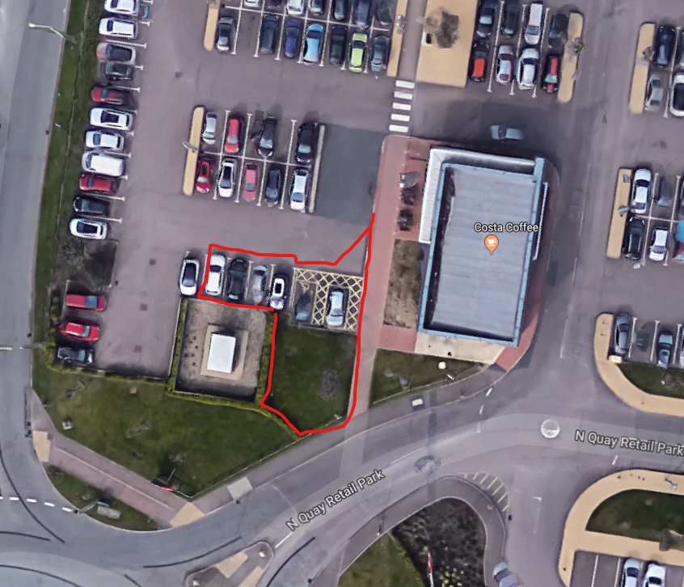
This is land to the West of Costa Coffee.
Land West Of Unit 11 North Quay Retail Park Peto Way Lowestoft Suffolk  Construction of a new 111 SQ. M (GIA) class A1/A3 building and associated physical works to site layout  Date Description Information 1 Information 2  31/01/2020 Consultee Responses Environmental Protection  28/01/2020 Consultee Responses CILTeam  27/01/2020 Site Notice & Neighbourhood Notification SNOTQR  22/01/2020 Application Form & Certificate  22/01/2020 Existing Block / Layout Plan 10835-PL-P01  22/01/2020 Plans 10835-PL-P03 Proposed floor and roof plan  22/01/2020 Proposed Block / Layout Plan 10835-PL-P02  22/01/2020 Proposed Elevations 10835-PL-E01  22/01/2020 Site / Location Plan 10835-PL-L01  22/01/2020 Supporting Documents Covering Letter | DC/20/0260/FUL  Public comments  Constraints  Related cases  Documents  Map

The Marina Customer Service Centre
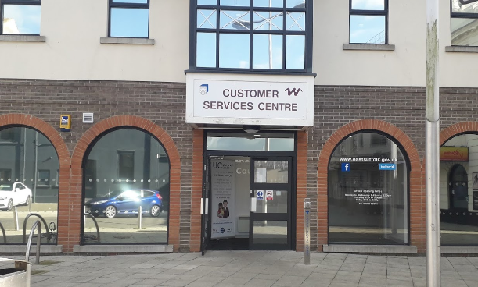
Note this application is DC/20/0271/FUL, not DC/20/2071/FUL as described in agenda.

The Marina Customer Service Centre Marina Lowestoft Suffolk NR32 1HH  Installation of new East Suffolk Council logo signage at high level to existing building  Date Description Information 1 Information 2  27/01/2020 Site Notice & Neighbourhood Notification SNOTQR  23/01/2020 Application Form & Certificate  23/01/2020 Plans Existing & Proposed elevations and site | DC/20/0271/FUL  Public comments  Constraints  Related cases  Documents  Map
The Marina Customer Service Centre Marina Lowestoft Suffolk NR32 1HH  Non Illuminated Advertisement Consent - New East Suffolk Council logo  Date Description Information 1 Information 2  23/01/2020 Application Form & Certificate  23/01/2020 Plans Existing & Proposed elevation & Site | DC/20/0272/ADN  Public comments  Constraints  Related cases  Documents  Map

54 London Road North
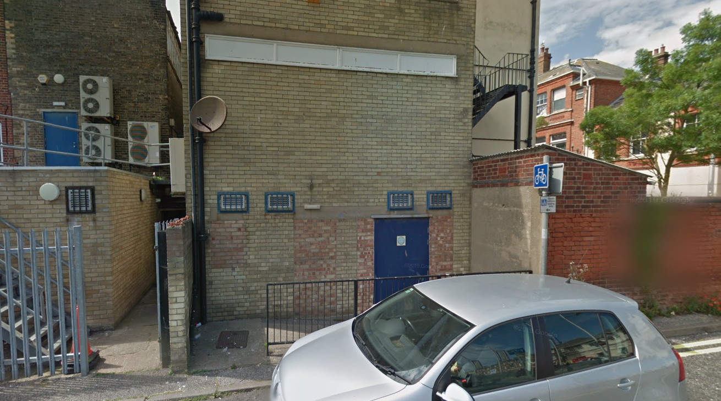
Signage to the rear of Cashino. off Bon Marche. Although this application is only advertisement consent, it also appears to imply the conversion of a fire exit into a customer entrance.
54 London Road North Lowestoft Suffolk NR32 1EP  Illuminated Advertisement Consent- New rear sign panel with internally illuminated individual letters and logo  Date Description Information 1 Information 2  22/01/2020 Consultee Responses Highways  21/01/2020 Application Form & Certificate  21/01/2020 Plans Existing & Proposed Elevations  21/01/2020 Proposed Block / Layout Plan  21/01/2020 Site / Location Plan  21/01/2020 Supporting Documents Sign Spec | DC/20/0226/ADI  Public comments  Constraints  Related cases  Documents  Map

18-20 Norwich Road
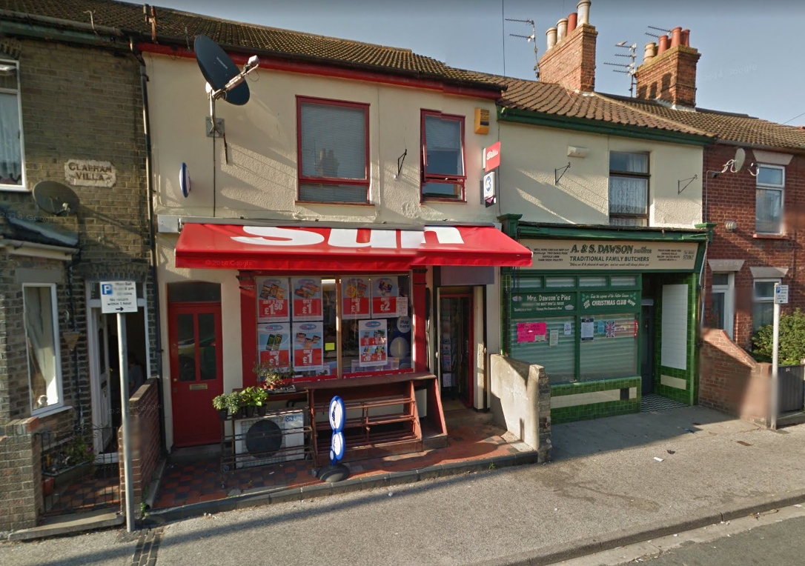
We’ve seen this one before in a similar form, which was refused at our level and by District. Then, we said “It was agreed that the application was presented was incomplete, with no application form nor details of the intention of what would 'match with the next shop' and as such should be rejected.” We struggled to discern the difference between the existing and proposed plans, and that there was no definition of the ‘next shop’ within the application.
We do now have an application form. The plans appear to remain vague.

18 - 20 Norwich Road Lowestoft Suffolk NR32 2BW  Creation of shop name board to match with the neighbouring property  Date Description Information 1 Information 2  31/01/2020 Consultee Responses Environmental  21/01/2020 Site Notice & Neighbourhood Notification SNOTQR  13/01/2020 Application Form & Certificate  13/01/2020 Plans DRW-01R existing/proposed elevation/floor  13/01/2020 Site / Location Plan | DC/20/0098/FUL  Public comments  Constraints  Related cases  Documents  Map

6 Saxon Road
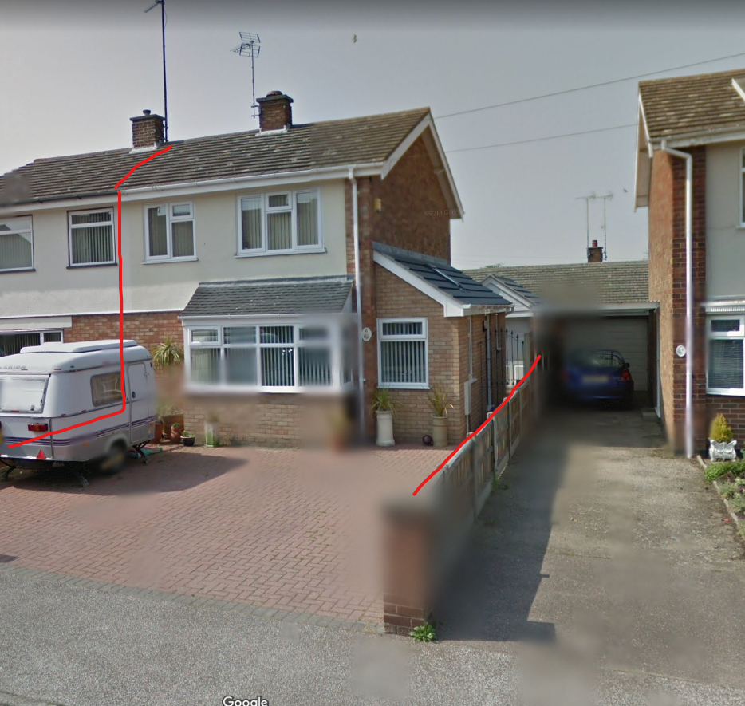
This application extends the first floor over the existing ground floor side extension, enlarging the two first floor bedrooms.
Two neighbour objections responses:
Ms Ludlam: Objects, loss of light to 3 Cunningham Way
Ms Whitehead: Objects, loss of light to bungalow behind property. Also commented that building has apex roof, where flat roof is indicated in the plan.
6 Saxon Road Lowestoft Suffolk NR33 7BS  First floor side extension and internal alterations  Date Description Information 1 Information 2  28/01/2020 Neighbour Responses Ludlam 3 Cunningham Way  24/01/2020 Neighbour Responses Whitehead  22/01/2020 Site Notice & Neighbourhood Notification SNOTQR  21/01/2020 Plans 164 09 Existing and proposed rear elevations  17/01/2020 Application Form & Certificate  17/01/2020 Existing Elevations 164.03  17/01/2020 Existing Floor Plans 164.01 Ground floor  17/01/2020 Existing Floor Plans 164.02 First floor  17/01/2020 Photographs  17/01/2020 Proposed Block / Layout Plan 164.08  17/01/2020 Proposed Elevations 164.06  17/01/2020 Proposed Floor Plan 164.04 Ground floor  17/01/2020 Proposed Floor Plan 164.05 First floor  17/01/2020 Site / Location Plan 164.07 | DC/20/0202/FUL  Public comments  Constraints  Related cases  Documents  Map

23 Cranesbill Road
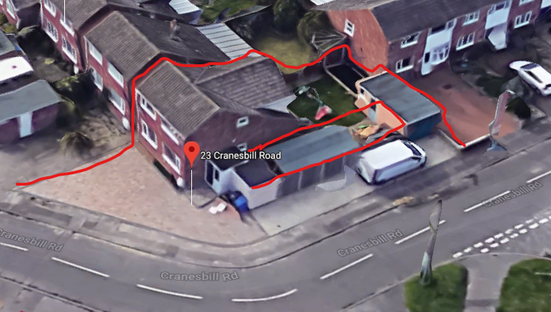
Note this application is DC/19/5065/FUL, not DC/20/5065/FUL as described in agenda.
This replaces the existing shed with an extension running the full length to the rear garage. Access to the garden would then be through the garage.
23 Cranesbill Road Lowestoft Suffolk NR33 7EB  Demolish large shed and replace with flat roof extension connected to existing.  Date Description Information 1 Information 2  16/01/2020 Site Notice & Neighbourhood Notification SNOTQR  02/01/2020 Application Form & Certificate  02/01/2020 Plans Proposed  02/01/2020 Plans Survey  02/01/2020 Proposed Block / Layout Plan  02/01/2020 Site / Location Plan | DC/19/5065/FUL  Public comments  Constraints  Related cases  Documents  Map

1, 2, 3 and 4 Lancing Court, Rectory Road
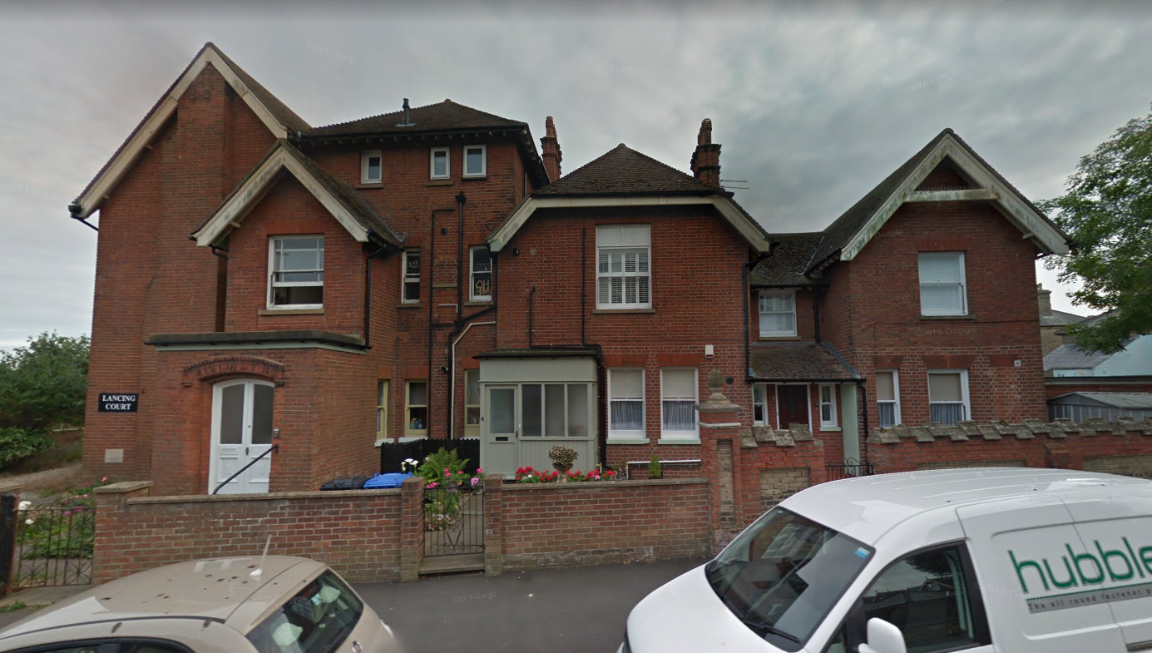
This is in a conservation area. I note that the replacement windows are of a heritage sash style very similar to the existing windows, but with the improved energy ratings.
1, 2, 3 And 4 Lancing Court Rectory Road Lowestoft Suffolk NR33 0BU  Change the windows of all flats in lancing court to double glazed and to replace existing single glazed porch double glazed on flat 4.  Date Description Information 1 Information 2  17/01/2020 Site Notice & Neighbourhood Notification SNOTQR  15/01/2020 Design & Access Statement & Heritage assessment  15/01/2020 Site / Location Plan  15/01/2020 Site Notice & Neighbourhood Notification SNOTQR  15/01/2020 Supporting Documents Propsoed window details brochure  13/01/2020 Application Form & Certificate  13/01/2020 Photographs Existing window  13/01/2020 Photographs Existing window  13/01/2020 Photographs Existing window  13/01/2020 Photographs Existing window  13/01/2020 Photographs Existing window  13/01/2020 Photographs Existing window | DC/20/0102/FUL  Public comments  Constraints  Related cases  Documents  Map

26 The Avenue, Lowestoft
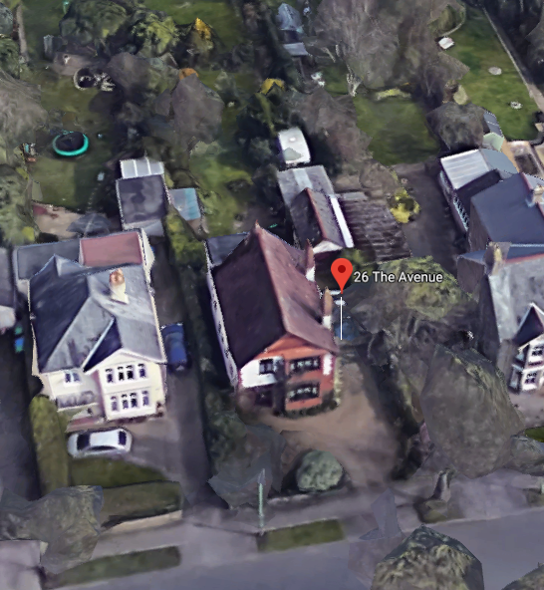
One objection from Hall, 55 The Avenue
- No site notice
- Do not meet the criteria for a conservation area
  - Replacing ornate red tiles in frontage with plastic cladding
  - Replacing wooden frames with plastic sashes.
  - Replacing garage door with roller.
- Loss of light to neighbouring properties
26 The Avenue Lowestoft Suffolk NR33 7LL  Replacement rear extension, replacement garage and workshop, remove conservatory and proposed alteration to elevations and front boundary  Date Description Information 1 Information 2  29/01/2020 Neighbour Responses Hall 55 The Avenue  17/01/2020 Site Notice & Neighbourhood Notification SNOTQR  15/01/2020 Application Form & Certificate  15/01/2020 Design & Access Statement  15/01/2020 Plans 2562.19.1A existing floor/elevations  15/01/2020 Plans 2562.19.2D proposed floor/elevations  15/01/2020 Site / Location Plan 2562.19.3 proposed /existing block railings  15/01/2020 Site Notice & Neighbourhood Notification SNOTQR | DC/20/0129/FUL  Public comments  Constraints  Related cases  Documents  Map

