Payments Made
Date | Person | Amount | Description | Status
1st October 2018 | Waveney District Council | £113 | Triangle Market Business Rates | Paid
1st October 2018 | Waveney District Council | £288 | Kensington Garden PC Business Rates | Paid
1st October 2018 | Waveney District Council | £168 | Pakefield Street PC Business Rates | Paid
2nd October 2018 | David Ogilvie Engineering | £2330 + £466 VAT | 2x Memorial Bench and Memorial Bin for Belle Vue Park | Paid
2nd October 2018 | Heritage Open Day Grant | £475 | Heritage Open Day Grant | Paid
2nd October 2018 | Shona Bendix | £7.95 | Stationery | Paid
2nd October 2018 | Sarah Foote | £20 | Royal British Legion Centenary Badges | Paid
4th October 2018 | SCC Pension Fund | £4406.98 | Staff Pensions September | Paid
5th October 2018 | Information Commissioners Office | £35 x 19 = £665 | ICO Registration x19 | Paid
8 October 2018 | Waveney Norse | £58,300 + £11660 VAT = £69960 | April Waveney Norse Payment | Paid
9th October 2018 | Waveney Norse | £58,300 + £11660 VAT = £69960 | May Waveney Norse Payment | Paid
10th October 2018 | Waveney Norse | £58,300 + £11660 VAT = £69960 | June Waveney Norse Payment | Paid
11th October 2018 | Waveney Norse | £58,300 + £11660 VAT = £69960 | July Waveney Norse Payment | Paid
11th October 2018 | HMRC | £12045.40 | HMRC Repayment July – September | Paid
11th October 2018 | Waveney District Council | £875 + £175 VAT = £1050 | 3 x Yearly Parking Permits for Whapload Road Car Park | Paid
11th October 2018 | Sarah Foote | £81.04 | Reimbursement for Stationery and Meeting expenses | Paid
11th October 2018 | Shona Bendix | £22.44 | Reimbursement for Meeting expenses | Paid
11th October 2018 | Nicholsons Solicitors | £2219 + £443.80 VAT = £2662.50 | Marina Theatre Management Agreement Professional Fees | Paid
11th October | Mark Speller | £33.85 | Reimbursement for Travel expenses and meeting expenses | Paid

Income Received
Date | Person | Amount | Description
8th October 2018 | Tenant | £213.16 | Rental Income from Tenant

Payments Scheduled
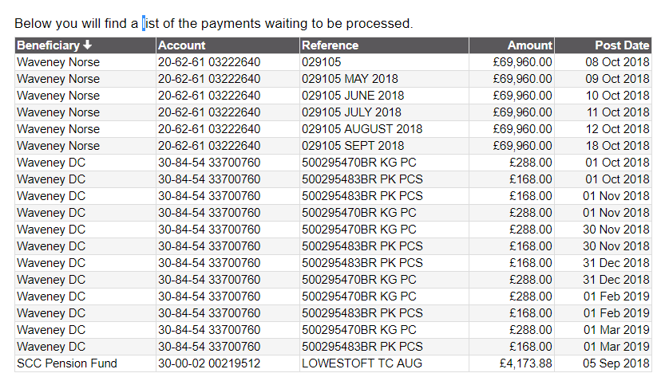

Payments for Authorisation
Person | Amount | Description
Cllr Alice Taylor | £159.61+ £31.98 VAT = £191.59 | Repayment of the .uk domain and emails

